<https://aws.amazon.com/certification/certified-cloud-practitioner/?c=sec&sec=resources>

Step1. Get to know the exam and exam-style questions

1) Review the CLF-C02 exam guide

https://d1.awsstatic.com/training-and-certification/docs-cloud-practitioner/AWS-Certified-Cloud-Practitioner_Exam-Guide.pdf

The exam has the following content domains and weightings:

• Domain 1: Cloud Concepts (24% of scored content)

• Domain 2: Security and Compliance (30% of scored content)

• Domain 3: Cloud Technology and Services (34% of scored content)

• Domain 4: Billing, Pricing, and Support (12% of scored content)

2) AWS Certified Cloud Practitioner Official Practice Question Set

<https://explore.skillbuilder.aws/learn/course/external/view/elearning/14050/aws-certified-cloud-practitioner-official-practice-question-set-clf-c02-english>

Step 2: Learn about exam topics

* [AWS glossary](https://docs.aws.amazon.com/general/latest/gr/glos-chap.html): <https://docs.aws.amazon.com/pdfs/glossary/latest/reference/glossary-ref.pdf#glos-chap>
* [Whitepaper: Overview of Amazon Web Services](https://d0.awsstatic.com/whitepapers/aws-overview.pdf): <https://d0.awsstatic.com/whitepapers/aws-overview.pdf>
* [AWS Fundamentals: Overview](https://aws.amazon.com/getting-started/fundamentals-overview/)
* [What is cloud computing?](https://aws.amazon.com/what-is-cloud-computing/)
* [Types of cloud computing](https://aws.amazon.com/types-of-cloud-computing/)
* [Cloud computing with AWS](https://aws.amazon.com/what-is-aws/)

AWS glossary

<https://docs.aws.amazon.com/pdfs/glossary/latest/reference/glossary-ref.pdf#glos-chap>

Whitepaper: Overview of Amazon Web Services

<https://d0.awsstatic.com/whitepapers/aws-overview.pdf>

AWS Fundamentals: Overview

What is cloud computing?

Types of cloud computing

Cloud computing with AWS

# Module 1 Introduction

**1-1. Deployment models for cloud computing**

When selecting a cloud strategy, a company must consider factors such as required cloud application components, preferred resource management tools, and any legacy IT infrastructure requirements.

The three cloud computing deployment models are cloud-based, on-premises, and hybrid.

To learn more about deployment models, choose each of the following three tabs.

1) CLOUD-BASED DEPLOYMENTON

* Run all parts of the application in the cloud.
* Migrate existing applications to the cloud.
* Design and build new applications in the cloud.

In a **cloud-based deployment** model, you can migrate existing applications to the cloud, or you can design and build new applications in the cloud. You can build those applications on low-level infrastructure that requires your IT staff to manage them. Alternatively, you can build them using higher-level services that reduce the management, architecting, and scaling requirements of the core infrastructure.

For example, a company might create an application consisting of virtual servers, databases, and networking components that are fully based in the cloud.

2) ON-PREMISES DEPLOYMENT

* Deploy resources by using virtualization and resource management tools.
* Increase resource utilization by using application management and virtualization technologies.

**On-premises deployment**is also known as a private cloud deployment. In this model, resources are deployed on premises by using virtualization and resource management tools.

For example, you might have applications that run on technology that is fully kept in your on-premises data center. Though this model is much like legacy IT infrastructure, its incorporation of application management and virtualization technologies helps to increase resource utilization.

3) HYBRID DEPLOYMENT

* Connect cloud-based resources to on-premises infrastructure.
* Integrate cloud-based resources with legacy IT applications.

In a **hybrid deployment**, cloud-based resources are connected to on-premises infrastructure. You might want to use this approach in a number of situations. For example, you have legacy applications that are better maintained on premises, or government regulations require your business to keep certain records on premises.

For example, suppose that a company wants to use cloud services that can automate batch data processing and analytics. However, the company has several legacy applications that are more suitable on premises and will not be migrated to the cloud. With a hybrid deployment, the company would be able to keep the legacy applications on premises while benefiting from the data and analytics services that run in the cloud.

**1-2. Benefits of cloud computing**

Consider why a company might choose to take a particular cloud computing approach when addressing business needs.

To learn more about the benefits, expand each for the following six categories.

**1) Trade upfront expense for variable expense**

Upfront expense refers to data centers, physical servers, and other resources that you would need to invest in before using them. Variable expense means you only pay for computing resources you consume instead of investing heavily in data centers and servers before you know how you’re going to use them.

By taking a cloud computing approach that offers the benefit of variable expense, companies can implement innovative solutions while saving on costs.

**2) Stop spending money to run and maintain data centers**

Computing in data centers often requires you to spend more money and time managing infrastructure and servers. A benefit of cloud computing is the ability to focus less on these tasks and more on your applications and customers.

**3) Stop guessing capacity**

With cloud computing, you don’t have to predict how much infrastructure capacity you will need before deploying an application. For example, you can launch Amazon EC2 instances when needed, and pay only for the compute time you use. Instead of paying for unused resources or having to deal with limited capacity, you can access only the capacity that you need. You can also scale in or scale out in response to demand.

**4) Benefit from massive economies of scale**

By using cloud computing, you can achieve a lower variable cost than you can get on your own.

Because usage from hundreds of thousands of customers can aggregate in the cloud, providers, such as AWS, can achieve higher economies of scale. The economy of scale translates into lower pay-as-you-go prices.

**5) Increase speed and agility**

The flexibility of cloud computing makes it easier for you to develop and deploy applications.

This flexibility provides you with more time to experiment and innovate. When computing in data centers, it may take weeks to obtain new resources that you need. By comparison, cloud computing enables you to access new resources within minutes.

**6) Go global in minutes**

The global footprint of the AWS Cloud enables you to deploy applications to customers around the world quickly, while providing them with low latency. This means that even if you are located in a different part of the world than your customers, customers are able to access your applications with minimal delays.

Later in this course, you will explore the AWS global infrastructure in greater detail. You will examine some of the services that you can use to deliver content to customers around the world.

# Module 2 Compute in the Cloud

**2-1. Amazon EC2 instance types**

**1) General purpose instances** provide a **balance of compute, memory, and networking resources**. You can use them for a variety of workloads, such as: application servers, gaming servers, backend servers for enterprise applications, and small and medium databases.

*Which Amazon EC2 instance type balances compute, memory, and networking resources?*

**2) Compute optimized instances** are ideal for compute-bound applications that benefit from **high-performance processors**. Like general purpose instances, you can use compute optimized instances for workloads such as web, application, and gaming servers.

However, the difference is compute optimized applications are ideal for high-performance web servers, compute-intensive applications servers, and dedicated gaming servers. You can also use compute optimized instances **for batch processing workloads** that require processing many transactions in a single group.

*Which Amazon EC2 instance type offers high-performance processors?* batch processing workload

**3) Memory optimized instances** are designed to deliver **fast performance for workloads that process large datasets in memory**. In computing, memory is a temporary storage area. It holds all the data and instructions that a central processing unit (CPU) needs to be able to complete actions. Before a computer program or application is able to run, it is loaded from storage into memory. This preloading process gives the CPU direct access to the computer program.

Suppose that you have a workload that requires large amounts of data to be preloaded before running an application. This scenario might be a high-performance database or a workload that involves performing real-time processing of a large amount of unstructured data. In these types of use cases, consider using a memory optimized instance. Memory optimized instances enable you to run workloads with high memory needs and receive great performance.

*Which Amazon EC2 instance type is ideal for high-performance databases? Memory optimized*

**4) Accelerated computing instances** use hardware accelerators, or coprocessors, to perform some functions more efficiently than is possible in software running on CPUs. Examples of these functions include **floating-point number calculations, graphics processing, and data pattern matching.**

In computing, a hardware accelerator is a component that can expedite data processing. Accelerated computing instances are ideal for workloads such as **graphics applications, game streaming, and application streaming.**

**5) Storage optimized instances** are designed for workloads that require high, sequential read and write access to **large datasets on local storage**. Examples of workloads suitable for storage optimized instances include distributed file systems, data warehousing applications, and high-frequency online transaction processing (OLTP) systems.

In computing, the term input/output operations per second (IOPS) is a metric that measures the performance of a storage device. It indicates how many different input or output operations a device can perform in one second. Storage optimized instances are designed to deliver tens of thousands of low-latency, random IOPS to applications.

*Which Amazon EC2 instance type is suitable for data warehousing applications?*

**2-2 Amazon EC2 Pricing**

1) On-Demand (제일 비쌈)

**On-Demand Instances** are ideal for short-term, irregular workloads that cannot be interrupted. No upfront costs or minimum contracts apply. The instances run continuously until you stop them, and you pay for only the compute time you use.

2) EC2 Instance Savings Plans (72% 할인) – 몇 시간 사용할 것에 대한 1년/3년 commitment

**EC2 Instance Savings Plans** reduce your EC2 instance costs when you make an hourly spend commitment to an instance family and Region for a 1-year or 3-year term. Any usage up to the commitment is charged at the discounted Savings Plans rate (for example, $10 per hour). Any usage beyond the commitment is charged at regular On-Demand rates. You have the benefit of saving costs on running any EC2 instance within an EC2 instance family in a chosen Region (for example, M5 usage in N. Virginia) regardless of Availability Zone, instance size, OS, or tenancy. The savings with EC2 Instance Savings Plans are similar to the savings provided by Standard Reserved Instances.

Unlike Reserved Instances, however, you don't need to specify up front what EC2 instance type and size (for example, m5.xlarge), OS, and tenancy to get a discount. Further, you don't need to commit to a certain number of EC2 instances over a 1-year or 3-year term. Additionally, the EC2 Instance Savings Plans don't include an EC2 capacity reservation option.

3) Reserved Instances (75% 할인) –

3-1) Standard Reserved Instances – Region 정해져 있을 때. Instance type & size 정해졌을 때. Platform(OS) 정해졌을 때. Tenancy 정해졌을 때.

3-2) Convertible Reserved Instances

If you need to run your EC2 instances in different Availability Zones or different instance types, then Convertible Reserved Instances might be right for you.

4) Spot Instances (90% 할인)–잠깐잠깐 사용할 때. Capacity 불가능할 때 instance가 interrupted 될 수 있음.

**Spot Instances** are ideal for workloads with flexible start and end times, or that can withstand interruptions. Spot Instances use unused Amazon EC2 computing capacity and offer you cost savings at up to 90% off of On-Demand prices. Suppose that you have a background processing job that can start and stop as needed (such as the data processing job for a customer survey). You want to start and stop the processing job without affecting the overall operations of your business.

You have a workload that will run for a total of 6 months and can withstand interruptions. What would be the most cost-efficient Amazon EC2 purchasing option?

**5) Dedicated Hosts**are physical servers with Amazon EC2 instance capacity that is fully dedicated to your use.

**2-3. Scalability**

**Scalability** involves beginning with only the resources you need and designing your architecture to automatically respond to changing demand by scaling out or in. As a result, you pay for only the resources you use. You don’t have to worry about a lack of computing capacity to meet your customers’ needs. If you wanted the scaling process to happen automatically, which AWS service would you use? The AWS service that provides this functionality for Amazon EC2 instances is **Amazon EC2 Auto Scaling**.

**1) Amazon EC2 Auto Scaling**

Within Amazon EC2 Auto Scaling, you can use two approaches: dynamic scaling and predictive scaling.

* *Dynamic scaling* responds to changing demand.
* *Predictive scaling*automatically schedules the right number of Amazon EC2 instances based on predicted demand.

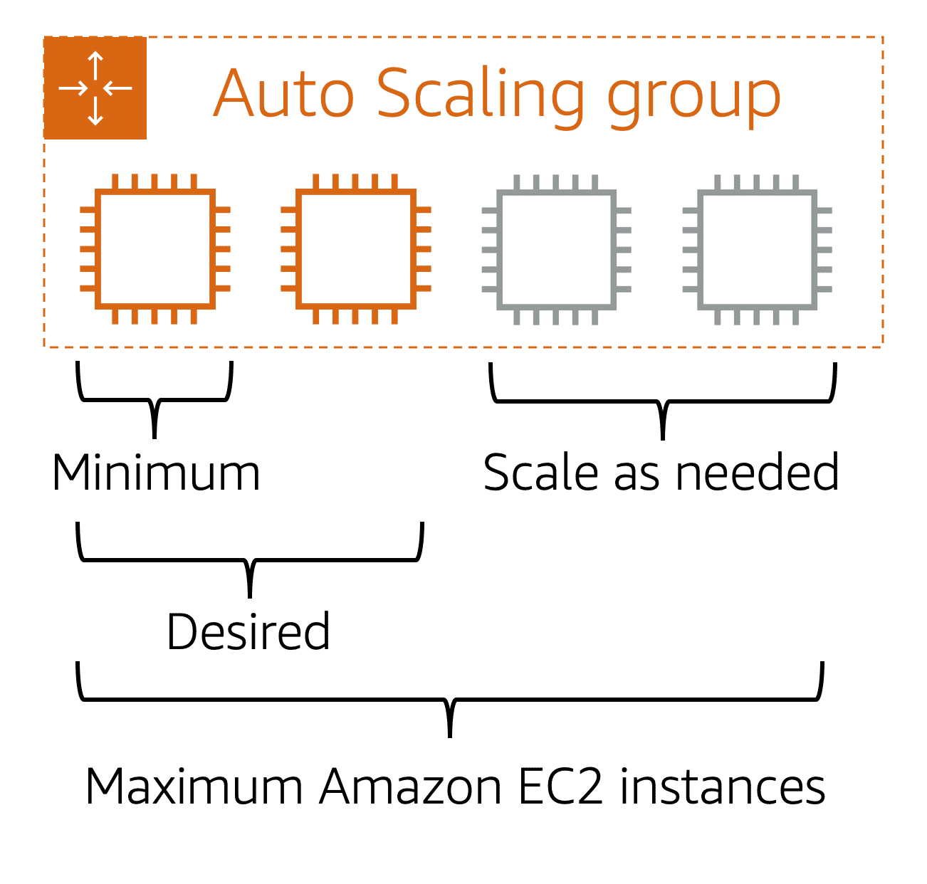

To scale faster, you can use dynamic scaling and predictive scaling together.

Amazon EC2 Auto Scaling. Adds instances based on demand and then decommissions instances when they are no longer needed. This means that every minute of the day, you always have the correct number of instances. Happy customers. Happy CFO. Happy architecture.

When you create an Auto Scaling group, you can set the minimum number of Amazon EC2 instances. Next, you can set the **desired capacity** at two Amazon EC2 instances even though your application needs a minimum of a single Amazon EC2 instance to run.

# 2-4. Directing Traffic with Elastic Load Balancing

A host stands at the door and when customers come into the coffee shop, they tell them which line to proceed to for placing their order. The host keeps an eye on the cashier's taking orders, and counts the number of people in line each cashier is serving. Then it will direct new customers to the cashier that has the shortest line, that's the least bogged down, thus allowing the lines to be even across cashiers and helping customers be served in the most efficient manner possible.

The same idea applies to your AWS environment. When you have multiple EC2 instances all running the same program, to serve the same purpose, and a request comes in, how does that request know which EC2 instance to go to? How can you ensure there's an even distribution of workload across EC2 instances? So not just one is backed up while the others are idle sitting by. You need a way to route requests to instances to process that request. What you need to solve this is called load balancing.

Introducing Elastic Load Balancing. Elastic Load Balancing, or ELB, is one of the first major managed services we're going to talk about in this course. And it's engineered to address the undifferentiated heavy lifting of load balancing. To illustrate this point, I need to zoom out a bit here. To begin with, Elastic Load Balancing is a regional construct, and we'll explain more of what that means in later videos. But the key value for you is that because it runs at the Region level rather than on individual EC2 instances, the service is automatically highly available with no additional effort on your part.

Well, we solve the back end traffic chaos with an ELB as well. Because ELB is regional, it's a single URL that each front end instance uses. Then the ELB directs traffic to the back end that has the least outstanding requests. Now, if the back end scales, once the new instance is ready, it just tells the ELB that it can take traffic, and it gets to work. The front end doesn't know and doesn't care how many back end instances are running. This is true decoupled architecture.

**Elastic Load Balancing**

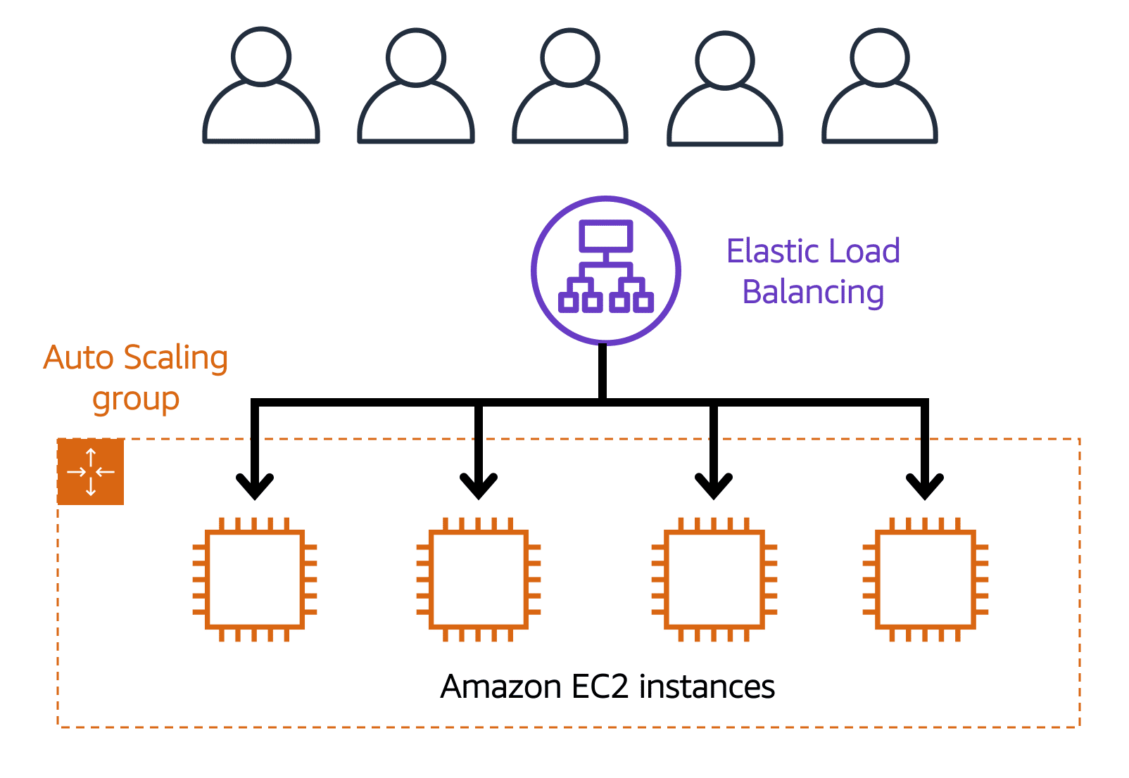**Elastic Load Balancing** is the AWS service that automatically distributes incoming application traffic across multiple resources, such as Amazon EC2 instances.

A load balancer acts as a single point of contact for all incoming web traffic to your Auto Scaling group. This means that as you add or remove Amazon EC2 instances in response to the amount of incoming traffic, these requests route to the load balancer first. Then, the requests spread across multiple resources that will handle them.

Although Elastic Load Balancing and Amazon EC2 Auto Scaling are separate services, they work together to help ensure that applications running in Amazon EC2 can provide high performance and availability.

Ensuring that no single Amazon EC2 instance has to carry the full workload on its own. This helps to ensure that no single resource becomes overutilized.

# 2-5. Messaging and Queuing

A hallmark trait of a tightly coupled architecture is where if a single component fails or changes, it causes issues for other components or even the whole system. For example, if we have Application A and it is sending messages directly to Application B, if Application B has a failure and cannot accept those messages, Application A will begin to see errors as well. This is a tightly coupled architecture.

A more reliable architecture is loosely coupled. This is an architecture where if one component fails, it is isolated and therefore won't cause cascading failures throughout the whole system. If we coded the application to use a more loosely coupled architecture, it could look as follows.

First up, let's discuss Amazon SQS. SQS allows you to send, store, and receive messages between software components at any volume. This is without losing messages or requiring other services to be available. Think of messages as our coffee orders and the order board as an SQS queue. Messages have the person's name, coffee order, and time they ordered. The data contained within a message is called a payload, and it's protected until delivery. SQS queues are where messages are placed until they are processed. And AWS manages the underlying infrastructure for you to host those queues. These scale automatically, are reliable, and are easy to configure and use.

Now, Amazon SNS is similar in that it is used to send out messages to services, but it can also send out notifications to end users. It does this in a different way called a publish/subscribe or pub/sub model. This means that you can create something called an SNS topic which is just a channel for messages to be delivered. You then configure subscribers to that topic and finally publish messages for those subscribers. In practice, that means you can send one message to a topic which will then fan out to all the subscribers in a single go. These subscribers can also be endpoints such as SQS queues, AWS Lambda functions, and HTTPS or HTTP web hooks.

Additionally, SNS can be used to fan out notifications to end users using mobile push, SMS, and email. Taking this back to our coffee shop, we could send out a notification when a customer's order is ready. This could be a simple SMS to let them know to pick it up or even a mobile push.

**1) Monolithic applications and microservices**

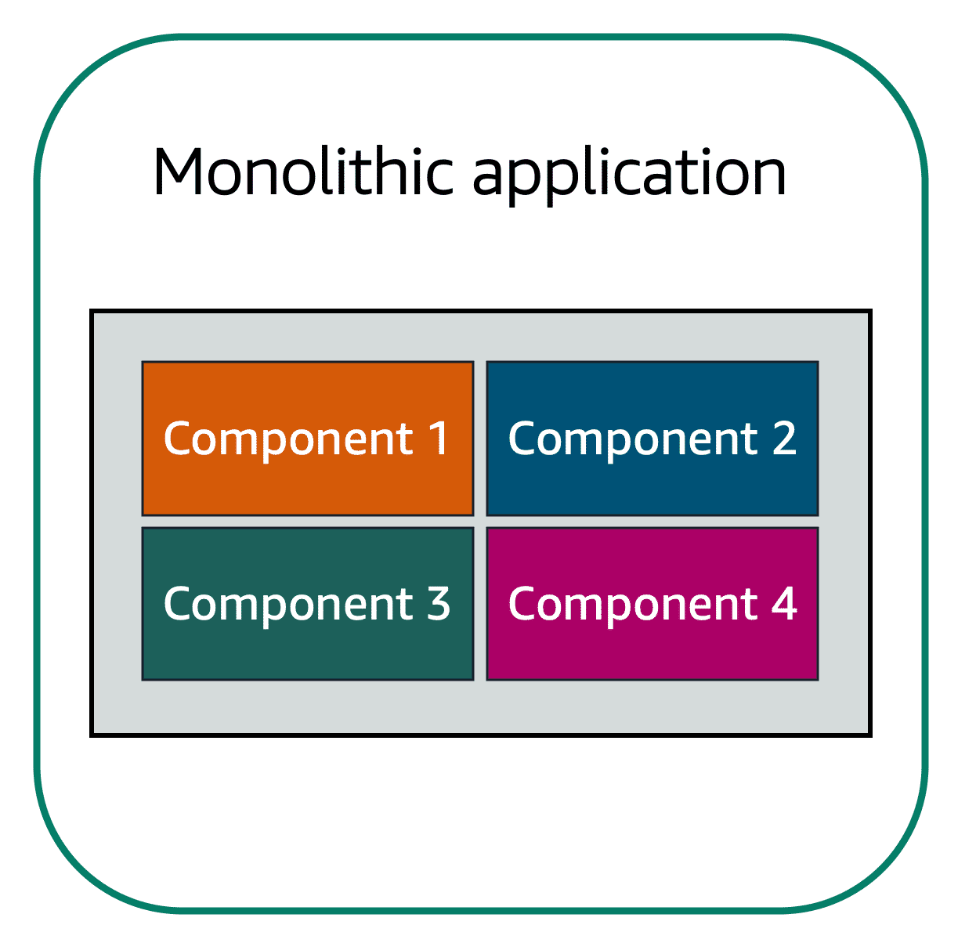Suppose that you have an application with tightly coupled components. These components might include databases, servers, the user interface, business logic, and so on. This type of architecture can be considered a **monolithic application**.

In this approach to application architecture, if a single component fails, other components fail, and possibly the entire application fails.

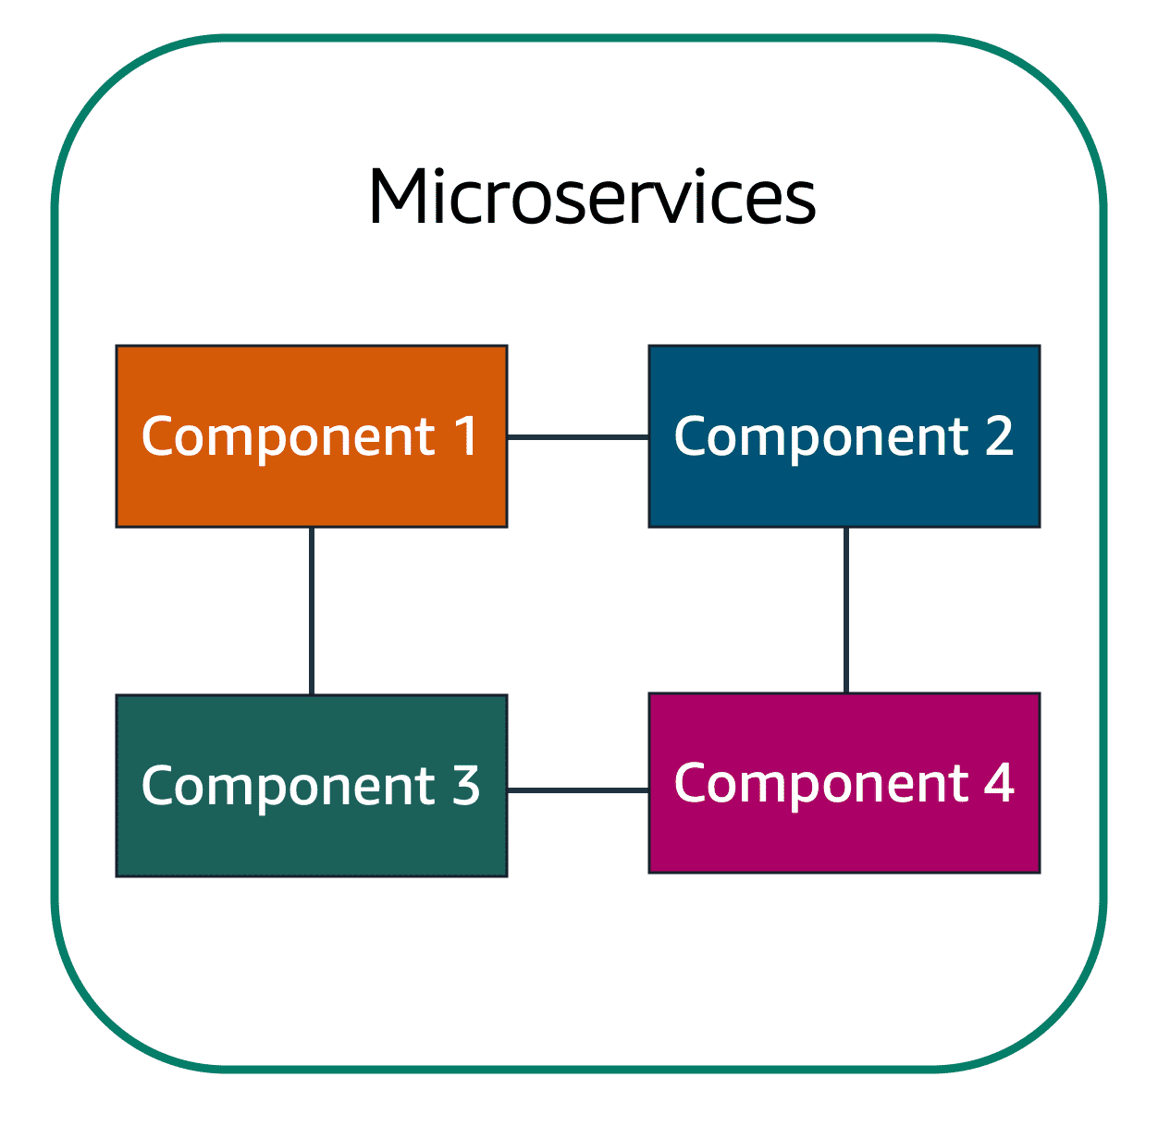In a microservices approach, application components are loosely coupled. In this case, if a single component fails, the other components continue to work because they are communicating with each other. The loose coupling prevents the entire application from failing.

When designing applications on AWS, you can take a microservices approach with services and components that fulfill different functions. Two services facilitate application integration: Amazon Simple Notification Service (Amazon SNS) and Amazon Simple Queue Service (Amazon SQS).

**2) Amazon Simple Notification Service (Amazon SNS)**

**Amazon Simple Notification Service (Amazon SNS)**is a publish/subscribe service. Using Amazon SNS topics, a publisher publishes messages to subscribers. This is similar to the coffee shop; the cashier provides coffee orders to the barista who makes the drinks.

In Amazon SNS, subscribers can be web servers, email addresses, AWS Lambda functions, or several other options.

*Which AWS service is the best choice for publishing messages to subscribers?*

**3) Amazon Simple Queue Service (Amazon SQS)**

**Amazon Simple Queue Service (Amazon SQS)** is a message queuing service.

Using Amazon SQS, you can send, store, and receive messages between software components, without losing messages or requiring other services to be available. In Amazon SQS, an application sends messages into a queue. A user or service retrieves a message from the queue, processes it, and then deletes it from the queue.

# 2-6. Additional Compute Services

AWS offers multiple serverless compute options. Serverless means that you cannot actually see or access the underlying infrastructure or instances that are hosting your application. Instead, all the management of the underlying environment from a provisioning, scaling, high availability, and maintenance perspective are taken care of for you. All you need to do is focus on your application and the rest is taken care of.

**Serverless computing**

Earlier in this module, you learned about Amazon EC2, a service that lets you run virtual servers in the cloud. If you have applications that you want to run in Amazon EC2, you must do the following:

1 Provision instances (virtual servers)

2 Upload your code.

3 Continue to manage the instances while your application is running.

The term “serverless” means that your code runs on servers, but you do not need to provision or manage these servers. With serverless computing, you can focus more on innovating new products and features instead of maintaining servers.

**1) AWS Lambda**

[**AWS Lambda**](https://aws.amazon.com/lambda) is a service that lets you run code without needing to provision or manage servers.

While using AWS Lambda, you pay only for the compute time that you consume. Charges apply only when your code is running. You can also run code for virtually any type of application or backend service, all with zero administration.

For example, a simple Lambda function might involve automatically resizing uploaded images to the AWS Cloud. In this case, the function triggers when uploading a new image.

**2) Containers**

**Containers** provide you with a standard way to package your application's code and dependencies into a single object. You can also use containers for processes and workflows in which there are essential requirements for security, reliability, and scalability.

**2-1) Amazon Elastic Container Service (Amazon ECS)**

[**Amazon Elastic Container Service (Amazon ECS)**](https://aws.amazon.com/ecs/) is a highly scalable, high-performance container management system that enables you to run and scale containerized applications on AWS.

Amazon ECS supports Docker containers. [Docker](https://www.docker.com/) is a software platform that enables you to build, test, and deploy applications quickly. AWS supports the use of open-source Docker Community Edition and subscription-based Docker Enterprise Edition. With Amazon ECS, you can use API calls to launch and stop Docker-enabled applications.

**2-2) Amazon Elastic Kubernetes Service (Amazon EKS)**

[**Amazon Elastic Kubernetes Service (Amazon EKS)**](https://aws.amazon.com/eks/)is a fully managed service that you can use to run Kubernetes on AWS.

[Kubernetes](https://kubernetes.io/) is open-source software that enables you to deploy and manage containerized applications at scale. A large community of volunteers maintains Kubernetes, and AWS actively works together with the Kubernetes community. As new features and functionalities release for Kubernetes applications, you can easily apply these updates to your applications managed by Amazon EKS.

**2-3) AWS Fargate**

[**AWS Fargate**](https://aws.amazon.com/fargate/) is a serverless compute engine for containers. It works with both Amazon ECS and Amazon EKS.

When using AWS Fargate, you do not need to provision or manage servers. AWS Fargate manages your server infrastructure for you. You can focus more on innovating and developing your applications, and you pay only for the resources that are required to run your containers.

# Module 3 Global Infrastructure and Reliability

**3-1. Selecting a Region**

When determining the right Region for your services, data, and applications, consider the following four business factors.

A Region consists of three or more Availability Zones.

**1) Compliance with data governance and legal requirements**

Depending on your company and location, you might need to run your data out of specific areas. For example, if your company requires all of its data to reside within the boundaries of the UK, you would choose the London Region. Not all companies have location-specific data regulations, so you might need to focus more on the other three factors.

**2) Proximity to your customers**

Selecting a Region that is close to your customers will help you to get content to them faster. For example, your company is based in Washington, DC, and many of your customers live in Singapore. You might consider running your infrastructure in the Northern Virginia Region to be close to company headquarters, and run your applications from the Singapore Region.

**3)Available services within a Region**

Sometimes, the closest Region might not have all the features that you want to offer to customers. AWS is frequently innovating by creating new services and expanding on features within existing services. However, making new services available around the world sometimes requires AWS to build out physical hardware one Region at a time.

Suppose that your developers want to build an application that uses Amazon Braket (AWS quantum computing platform). As of this course, Amazon Braket is not yet available in every AWS Region around the world, so your developers would have to run it in one of the Regions that already offers it.

**4) Pricing**

Suppose that you are considering running applications in both the United States and Brazil. The way Brazil’s tax structure is set up, it might cost 50% more to run the same workload out of the São Paulo Region compared to the Oregon Region. You will learn in more detail that several factors determine pricing, but for now know that the cost of services can vary from Region to Region.

**3-2. Availability Zones (zone은 data center 단위, zone이 모이면 region)**

An **Availability Zone** is **a single data center or a group of data centers within a Region**. Availability Zones are located tens of miles apart from each other. This is close enough to have low latency (the time between when content requested and received) between Availability Zones. However, if a disaster occurs in one part of the Region, they are distant enough to reduce the chance that multiple Availability Zones are affected.

# 3-3. Edge Locations

An **edge location** is a site that Amazon CloudFront uses to store cached copies of your content closer to your customers for faster delivery.

Amazon CloudFront is a content delivery service. It uses a network of edge locations to cache content and deliver content to customers all over the world. When content is cached, it is stored locally as a copy. This content might be video files, photos, webpages, and so on.

To learn more, choose each of the numbered markers.

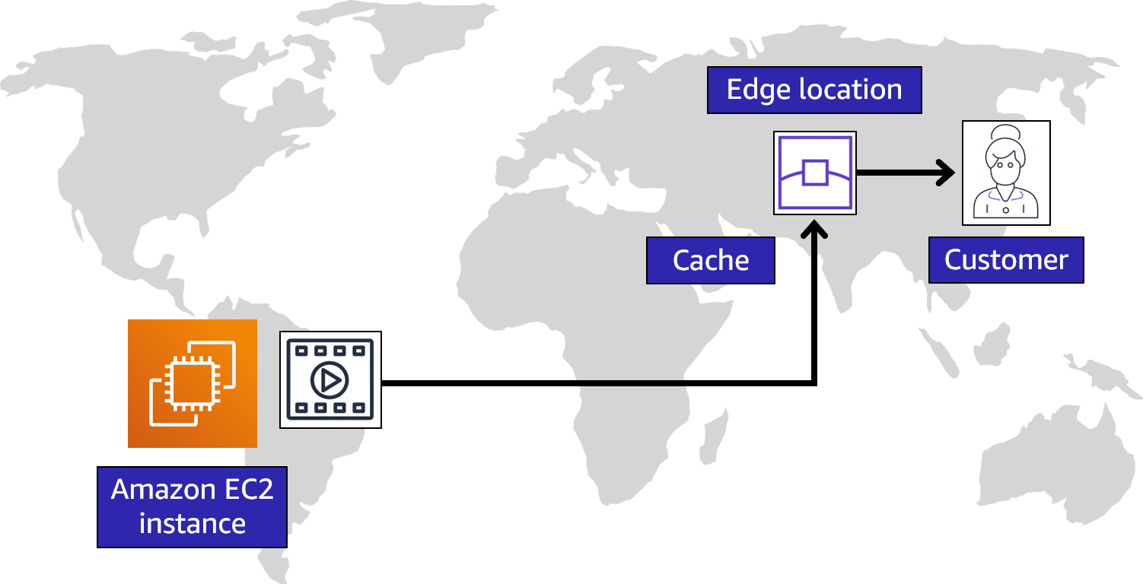

# 3-4. How to Provision AWS Resources

# **1) Ways to interact with AWS services**

# 1-1) The AWS Management Console is a web-based interface for accessing and managing AWS services. You can quickly access recently used services and search for other services by name, keyword, or acronym. The console includes wizards and automated workflows that can simplify the process of completing tasks.

# You can also use the AWS Console mobile application to perform tasks such as monitoring resources, viewing alarms, and accessing billing information. Multiple identities can stay logged into the AWS Console mobile app at the same time.

**1-2)** To save time when making API requests, you can use the **AWS Command Line Interface (AWS CLI)**. AWS CLI enables you to control multiple AWS services directly from the command line within one tool. AWS CLI is available for users on Windows, macOS, and Linux.

By using AWS CLI, you can automate the actions that your services and applications perform through scripts. For example, you can use commands to launch an Amazon EC2 instance, connect an Amazon EC2 instance to a specific Auto Scaling group, and more.

**1-3)** Another option for accessing and managing AWS services is the **software development kits (SDKs)**. SDKs make it easier for you to use AWS services through an API designed for your programming language or platform. SDKs enable you to use AWS services with your existing applications or create entirely new applications that will run on AWS.

To help you get started with using SDKs, AWS provides documentation and sample code for each supported programming language. Supported programming languages include C++, Java, .NET, and more.

**2) AWS Elastic Beanstalk**

With **AWS Elastic Beanstalk**, you provide **code and configuration settings**, and Elastic Beanstalk **deploys the resources necessary** to perform the following tasks:

* Adjust capacity
* Load balancing
* Automatic scaling
* Application health monitoring

**3) AWS CloudFormation**

With **AWS CloudFormation**, you can treat your **infrastructure as code**. This means that you can build an environment by writing lines of code instead of using the AWS Management Console to individually provision resources.

AWS CloudFormation provisions your resources in a safe, repeatable manner, enabling you to frequently build your infrastructure and applications without having to perform manual actions. It determines the right operations to perform when managing your stack and rolls back changes automatically if it detects errors.

# 4) AWS Outposts Family overview

AWS Outposts is a family of fully managed solutions delivering AWS infrastructure and services to virtually any on-premises or edge location for a truly consistent hybrid experience. Outposts solutions allow you to extend and run native AWS services on premises, and is available in a variety of form factors, from 1U and 2U Outposts servers to 42U Outposts racks, and multiple rack deployments.

With AWS Outposts, you can run some AWS services locally and connect to a broad range of services available in the local AWS Region. Run applications and workloads on premises using familiar AWS services, tools, and APIs. Outposts supports workloads and devices requiring low latency access to on-premises systems, local data processing, data residency, and application migration with local system interdependencies.

# Module 4 Networking

# 4-1. Connectivity to AWS

**1) Amazon Virtual Private Cloud (Amazon VPC)**

Imagine the millions of customers who use AWS services. Also, imagine the millions of resources that these customers have created, such as Amazon EC2 instances. Without boundaries around all of these resources, network traffic would be able to flow between them unrestricted.

A **networking service** that you can use to establish **boundaries around your AWS resources** is [**Amazon Virtual Private Cloud (Amazon VPC)**](https://aws.amazon.com/vpc/) .

Amazon VPC enables you to provision an isolated section of the AWS Cloud. In this isolated section, you can launch resources in a virtual network that you define. Within a virtual private cloud (VPC), you can organize your resources into subnets. A **subnet** is a section of a VPC that can contain resources such as Amazon EC2 instances.

**2) Internet gateway**

To allow public traffic from the internet to access your VPC, you attach an **internet gateway** to the VPC.

Internet gateway icon attached to a VPC that holds three EC2 instances. An arrow connects the client to the gateway over the internet indicating that the client's request has gained access to the VPC.

An internet gateway is a connection between a VPC and the internet. You can think of an internet gateway as being similar to a doorway that customers use to enter the coffee shop. Without an internet gateway, no one can access the resources within your VPC.

**3) Virtual private gateway**

To access private resources in a VPC, you can use a **virtual private gateway**.

Here’s an example of how a virtual private gateway works. You can think of the internet as the road between your home and the coffee shop. Suppose that you are traveling on this road with a bodyguard to protect you. You are still using the same road as other customers, but with an extra layer of protection.

The bodyguard is like a virtual private network (VPN) connection that encrypts (or protects) your internet traffic from all the other requests around it.

The virtual private gateway is the component that allows protected internet traffic to enter into the VPC. Even though your connection to the coffee shop has extra protection, traffic jams are possible because you’re using the same road as other customers.

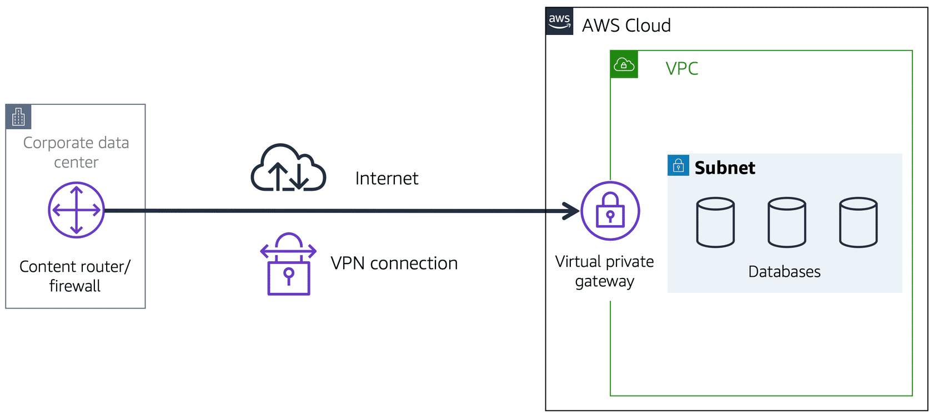

A virtual private gateway enables you to establish a virtual private network (VPN) connection between your VPC and a private network, such as an on-premises data center or internal corporate network. A virtual private gateway allows traffic into the VPC only if it is coming from an approved network.

**4) AWS Direct Connect**

[**AWS Direct Connect**](https://aws.amazon.com/directconnect/) is a service that lets you to establish a dedicated private connection between your **data center and a VPC**.

Suppose that there is an apartment building with a hallway directly linking the building to the coffee shop. Only the residents of the apartment building can travel through this hallway.

This private hallway provides the same type of dedicated connection as AWS Direct Connect. Residents are able to get into the coffee shop without needing to use the public road shared with other customers.

The private connection that AWS Direct Connect provides helps you to **reduce network costs** and **increase the amount of bandwidth** that can travel through your network.

A corporate data center routes network traffic to an AWS Direct Connect location. That traffic is then routed to a VPC through a virtual private gateway. All network traffic between the corporate data center and VPC flows through this dedicated private connection.

# 4-2. Subnets and Network Access Control Lists

**1) Subnets**

A subnet is a **section of a VPC** in which you can group resources based on **security or operational needs**. Subnets can be public or private.

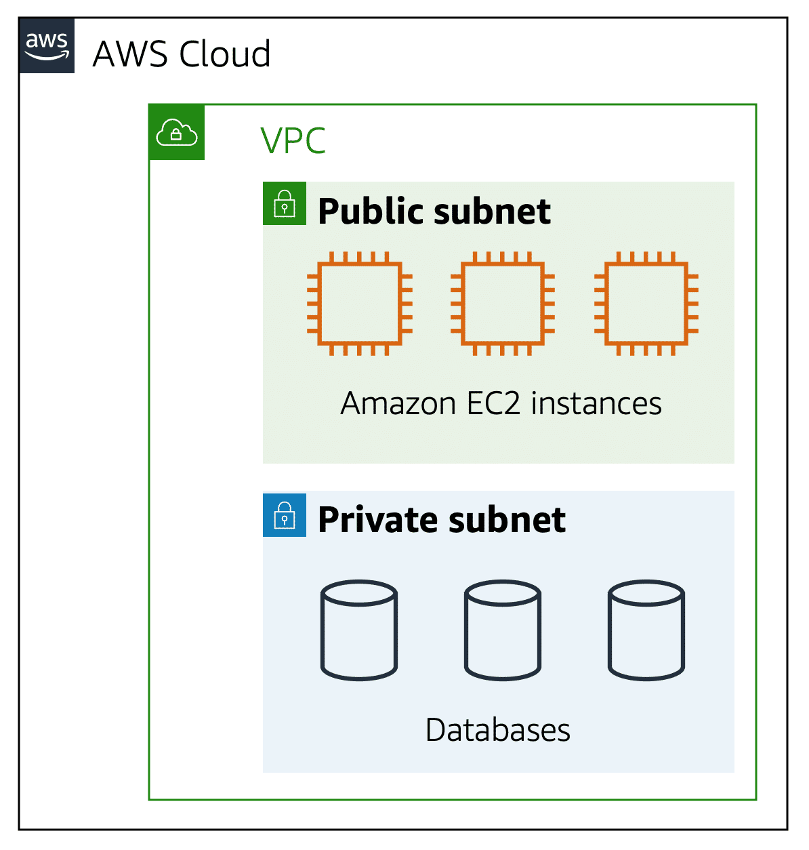

**Public subnets** contain resources that need to be accessible by the public, such as an online store’s website.

**Private subnets** contain resources that should be accessible only through your private network, such as a database that contains customers’ personal information and order histories.

In a VPC, subnets can communicate with each other. For example, you might have an application that involves Amazon EC2 instances in a public subnet communicating with databases that are located in a private subnet.

**2) Network traffic in a VPC**

When a customer requests data from an application hosted in the AWS Cloud, this request is sent as a packet. A **packet** is a unit of data sent over the internet or a network.

It enters into a VPC through an internet gateway. Before a packet can enter into a subnet or exit from a subnet, it checks for permissions. These permissions indicate who sent the packet and how the packet is trying to communicate with the resources in a subnet. The VPC component that checks packet permissions for subnets is a [**network access control list (ACL)**](https://docs.aws.amazon.com/vpc/latest/userguide/vpc-network-acls.html) .

**3) Network ACLs**

A network ACL is a **virtual firewall that controls inbound and outbound traffic at the subnet level**.

For example, step outside of the coffee shop and imagine that you are in an airport. In the airport, travelers are trying to enter into a different country. You can think of the travelers as packets and **the passport control officer as a network ACL**. The passport control officer checks travelers’ credentials when they are both entering and exiting out of the country. If a traveler is on an approved list, they are able to get through. However, if they are not on the approved list or are explicitly on a list of banned travelers, they cannot come in.

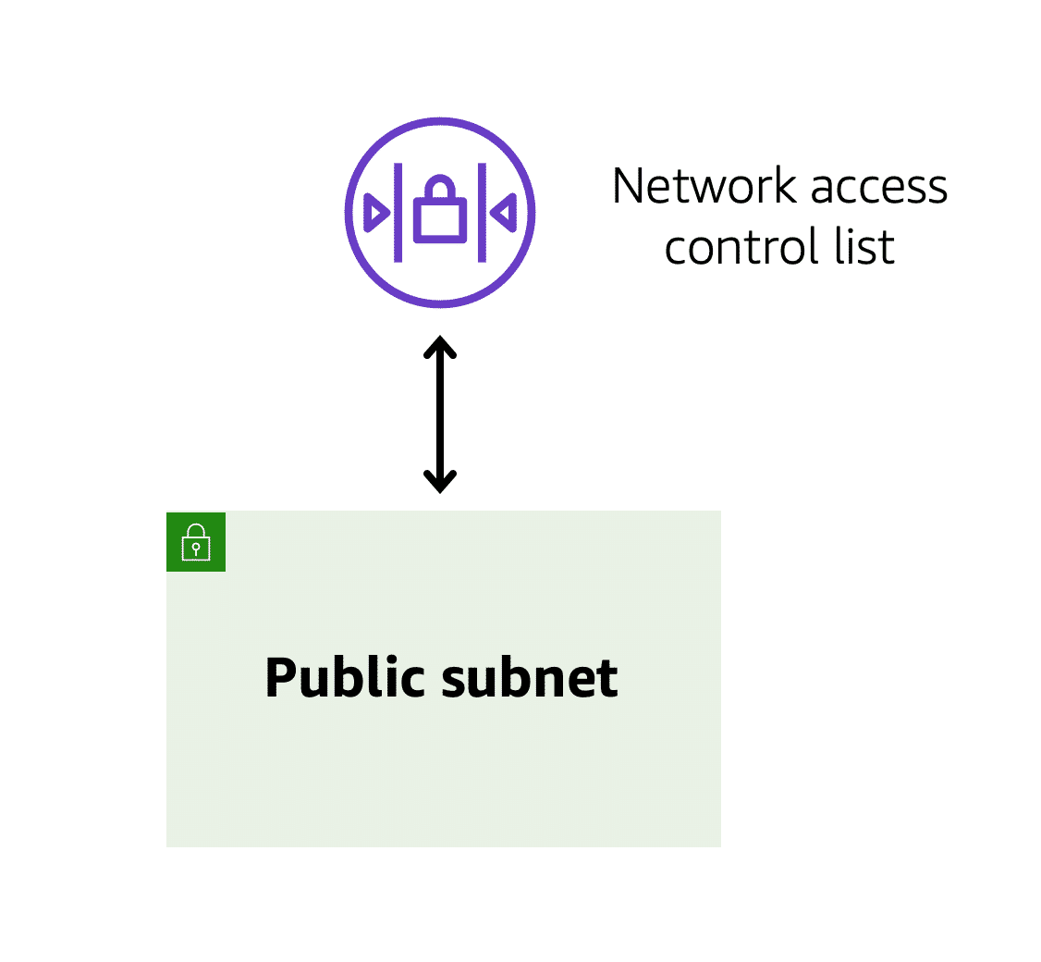Each AWS account includes a default network ACL. When configuring your VPC, you can use your account’s default network ACL or create custom network ACLs.

By default, your account’s default network ACL **allows** all inbound and outbound traffic, but you can modify it by adding your own rules. For custom network ACLs, all inbound and outbound traffic is denied until you add rules to specify which traffic to allow. Additionally, **all network ACLs have an explicit deny rule**. This rule ensures that if a packet doesn’t match any of the other rules on the list, the packet is denied.

**4) Stateless packet filtering**

**Network ACLs perform stateless packet filtering**. **They remember nothing** and check packets that cross the subnet border each way: inbound and outbound.

Recall the previous example of a traveler who wants to enter into a different country. This is similar to sending a request out from an Amazon EC2 instance and to the internet.

When a packet response for that request comes back to the subnet, the network ACL does not remember your previous request. The network ACL checks the packet response against its list of rules to determine whether to allow or deny.

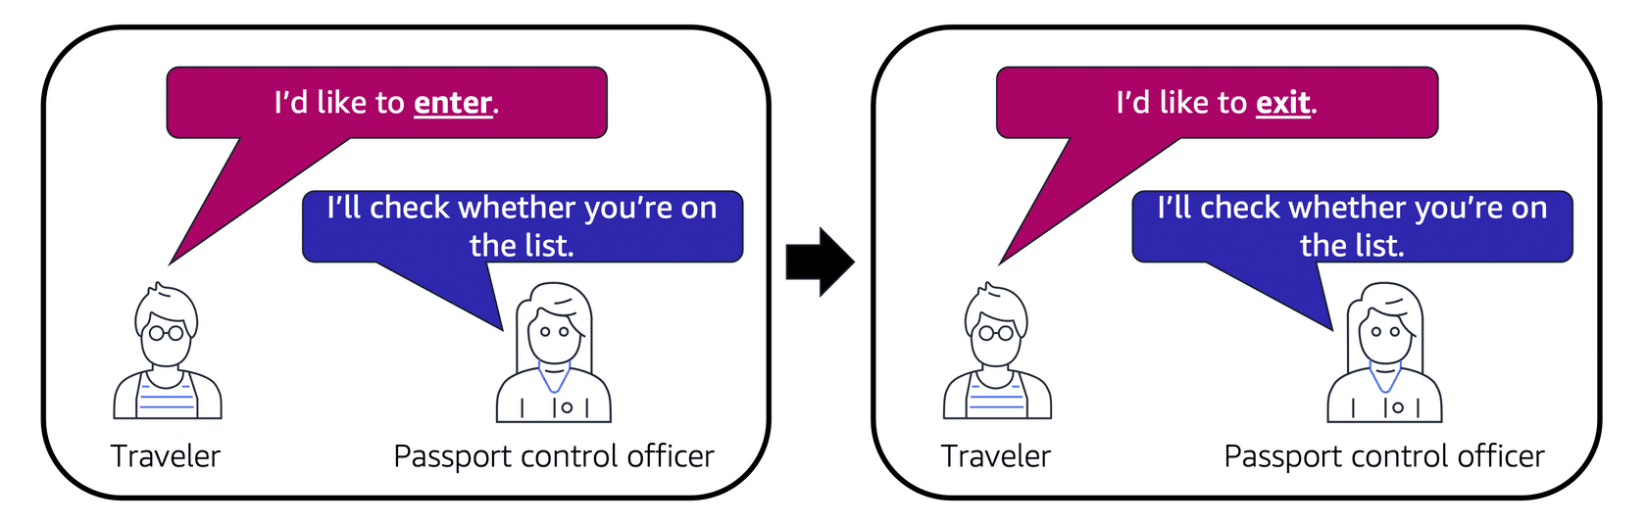After a packet has entered a subnet, it must have its permissions evaluated for resources within the subnet, such as Amazon EC2 instances.

The VPC component that checks packet permissions for an Amazon EC2 instance is a [**security group**](https://docs.aws.amazon.com/vpc/latest/userguide/VPC_SecurityGroups.html).

**5) Security groups**

**A security group is a virtual firewall** that **controls inbound and outbound traffic for an Amazon EC2 instance**.

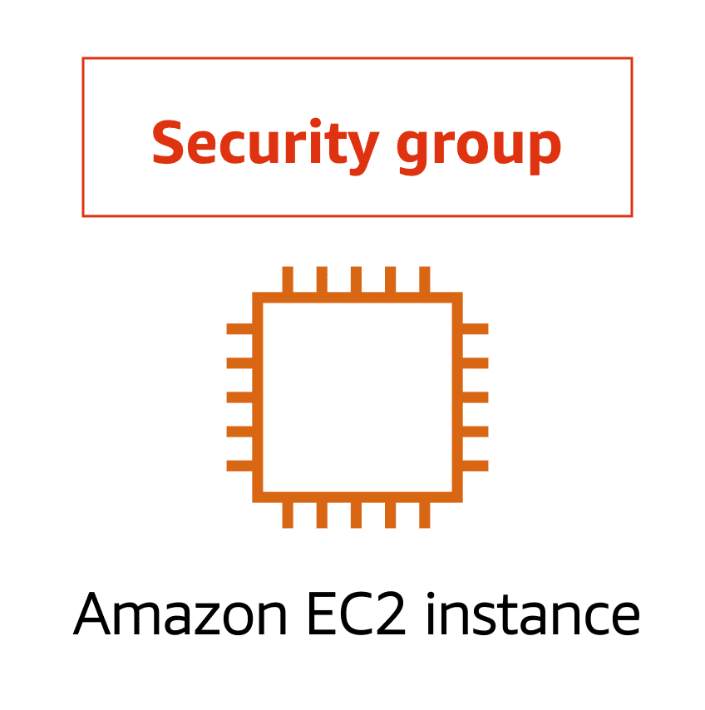By default, a security group **denies** all inbound traffic and allows all outbound traffic. You can add custom rules to configure which traffic should be allowed; any other traffic would then be denied.

For this example, suppose that you are in an apartment building with a door attendant who greets guests in the lobby. You can think of the guests as packets and the door attendant as a security group. As guests arrive, the door attendant checks a list to ensure they can enter the building. However, the door attendant does not check the list again when guests are exiting the building.

If you have multiple Amazon EC2 instances within the same VPC, you can associate them with the same security group or use different security groups for each instance.

**6) Stateful packet filtering**

Security groups perform **stateful** packet filtering. **They remember previous decisions made for incoming packets.**

Consider the same example of sending a request out from an Amazon EC2 instance to the internet.

When a packet response for that request returns to the instance, the security group remembers your previous request. The security group allows the response to proceed, regardless of inbound security group rules.

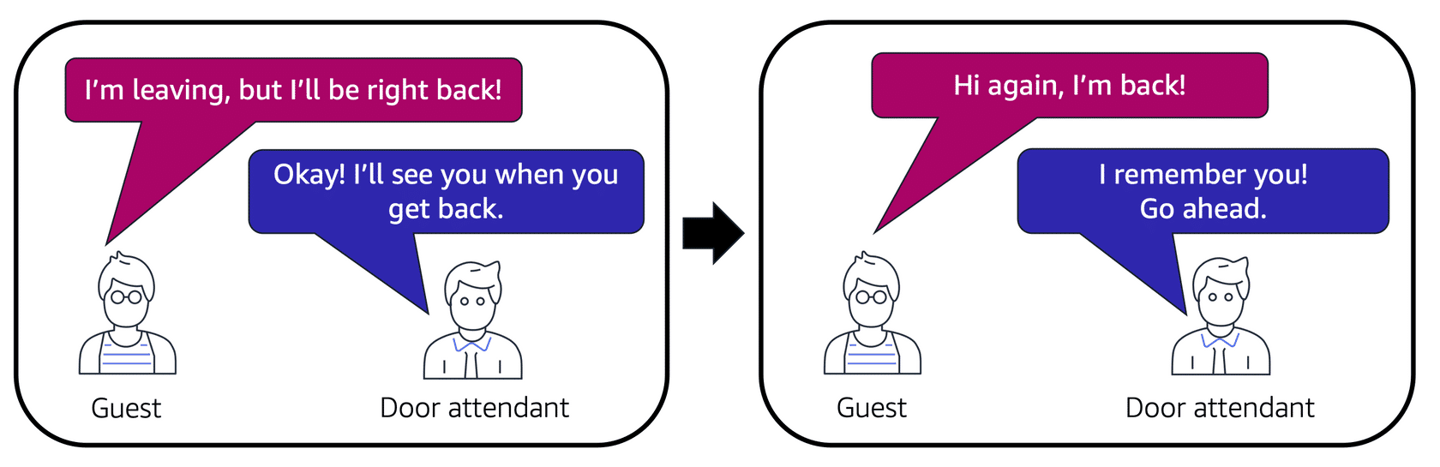

With both network ACLs and security groups, you can configure custom rules for the traffic in your VPC. As you continue to learn more about AWS security and networking, make sure to understand the differences between network ACLs and security groups.

A packet travels over the internet from a client to the internet gateway and into the VPC. Then the pack goes through the network access control list and accesses the public subnet, where two EC2 instances are located.

**7) VPC component recall**

Recall the purpose of the following four VPC components. Compare your response by choosing each VPC component flashcard.

To practice recalling VPC components, select each of the following flashcards by choosing them.

# 4-3. Global Networking

**1) Amazon Route 53**

[**Amazon Route 53**(opens in a new tab)](https://aws.amazon.com/route53) is a DNS web service. It gives developers and businesses a **reliable way to route end users to internet applications hosted in AWS**.

Amazon Route 53 connects user requests to infrastructure running in AWS (such as Amazon EC2 instances and load balancers). It can route users to infrastructure outside of AWS.

Another feature of Route 53 is the ability to manage the DNS records for domain names. You can register new domain names directly in Route 53. You can also transfer DNS records for existing domain names managed by other domain registrars. This enables you to manage all of your domain names within a single location.

In the previous module, you learned about Amazon CloudFront, a content delivery service. The following example describes how Route 53 and Amazon CloudFront work together to deliver content to customers.

# Module 5 Storage and Databases

# 5-1. Instance Stores and Amazon Elastic Block Store (Amazon EBS)

**Instance stores**

Block-level storage volumes behave like physical hard drives.

An [**instance store**](https://docs.aws.amazon.com/AWSEC2/latest/UserGuide/InstanceStorage.html) provides temporary block-level storage for an Amazon EC2 instance. An instance store is disk storage that is physically attached to the host computer for an EC2 instance, and therefore has the same lifespan as the instance. When the instance is terminated, you lose any data in the instance store.

2) [**Amazon Elastic Block Store (Amazon EBS)**](https://aws.amazon.com/ebs) is a service that provides block-level storage volumes that you can use with Amazon EC2 instances. If you stop or terminate an Amazon EC2 instance, all the data on the attached EBS volume remains available.

To create an EBS volume, you define the configuration (such as volume size and type) and provision it. After you create an EBS volume, it can attach to an Amazon EC2 instance.

Because EBS volumes are for data that needs to persist, it’s important to back up the data. You can take incremental backups of EBS volumes by creating Amazon EBS snapshots.

Incremental backups of EBS volumes with Amazon EBS snapshots. On Day 1, two volumes are backed up. Day 2 adds one new volume, and the new volume is backed up. Day 3 adds two more volumes for a total of five volumes. Only the two new volumes are backed up.

# 5-2. Amazon Simple Storage Service (Amazon S3)

[**Amazon Simple Storage Service (Amazon S3)**(opens in a new tab)](https://aws.amazon.com/s3/) is a service that provides object-level storage. Amazon S3 stores data as objects in buckets.

You can upload any type of file to Amazon S3, such as images, videos, text files, and so on. For example, you might use Amazon S3 to store backup files, media files for a website, or archived documents. Amazon S3 offers unlimited storage space. The maximum file size for an object in Amazon S3 is 5 TB.

When you upload a file to Amazon S3, you can set permissions to control visibility and access to it. You can also use the Amazon S3 versioning feature to track changes to your objects over time.

**1) Amazon S3 storage classes**

When selecting an Amazon S3 storage class, consider these two factors:

* How often you plan to retrieve your data
* How available you need your data to be

**1-1) S3 Standard**

* Designed for frequently accessed data
* Stores data in a minimum of three Availability Zones

Amazon S3 Standard provides high availability for objects. This makes it a good choice for a wide range of use cases, such as websites, content distribution, and data analytics. **Amazon S3 Standard has a higher cost** than other storage classes intended for infrequently accessed data and archival storage.

**1-2) S3 Standard-Infrequent Access (S3 Standard-IA)**

* Ideal for infrequently accessed data
* Similar to Amazon S3 Standard but has a lower storage price and higher retrieval price

Amazon S3 Standard-IA is ideal for data infrequently accessed but requires **high availability when needed**. Both Amazon S3 Standard and Amazon S3 Standard-IA store data in a **minimum of three Availability Zones**. Amazon S3 Standard-IA provides the same level of availability as Amazon S3 Standard but with a **lower storage price** and a **higher retrieval price**.

*You want to store data that is infrequently accessed but must be immediately available when needed.*

**1-3) S3 One Zone-Infrequent Access (S3 One Zone-IA)**

* Stores data in a single Availability Zone
* Has a lower storage price than Amazon S3 Standard-IA

Compared to S3 Standard and S3 Standard-IA, which store data in a minimum of three Availability Zones, S3 One Zone-IA stores data **in a single Availability Zone**. This makes it a good storage class to consider if the following conditions apply:

* You want to save costs on storage.
* **You can easily reproduce your data in the event of an Availability Zone failure**.

**1-4) S3 Intelligent-Tiering (접근 많이 안 하면 자동으로 tier를 바꿔서 돈을 세이브함)**

* Ideal for data with unknown or changing access patterns
* Requires a small monthly monitoring and automation fee per object

In the S3 Intelligent-Tiering storage class, Amazon S3 monitors objects’ access patterns. If you haven’t accessed an object for 30 consecutive days, Amazon S3 automatically moves it to the infrequent access tier, S3 Standard-IA. If you access an object in the infrequent access tier, Amazon S3 automatically moves it to the frequent access tier, S3 Standard.

**1-5) S3 Glacier Instant Retrieval**

* Works well for archived data that requires immediate access
* Can retrieve objects within a few milliseconds

When you decide between the options for archival storage, consider how quickly you must retrieve the archived objects. You can retrieve objects stored in the S3 Glacier Instant Retrieval storage class within milliseconds, with the same performance as S3 Standard.

**1-6) S3 Glacier Flexible Retrieval**

* Low-cost storage designed for **data archiving.**
* Able to retrieve objects within a few minutes to hours.

S3 Glacier Flexible Retrieval is a low-cost storage class that is ideal for data archiving. For example, you might use this storage class to store archived customer records or older photos and video files. You can retrieve your data from S3 Glacier Flexible Retrieval from 1 minute to 12 hours.

**1-7) S3 Glacier Deep Archive**

* **Lowest-cost object storage** class ideal for archiving
* Able to retrieve objects within 12 hours

S3 Deep Archive supports long-term retention and digital preservation for data that might be **accessed once or twice in a year**. This storage class is the lowest-cost storage in the AWS Cloud, with data retrieval from 12 to 48 hours. All objects from this storage class are replicated and stored across at least three geographically dispersed Availability Zones.

**1-8) S3 Outposts**

* Creates S3 buckets on Amazon S3 Outposts
* Makes it easier to retrieve, store, and access data on AWS Outposts

**Amazon S3** Outposts **delivers object storage to your on-premises AWS Outposts environment**. Amazon S3 Outposts is designed to store data durably and redundantly across multiple devices and servers on your Outposts. It works well for workloads with local data residency requirements that must satisfy demanding performance needs by keeping data close to on-premises applications.

# **2) Comparing Amazon EBS and Amazon S3**

# In the block storage corner, weighing in at sizes up to 16 tebibytes each, with a unique ability to survive the termination of their Amazon EC2 instances, they are solid state, they are spinning platters, they are Amazon Elastic Block Storage!

# In the regional object storage corner, weighing in at unlimited storage, with individual objects at 5,000 gigabytes in size, they specialize in write once/read many, they are 99 .999 999 999% durable, they are Amazon Simple Storage Service!

# Round one. Let's say you're running a photo analysis website where users upload a photo of themselves, and your application finds the animals that look just like them. You have potentially millions of animal pictures that all need to be indexed and possibly viewed by thousands of people at once. This is the perfect use case for S3. S3 is already web enabled. Every object already has a URL that you can control access rights to who can see or manage the image. It's regionally distributed, which means that it has 11 nines of durability, so no need to worry about backup strategies. S3 is your backup strategy. Plus the cost savings is substantial overrunning the same storage load on EBS. With the additional advantage of being serverless, no Amazon EC2 instances are needed. Sounds like S3 is the judge's winner here for this round.

# But wait, round two, you have an 80-gigabyte video file that you're making edit corrections on. To know the best storage class here, we need to understand the difference between object storage and block storage. Object storage treats any file as a complete, discreet object. Now this is great for documents, and images, and video files that get uploaded and consumed as entire objects, but every time there's a change to the object, you must re-upload the entire file. There are no delta updates. Block storage breaks those files down to small component parts or blocks. This means, for that 80-gigabyte file, when you make an edit to one scene in the film and save that change, the engine only updates the blocks where those bits live. If you're making a bunch of micro edits, using EBS, elastic block storage, is the perfect use case. If you were using S3, every time you saved the changes, the system would have to upload all 80 gigabytes, the whole thing, every time. EBS clearly wins round two.

# This means, if you are using complete objects or only occasional changes, S3 is victorious. If you are doing complex read, write, change functions, then, absolutely, EBS is your knockout winner. Your winner depends on your individual workload. Each service is the right service for specific needs. Once you understand what you need, you will know which service is your champion!

# 5-3. Amazon Elastic File System (Amazon EFS)

**1) File storage**

In **file storage**, multiple clients (such as users, applications, servers, and so on) can access data that is stored in shared file folders. In this approach, a storage server uses **block storage** with a local file system to organize files. Clients access data through file paths.

Compared to block storage and object storage, **file storage is ideal for use cases in which a large number of services and resources** need to access the same data at the same time.

[**Amazon Elastic File System (Amazon EFS)**](https://aws.amazon.com/efs/) is a scalable file system used with AWS Cloud services and on-premises resources. As you add and remove files, Amazon EFS grows and shrinks automatically. It can scale on demand to petabytes without disrupting applications.

**2) Comparing Amazon EBS and Amazon EFS**

**5-4. Amazon Relational database Service**

**1) Relational databases**

In a **relational database**, data is stored in a way that relates it to other pieces of data.

Relational databases use **structured query language (SQL)** to store and query data. This approach allows data to be stored in an easily understandable, consistent, and scalable way. For example, the coffee shop owners can write a SQL query to identify all the customers whose most frequently purchased drink is a medium latte.

**2)Amazon Relational Database Service**

[**Amazon Relational Database Service (Amazon RDS)**](https://aws.amazon.com/rds/) is a service that enables you to run relational databases in the AWS Cloud.

Amazon RDS is a managed service that automates tasks such as **hardware provisioning, database setup, patching, and backups**. With these capabilities, you can spend less time completing administrative tasks and more time using data to innovate your applications. You can integrate Amazon RDS with other services to fulfill your business and operational needs, such as using AWS Lambda to query your database from a serverless application.

Amazon RDS provides a number of different security options. Many Amazon RDS database engines offer encryption **at rest (protecting data while it is stored)** and **encryption in transit** (protecting data while it is being sent and received).

**3) Amazon RDS database engines**

Amazon RDS is available on six database engines, which optimize for memory, performance, or input/output (I/O). Supported database engines include:

* Amazon Aurora
* PostgreSQL
* MySQL
* MariaDB
* Oracle Database
* Microsoft SQL Server

**4) Amazon Aurora**

[**Amazon Aurora**](https://aws.amazon.com/rds/aurora/) is an **enterprise-class relational database**. It is compatible with MySQL and PostgreSQL relational databases. It is up to five times faster than standard MySQL databases and up to three times faster than standard PostgreSQL databases.

Amazon Aurora helps to reduce your database costs by reducing unnecessary input/output (I/O) operations, while ensuring that your database resources remain reliable and available.

Consider Amazon Aurora if your workloads require high availability. **It replicates six copies of your data across three Availability Zones and continuously backs up your data to Amazon S3**.

# 5-5. Amazon DynamoDB

**1) Nonrelational databases**

In a **nonrelational database**, you create tables. A table is a place where you can store and query data.

Nonrelational databases are sometimes referred to as **“NoSQL databases”** because they use structures other than rows and columns to organize data. One type of structural approach for nonrelational databases is key-value pairs. With **key-value pairs**, data is organized into items (keys), and items have attributes (values). You can think of attributes as being different features of your data.

**In a key-value database, you can add or remove attributes from items in the table at any time.** Additionally, not every item in the table has to have the same attributes.

**2) Amazon DynamoDB**

[**Amazon DynamoDB**](https://aws.amazon.com/dynamodb/) is a key-value database service. It delivers **single-digit millisecond performance** at any scale.

* DynamoDB is **serverless**, which means that you do not have to provision, patch, or manage servers. You also do not have to install, maintain, or operate software.
* As the size of your database shrinks or grows, DynamoDB **automatically scales** to adjust for changes in capacity while maintaining consistent performance. This makes it a suitable choice for use cases that require high performance while scaling. Scaling up to 10 trillion requests per day

# 5-6. Amazon Redshift

**Amazon Redshift**

**Amazon Redshift** is a data warehousing service that you can use for **big data analytics**. It offers the ability to collect data from many sources and helps you to understand relationships and trends across your data.

Introducing Amazon Redshift. This is data warehousing as a service. It's massively scalable. Redshift nodes in multiple petabyte sizes is very common. In fact, in cooperation with Amazon Redshift Spectrum, you can directly run a single SQL query against exabytes of unstructured data running in data lakes.

But it's more than just being able to handle massively larger data sets. Redshift uses a variety of innovations that allow you to achieve up to 10 times higher performance than traditional databases, when it comes to these kinds of business intelligence workloads.

# 5-7. AWS Database Migration Service

**1) AWS Database Migration Service (AWS DMS)**

[**AWS Database Migration Service (AWS DMS)**](https://aws.amazon.com/dms/) enables you to migrate relational databases, nonrelational databases, and other types of data stores.

With AWS DMS, you move data between a source database and a target database. [The source and target databases](https://aws.amazon.com/dms/resources) can be of the same type or different types. During the migration, your source database remains operational, reducing downtime for any applications that rely on the database.

For example, suppose that you have a MySQL database that is stored on premises in an Amazon EC2 instance or in Amazon RDS. Consider the MySQL database to be your source database. Using AWS DMS, you could migrate your data to a target database, such as an Amazon Aurora database.

**2) Other use cases for AWS DMS**

To review other use cases for AWS DMS, select each of the following flashcards.

# 5-8. Additional Database Services

1) [**Amazon DocumentDB**](https://aws.amazon.com/documentdb) is a document database service that supports MongoDB workloads. (MongoDB is a document database program.)

2) [**Amazon Neptune**](https://aws.amazon.com/neptune) is a graph database service. You can use Amazon Neptune to build and run applications that work with highly connected datasets, such as recommendation engines, fraud detection, and knowledge graphs.

3) [**Amazon Quantum Ledger Database (Amazon QLDB)**](https://aws.amazon.com/qldb) is a ledger database service. You can use Amazon QLDB to review a complete history of all the changes that have been made to your application data.

4) [**Amazon Managed Blockchain**](https://aws.amazon.com/managed-blockchain) is a service that you can use to create and manage blockchain networks with open-source frameworks. Blockchain is a distributed ledger system that lets multiple parties run transactions and share data without a central authority.

5) [**Amazon ElastiCache**](https://aws.amazon.com/elasticache) is a service that adds caching layers on top of your databases to help improve the read times of common requests. It supports two types of data stores: Redis and Memcached.

6) [**Amazon DynamoDB Accelerator (DAX)**](https://aws.amazon.com/dynamodb/dax/) is an in-memory cache for DynamoDB. It helps improve response times from single-digit milliseconds to microseconds.

# Module 6 Security

# 6-1. AWS Shared Responsibility Model

**1) The AWS shared responsibility model**

Throughout this course, you have learned about a variety of resources that you can create in the AWS Cloud. These resources include Amazon EC2 instances, Amazon S3 buckets, and Amazon RDS databases. Who is responsible for keeping these resources secure: you (the customer) or AWS?

The answer is both. The reason is that you do not treat your AWS environment as a single object. Rather, you treat the environment as a collection of parts that build upon each other. AWS is responsible for some parts of your environment and you (the customer) are responsible for other parts. This concept is known as the [**shared responsibility model**](https://aws.amazon.com/compliance/shared-responsibility-model/).

The shared responsibility model divides into customer responsibilities (commonly referred to as “security in the cloud”) and AWS responsibilities (commonly referred to as “security of the cloud”).

| **Entity responsible** | **Part of the AWS Environment** |
| --- | --- |
| Customer | Customer data |
| Platform, applications, **Identity and Access Management (IAM)** |
| **Operating systems, and network and firewall configuration** |
| Client-side data encryption, server-side **data encryption**, and **networking traffic protection** |
| Amazon Web Services (AWS) | **Software**: Compute, storage, database, networking |
| **Hardware**: Regions, Availability Zones, Edge Locations |

You can think of this model as being similar to the division of responsibilities between a homeowner and a homebuilder. The builder (AWS) is responsible for constructing your house and ensuring that it is solidly built. As the homeowner (the customer), it is your responsibility to secure everything in the house by ensuring that the doors are closed and locked.

**Customers: Security in the cloud**

Customers are responsible for the security of everything that they create and put in the AWS Cloud.

When using AWS services, you, the customer, maintain complete control over your content. You are responsible for managing security requirements for your content, including which content you choose to store on AWS, which AWS services you use, and who has access to that content. You also control how access rights are granted, managed, and revoked.

The security steps that you take will depend on factors such as the services that you use, the complexity of your systems, and your company’s specific operational and security needs. Steps include **selecting, configuring, and patching the operating systems that will run on Amazon EC2 instances**, **configuring security groups**, and **managing user accounts**.

**AWS: Security of the cloud**

AWS is responsible for security of the cloud.

AWS operates, manages, and controls the components at all layers of infrastructure. This includes areas such as the host operating system, the virtualization layer, and even the physical security of the data centers from which services operate.

AWS is responsible for protecting the global infrastructure that runs all of the services offered in the AWS Cloud. This infrastructure includes AWS Regions, Availability Zones, and edge locations.

AWS manages the security of the cloud, specifically the physical infrastructure that hosts your resources, which include:

* Physical security of data centers
* Hardware and software infrastructure
* Network infrastructure
* Virtualization infrastructure

Although you cannot visit AWS data centers to see this protection firsthand, AWS provides several reports from third-party auditors. These auditors have verified its compliance with a variety of computer security standards and regulations.

# 6-2 User Permissions and Access

**1) AWS Identity and Access Management (IAM)**

[**AWS Identity and Access Management (IAM)**](https://aws.amazon.com/iam/) enables you to manage access to AWS services and resources securely.

IAM gives you the flexibility to configure access based on your company’s specific operational and security needs. You do this by using a combination of IAM features, which are explored in detail in this lesson:

* IAM users, groups, and roles
* IAM policies
* Multi-factor authentication

You will also learn best practices for each of these features.

**2) AWS account root user**

When you first create an AWS account, you begin with an identity known as the [**root user**(opens in a new tab)](https://docs.aws.amazon.com/IAM/latest/UserGuide/id_root-user.html).

The root user is accessed by signing in with the email address and password that you used to create your AWS account. You can think of the root user as being similar to the owner of the coffee shop. It has complete access to all the AWS services and resources in the account.

**Best practice:**

Do **not** use the root user for everyday tasks.

Instead, use the root user to create your first IAM user and assign it permissions to create other users.

Then, continue to create other IAM users, and access those identities for performing regular tasks throughout AWS. Only use the root user when you need to perform a limited number of tasks that are only available to the root user. **Examples of these tasks include changing your root user email address and changing your AWS support plan**. For more information, see “Tasks that require root user credentials” in the [AWS Account Management Reference Guide](https://docs.aws.amazon.com/accounts/latest/reference/root-user-tasks.html).

**3) IAM users**

An **IAM user** is an identity that you create in AWS. It represents the person or application that interacts with AWS services and resources. It consists of a name and credentials.

By default, when you create a new IAM user in AWS, it has no permissions associated with it. To allow the IAM user to perform specific actions in AWS, such as launching an Amazon EC2 instance or creating an Amazon S3 bucket, you must grant the IAM user the necessary permissions.

**Best practice:**

We recommend that you create individual IAM users for each person who needs to access AWS.

Even if you have multiple employees who require the same level of access, you should create individual IAM users for each of them. This provides additional security by allowing each IAM user to have a unique set of security credentials.

**4) IAM policies**

An **IAM policy** is a **document that** allows or denies permissions to AWS services and resources.

IAM policies enable you to **customize users’ levels of access to resources**. For example, you can allow users to access all of the Amazon S3 buckets within your AWS account, or only a specific bucket.

**Best practice:**

Follow the security principle of **least privilege** when granting permissions.

By following this principle, you help to prevent users or roles from having more permissions than needed to perform their tasks. For example, if an employee needs access to only a specific bucket, specify the bucket in the IAM policy. Do this instead of granting the employee access to all of the buckets in your AWS account.

**5) IAM groups**

An IAM group is a collection of IAM users. When you assign an IAM policy to a group, all users in the group are granted permissions specified by the policy.

Here’s an example of how this might work in the coffee shop. Instead of assigning permissions to cashiers one at a time, the owner can create a “Cashiers” IAM group. The owner can then add IAM users to the group and then attach permissions at the group level.

**6) IAM roles**

In the coffee shop, an employee rotates to different workstations throughout the day. Depending on the staffing of the coffee shop, this employee might perform several duties: work at the cash register, update the inventory system, process online orders, and so on.

When the employee needs to switch to a different task, they give up their access to one workstation and gain access to the next workstation. The employee can easily switch between workstations, but at any given point in time, they can have access to only a single workstation. This same concept exists in AWS with IAM roles.

**An IAM role is an identity that you can assume to gain temporary access to permissions**.

Before an IAM user, application, or service can assume an IAM role, they must be granted permissions to switch to the role. When someone assumes an IAM role, they abandon all previous permissions that they had under a previous role and assume the permissions of the new role.

**Best practice:**

**IAM roles are ideal for situations in which access to services or resources needs to be granted temporarily, instead of long-term.**

**7) Multi-factor authentication**

Have you ever signed in to a website that required you to provide multiple pieces of information to verify your identity? You might have needed to provide your password and then a second form of authentication, such as a random code sent to your phone. This is an example of [**multi-factor authentication**](https://aws.amazon.com/iam/features/mfa/).

In IAM, multi-factor authentication (MFA) provides an extra layer of security for your AWS account.

To learn more about how MFA works, choose the arrow buttons to display each of the following two steps.

You can enable MFA for the root user and IAM users. As a best practice, enable MFA for the root user and all IAM users in your account. By doing this, you can keep your AWS account safe from unauthorized access.

# 6-3. AWS Organizations

**1) AWS Organizations**

Suppose that your company has multiple **AWS accounts**. You can use [**AWS Organizations**](https://aws.amazon.com/organizations)to consolidate and **manage multiple AWS accounts within a central location**.

When you create an organization, AWS Organizations automatically creates a **root**, which is the parent container for all the accounts in your organization.

In AWS Organizations, you can centrally control permissions for the accounts in your organization by using [**service control policies (SCPs)**](https://docs.aws.amazon.com/organizations/latest/userguide/orgs_manage_policies_scps.html) . **SCPs enable you to place restrictions on the AWS services, resources, and individual API actions that users and roles in each account can access.**

Consolidated billing is another feature of AWS Organizations. You will learn about consolidated billing in a later module.

**2) Organizational units**

In AWS Organizations, you can **group accounts into organizational units** (OUs) to make it easier to manage accounts with **similar business** or security requirements. When you apply a policy to an OU, all the accounts in the OU automatically inherit the permissions specified in the policy.

By organizing separate accounts into OUs, you can more easily isolate workloads or applications that have specific security requirements. For instance, if your company has accounts that can access only the AWS services that meet certain regulatory requirements, you can put these accounts into one OU. Then, you can attach a policy to the OU that blocks access to all other AWS services that do not meet the regulatory requirements.

# 6-4 Compliance

**1) AWS Artifact**

Depending on your company’s industry, you may need to uphold specific standards. An audit or inspection will ensure that the company has met those standards.

[**AWS Artifact**](https://aws.amazon.com/artifact) is a service that **provides on-demand access to AWS security and compliance reports** and **select online agreements**. AWS Artifact consists of two main sections: AWS Artifact Agreements and AWS Artifact Reports.

To learn more, expand each of the following two categories.

**1-1) AWS Artifact Agreements**

Suppose that your company needs to sign an agreement with AWS regarding your use of certain types of information throughout AWS services. You can do this through **AWS Artifact Agreements**.

In AWS Artifact Agreements, you can review, accept, and manage agreements for an individual account and for all your accounts in AWS Organizations. Different types of agreements are offered to address the needs of customers who are subject to specific regulations, such as the Health Insurance Portability and Accountability Act (HIPAA).

**1-2) AWS Artifact Reports**

Next, suppose that a member of your company’s development team is building an application and needs more information about their responsibility for complying with certain regulatory standards. You can advise them to access this information in **AWS Artifact Reports**.

AWS Artifact Reports provide compliance reports from third-party auditors. These auditors have tested and verified that AWS is compliant with a variety of global, regional, and industry-specific security standards and regulations. AWS Artifact Reports remains up to date with the latest reports released. You can provide the AWS audit artifacts to your auditors or regulators as evidence of AWS security controls.

The following are some of the compliance reports and regulations that you can find within AWS Artifact. Each report includes a description of its contents and the reporting period for which the document is valid.

**AWS Artifact provides access to AWS security and compliance documents**, such as AWS ISO certifications, Payment Card Industry (PCI) reports, and Service Organization Control (SOC) reports.  To learn more about the available compliance reports, visit [AWS Compliance Programs](https://aws.amazon.com/compliance/programs/).

**2) Customer Compliance Center**

The [**Customer Compliance Center**](https://aws.amazon.com/compliance/customer-center/) contains resources to help you learn more about AWS compliance.

In the Customer Compliance Center, you can read customer compliance stories to discover how companies in regulated industries have solved various compliance, governance, and audit challenges.

You can also access compliance whitepapers and documentation on topics such as:

* AWS answers to key compliance questions
* An overview of AWS risk and compliance
* An auditing security checklist

Additionally, the Customer Compliance Center includes an auditor learning path. This learning path is designed for individuals in auditing, compliance, and legal roles who want to learn more about how their internal operations can demonstrate compliance using the AWS Cloud.

# 6-5 Denial-of-Service Attacks

**1) Denial-of-service attacks (DoS)**

A **denial-of-service (DoS) attack** is a deliberate attempt to make a website or application unavailable to users.

For example, an attacker might flood a website or application with excessive network traffic until the targeted website or application becomes overloaded and is no longer able to respond. If the website or application becomes unavailable, this denies service to users who are trying to make legitimate requests.

**2) Distributed denial-of-service attacks (DDoS)**

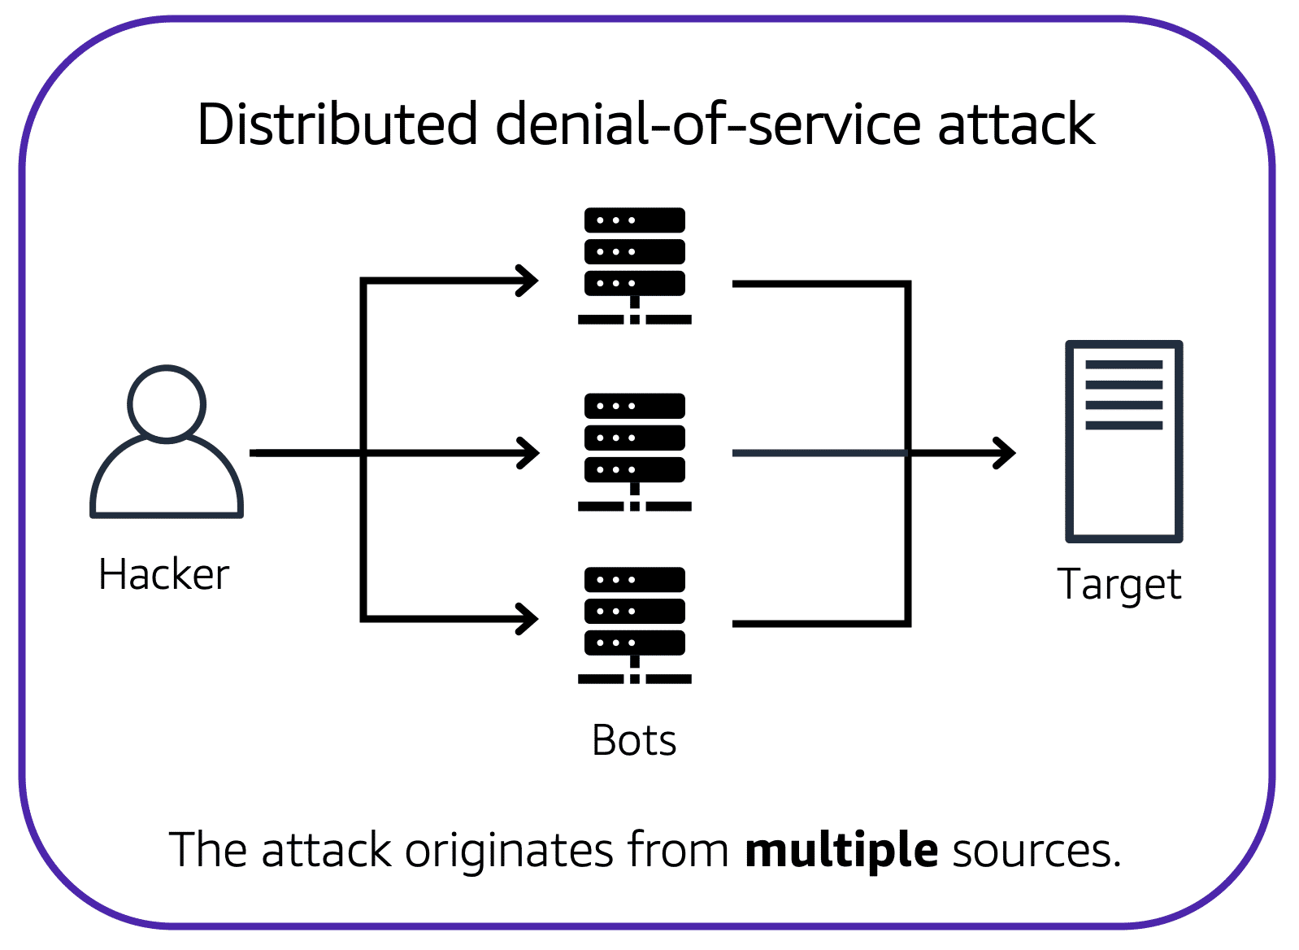Now, suppose that the prankster has enlisted the help of friends.

The prankster and their friends repeatedly call the coffee shop with requests to place orders, even though they do not intend to pick them up. These requests are coming in from different phone numbers, and it’s impossible for the coffee shop to block them all. Additionally, the influx of calls has made it increasingly difficult for customers to be able to get their calls through. This is similar to a **distributed denial-of-service attack**.

In a distributed denial-of-service (DDoS) attack, multiple sources are used to start an attack that aims to make a website or application unavailable. This can come from a group of attackers, or even a single attacker. The single attacker can use multiple infected computers (also known as “bots”) to send excessive traffic to a website or application.

To help minimize the effect of DoS and DDoS attacks on your applications, you can use [**AWS Shield**](https://aws.amazon.com/shield).

**3) AWS Shield**

AWS Shield is a service that protects applications against DDoS attacks. AWS Shield provides two levels of protection: Standard and Advanced. To learn more about AWS Shield, expand each of the following two categories.

**3-1) AWS Shield Standard**

**AWS Shield Standard** automatically protects all AWS customers **at no cost**. It protects your AWS resources from the most common, frequently occurring types of DDoS attacks.

As network traffic comes into your applications, AWS Shield Standard uses a variety of analysis techniques to **detect malicious traffic in real time and automatically mitigates it**.

**3-2) AWS Shield Advanced**

**AWS Shield Advanced** is a paid service that provides **detailed attack diagnostics** and the ability to detect and mitigate sophisticated DDoS attacks.

It also integrates with other services such as Amazon CloudFront, Amazon Route 53, and Elastic Load Balancing. Additionally, you can integrate AWS Shield with AWS WAF by writing custom rules to mitigate complex DDoS attacks.

# 6-6 Additional Security Services

**1) AWS Key Management Service (AWS KMS)**

The coffee shop has many items, such as coffee machines, pastries, money in the cash registers, and so on. You can think of these items as data. The coffee shop owners want to ensure that all of these items are secure, whether they’re sitting in the storage room or being transported between shop locations.

In the same way, you must ensure that your applications’ data is secure while in storage **(encryption at rest)** and while it is transmitted, known as **encryption in transit**.

[**AWS Key Management Service (AWS KMS)**](https://aws.amazon.com/kms) enables you to perform encryption operations through the use of **cryptographic keys**. A cryptographic key is a **random string of digits** used for locking (encrypting) and unlocking (decrypting) data. You can use AWS KMS to create, manage, and use **cryptographic keys**. You can also control the use of keys across a wide range of services and in your applications.

With AWS KMS, you can choose the specific levels of access control that you need for your keys. For example, you can specify which IAM users and roles are able to manage keys. Alternatively, you can temporarily disable keys so that they are no longer in use by anyone. Your keys never leave AWS KMS, and you are always in control of them.

**2) AWS WAF**

[**AWS WAF**](https://aws.amazon.com/waf) is a **web application firewall** that lets you monitor network requests that come into your web applications.

**AWS WAF works together with Amazon CloudFront and an Application Load Balancer**. Recall the **network access control lists** that you learned about in an earlier module. AWS WAF works in a similar way to **block or allow traffic**. However, it does this by using a [**web access control list (ACL)**](https://docs.aws.amazon.com/waf/latest/developerguide/web-acl.html)  to protect your AWS resources.

However, if a request comes from one of **the blocked IP addresses** that you have specified in the web ACL, AWS WAF denies access.

**3) Amazon Inspector (pin test)**

Suppose that the developers at the coffee shop are developing and testing a new ordering application. They want to make sure that they are designing the application in accordance with security best practices. However, they have several other applications to develop, so they cannot spend much time conducting manual assessments. **To perform automated security assessments**, they decide to use [**Amazon Inspector**](https://aws.amazon.com/inspector/).

Amazon Inspector helps to improve the security and compliance of applications by running automated security assessments. It checks applications for security vulnerabilities and deviations from security best practices, such as open access to Amazon EC2 instances and installations of vulnerable software versions.

After Amazon Inspector has performed an assessment, it provides you with a list of security findings. The list prioritizes by severity level, including a detailed description of each security issue and a recommendation for how to fix it. However, AWS does not guarantee that following the provided recommendations resolves every potential security issue. Under the shared responsibility model, customers are responsible for the security of their applications, processes, and tools that run on AWS services.

**4) Amazon GuardDuty**

[**Amazon GuardDuty**](https://aws.amazon.com/guardduty) is a service that provides **intelligent threat detection** for your AWS infrastructure and resources. It identifies threats by continuously **monitoring the network activity and account behavior** within your AWS environment.

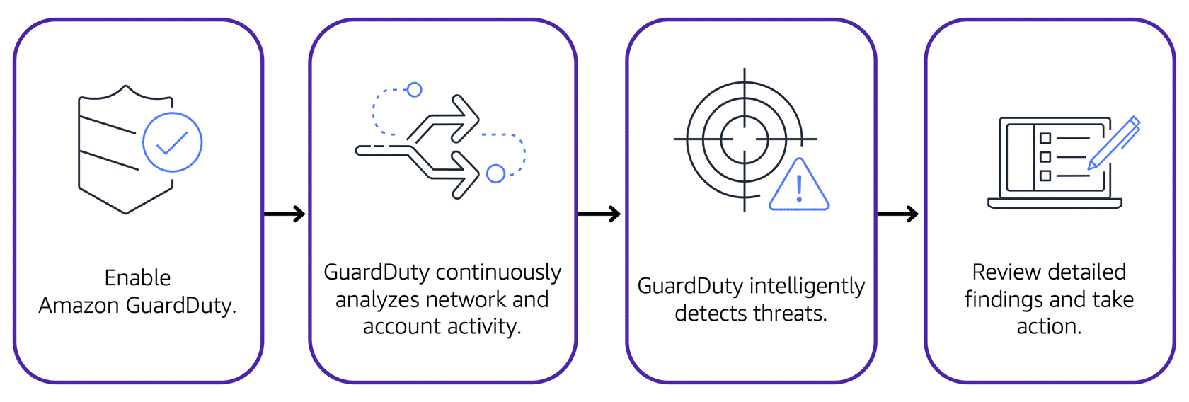

After you have enabled GuardDuty for your AWS account, GuardDuty begins monitoring your network and account activity. You do not have to deploy or manage any additional security software. GuardDuty then continuously analyzes data from multiple AWS sources, including **VPC Flow Logs and DNS logs**.

If GuardDuty detects any threats, you can review detailed findings about them **from the AWS Management Console**. Findings include recommended steps for remediation. You can also **configure AWS Lambda functions** to take remediation steps automatically in response to GuardDuty’s security findings.

# Module 7 Monitoring and Analytics

# 7-1. Amazon CloudWatch

**1) Amazon CloudWatch**

[**Amazon CloudWatch**](https://aws.amazon.com/cloudwatch/) is a web service that enables you to monitor and manage various metrics and configure alarm actions based on data from those metrics.

CloudWatch uses [**metrics**](https://docs.aws.amazon.com/AmazonCloudWatch/latest/monitoring/working_with_metrics.html) to represent the **data points** for your resources. AWS services send metrics to CloudWatch. CloudWatch then uses these metrics to create graphs automatically that **show how performance has changed over time**.

**2) CloudWatch alarms**

With CloudWatch, you can create [**alarms**](https://docs.aws.amazon.com/AmazonCloudWatch/latest/monitoring/AlarmThatSendsEmail.html) that automatically perform actions if the value of your metric has gone above or below a predefined threshold.

For example, suppose that your company’s developers use Amazon EC2 instances for application development or testing purposes. If the developers occasionally forget to stop the instances, the instances will continue to run and incur charges.

In this scenario, you could create a CloudWatch alarm that automatically stops an Amazon EC2 instance when the CPU utilization percentage has remained below a certain threshold for a specified period. When configuring the alarm, you can specify to receive a notification whenever this alarm is triggered.

**3) CloudWatch dashboard**

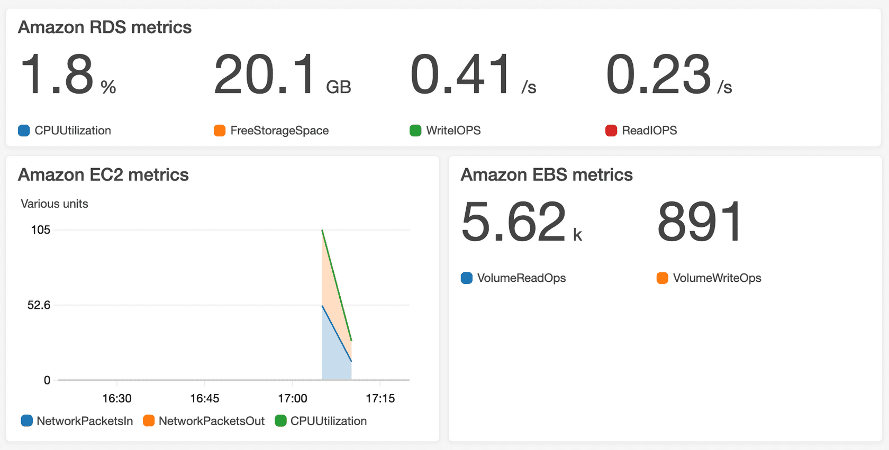

The CloudWatch [**dashboard**](https://docs.aws.amazon.com/AmazonCloudWatch/latest/monitoring/CloudWatch_Dashboards.html) feature enables you to access all the metrics for your resources from a single location. For example, you can use a CloudWatch dashboard to monitor the CPU utilization of an Amazon EC2 instance, the total number of requests made to an Amazon S3 bucket, and more. You can even customize separate dashboards for different business purposes, applications, or resources.

# 7-2. AWS CloudTrail

**1) AWS CloudTrail**

[**AWS CloudTrail**](https://aws.amazon.com/cloudtrail/) **records API calls** for your account. The recorded information includes the identity of the API caller, the time of the API call, the source IP address of the API caller, and more. You can think of CloudTrail as a “trail” of breadcrumbs (or **a log of actions**) that someone has left behind them.

Recall that you can use API calls to provision, manage, and configure your AWS resources. With CloudTrail, **you can view a complete history of user activity and API calls** for your applications and resources.

Events are typically updated in CloudTrail within **15 minutes** after an API call. You can filter events by specifying the time and date that an API call occurred, the user who requested the action, the type of resource that was involved in the API call, and more.

**Example: AWS CloudTrail event**

Suppose that the coffee shop owner is browsing through the AWS Identity and Access Management (IAM) section of the AWS Management Console. They discover that a new IAM user named Mary was created, but they do not know who, when, or which method created the user.

To answer these questions, the owner navigates to AWS CloudTrail.

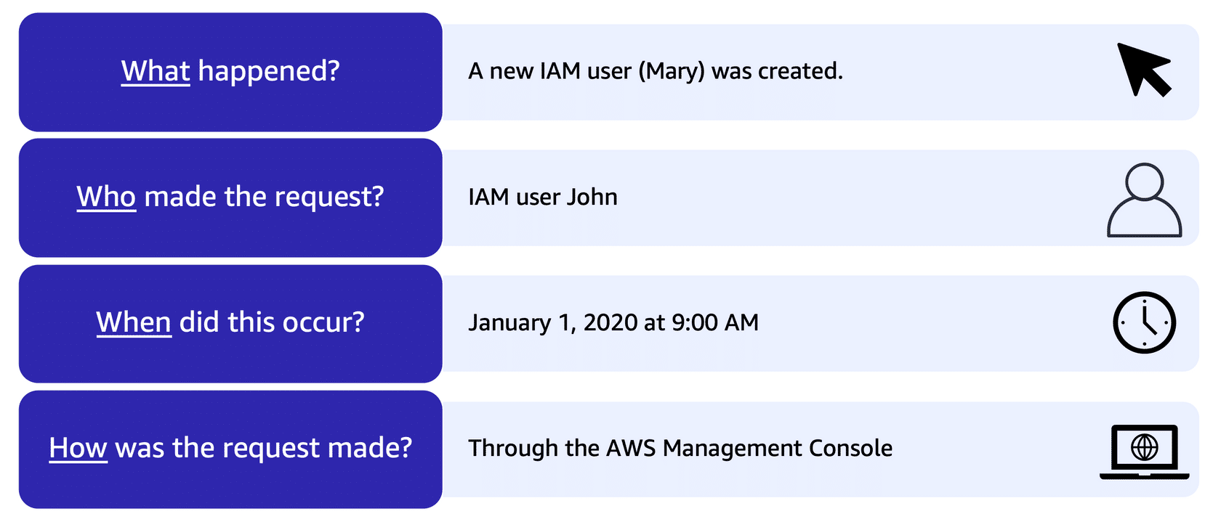

In the CloudTrail Event History section, the owner applies a filter to display only the events for the “CreateUser” API action in IAM. The owner locates the event for the API call that created an IAM user for Mary. This event record provides complete details about what occurred:

On January 1, 2020 at 9:00 AM, IAM user John created a new IAM user (Mary) through the AWS Management Console.

**CloudTrail Insights**

Within CloudTrail, you can also enable [**CloudTrail Insights**](https://docs.aws.amazon.com/awscloudtrail/latest/userguide/logging-insights-events-with-cloudtrail.html). **This optional feature allows CloudTrail to automatically detect unusual API activities in your AWS account.**

For example, CloudTrail Insights might detect that a higher number of Amazon EC2 instances than usual have recently launched in your account. You can then review the full event details to determine which actions you need to take next.

# 7-3. AWS Trusted Advisor

**1) AWS Trusted Advisor**

[**AWS Trusted Advisor**](https://aws.amazon.com/premiumsupport/technology/trusted-advisor/) is a **web service that inspects your AWS environment and provides real-time recommendations** in accordance with AWS best practices.

Trusted Advisor compares its findings to AWS best practices in five categories: **cost optimization, performance, security, fault tolerance, and service limits**. For the checks in each category, Trusted Advisor offers a list of recommended actions and additional resources to learn more about AWS best practices.

The guidance provided by AWS Trusted Advisor can benefit your company at all stages of deployment. For example, you can use AWS Trusted Advisor to assist you while you are creating new workflows and developing new applications. You can also use it while you are making ongoing improvements to existing applications and resources.

**2) AWS Trusted Advisor dashboard**

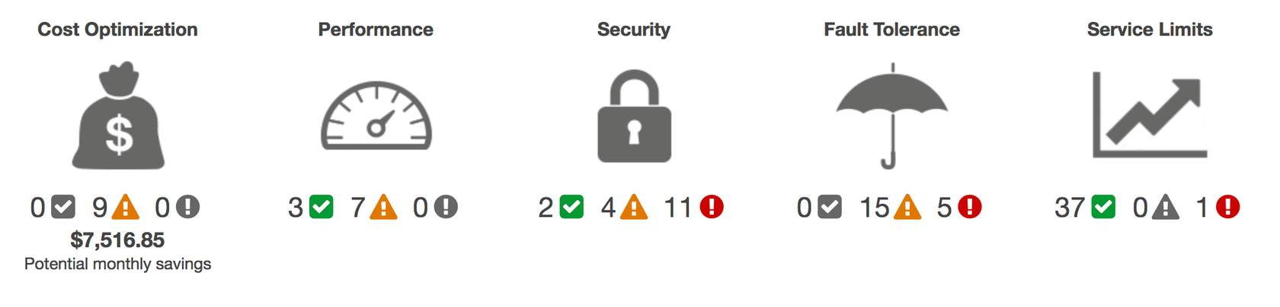

When you access the Trusted Advisor dashboard on the AWS Management Console, you can review completed checks for cost optimization, performance, security, fault tolerance, and service limits.

For each category:

* The green check indicates the number of items for which it detected **no problems**.
* The orange triangle represents the number of recommended **investigations**.
* The red circle represents the number of recommended **actions**.

Q1) Which actions can you perform using Amazon CloudWatch? (Select TWO.)

* Monitor your resources’ utilization and performance  🡺 CloudWatch
* Receive real-time guidance for improving your AWS environment 🡺 Trusted Advisor
* Compare your infrastructure to AWS best practices in five categories 🡺 Trusted Advisor
* Access metrics from a single dashboard 🡺 CloudWatch
* Automatically detect unusual account activity 🡺 CloudTrail

Q2) Which service enables you to review the security of your Amazon S3 buckets by checking for open access permissions?

* Amazon CloudWatch
* AWS CloudTrail
* AWS Trusted Advisor
* Amazon GuardDuty

# AWS Trusted Advisor is a web service that inspects your AWS environment and provides real-time recommendations in accordance with AWS best practices. The inspection includes security checks, such as Amazon S3 buckets with open access permissions.

# Module 8 Pricing and Support

# 8-1. AWS Free Tier

**1) Always Free**

These offers do not expire and are available to all AWS customers.

For example, AWS Lambda allows 1 million free requests and up to 3.2 million seconds of compute time per month. Amazon DynamoDB allows 25 GB of free storage per month.

**2) 12 Months Free**

These offers are free for 12 months following your initial sign-up date to AWS.

Examples include specific amounts of Amazon S3 Standard Storage, thresholds for monthly hours of Amazon EC2 compute time, and amounts of Amazon CloudFront data transfer out.

**3) Trials**

Short-term free trial offers start from the date you activate a particular service. The length of each trial might vary by number of days or the amount of usage in the service.

For example, Amazon Inspector offers a 90-day free trial. Amazon Lightsail (a service that enables you to run virtual private servers) offers 750 free hours of usage over a 30-day period.

# 8-2. AWS Pricing Concepts

**1) How AWS pricing works**

**Pay for what you use.**

For each service, you pay for exactly the amount of resources that you actually use, without requiring long-term contracts or complex licensing.

**Pay less when you reserve.**

Some services offer reservation options that provide a significant discount compared to On-Demand Instance pricing.

For example, suppose that your company is using Amazon EC2 instances for a workload that needs to run continuously. You might choose to run this workload on Amazon EC2 Instance Savings Plans, because the plan allows you to save up to 72% over the equivalent On-Demand Instance capacity.

**Pay less with volume-based discounts when you use more.**

Some services offer tiered pricing, so the per-unit cost is incrementally lower with increased usage.

For example, the more Amazon S3 storage space you use, the less you pay for it per GB.

**2) AWS Pricing Calculator**

The [**AWS Pricing Calculator**](https://calculator.aws/#/) lets you explore AWS services and create an **estimate for the cost of your use cases on AWS**. You can organize your AWS estimates by groups that you define. A group can reflect how your company is organized, such as providing estimates by cost center.

When you have created an estimate, you can save it and generate a link to share it with others.

Suppose that your company is interested in using Amazon EC2. However, you are not yet sure which AWS Region or instance type would be the most cost-efficient for your use case. In the AWS Pricing Calculator, you can enter details, such as the kind of operating system you need, memory requirements, and input/output (I/O) requirements. By using the AWS Pricing Calculator, you can review an estimated **comparison of different EC2 instance types across AWS Regions**.

**3) AWS pricing examples**

**3-1) AWS Lambda**

**AWS LAMBDA PRICING**

For AWS Lambda, you are charged based on the **number of requests for your functions and the time** that it takes for them to run.

AWS Lambda allows **1 million free requests** and up to **3.2 million seconds of compute time per month**.

You can save on AWS Lambda costs by signing up for a Compute Savings Plan. A Compute Savings Plan offers lower compute costs in exchange for committing to a consistent amount of usage over a 1-year or 3-year term. This is an example of **paying less when you reserve**.

**3-2) Amazon EC2**

**AMAZON EC2 PRICING**

With Amazon EC2, you pay for **only the compute time** that you use while your instances are running.

For some workloads, you can significantly reduce Amazon EC2 costs by using Spot Instances. For example, suppose that you are running a batch processing job that is able to withstand interruptions. Using a Spot Instance would provide you with up to 90% cost savings while still meeting the availability requirements of your workload.

You can find additional cost savings for Amazon EC2 by considering Savings Plans and Reserved Instances.

# PRICING EXAMPLE

Take an Amazon EC2 instance that has been deployed in the Northern Virginia Region for example. The service charges include details for the following items:

* One Amazon EC2 instance that has been running for about 107 hours
* Roughly 11 GB of Amazon EBS storage space that has been provisioned in the month
* An Application Load Balancer that has been used for 268 hours

In this example, all the usage amounts are under the thresholds in the AWS Free Tier, so the account owner would not have to pay for any Amazon EC2 usage in this month.

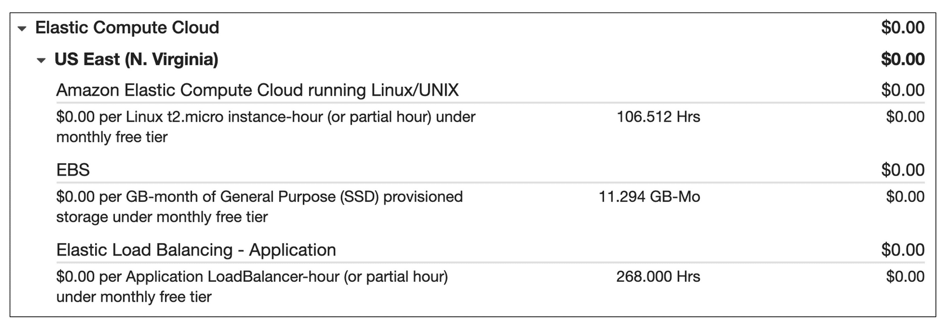

**3-3) Amazon S3**

**AMAZON S3 PRICING**

For Amazon S3 pricing, consider the following cost components:

* **Storage - You pay for only the storage that you use**. You are charged the rate to store objects in your Amazon S3 buckets based on your objects’ sizes, storage classes, and how long you have stored each object during the month.
* **Requests and data retrievals -**You pay for requests made to your Amazon S3 objects and buckets. For example, suppose that you are storing photo files in Amazon S3 buckets and hosting them on a website. Every time a visitor **requests** the website that includes these photo files, this counts towards requests you must pay for.
* **Data transfer - There is no cost to transfer data between different Amazon S3 buckets or from Amazon S3 to other services within the same AWS Region. However, you pay for data that you transfer into and out of Amazon S3**, with a few exceptions. There is no cost for data transferred into Amazon S3 from the **internet or out to Amazon CloudFront**. There is also no cost for data transferred out to an **Amazon EC2 instance in the same AWS Region** as the Amazon S3 bucket.
* **Management and replication -** You pay for the **storage management features** that you have enabled on your account’s Amazon S3 buckets. These features include **Amazon S3 inventory, analytics, and object tagging.**

**PRICING EXAMPLE**

Let's look at an AWS account that has used Amazon S3 in two Regions: Northern Virginia and Ohio.For each Region, itemized charges are based on the following factors:

* The number of requests to add or copy objects into a bucket. More specifically, these commands are also known as PUT, COPY, POST or LIST.
* The number of requests to retrieve objects from a bucket. This command is also known as GET.
* The amount of storage space used.

The Northern Virginia Region has two tiers of Amazon S3: Tier 1 and Tier 2.

* In Tier 1, there were 185 requests to add or copy objects into a bucket. (There were no requests to retrieve objects from a bucket.) 0.159 GB of storage space was used.
* In Tier 2, there were 923 requests to retrieve objects from a bucket. (There were no requests to add or copy objects to a bucket.)

The Ohio Region has one tier of Amazon S3: Tier 2. There were four requests to retrieve objects from a bucket and 0.000001 GB of storage space was used. There were no requests to add or copy objects to a bucket.

All the usage for Amazon S3 in this example is under the AWS Free Tier limits, so the account owner would not have to pay for any Amazon S3 usage in this month.

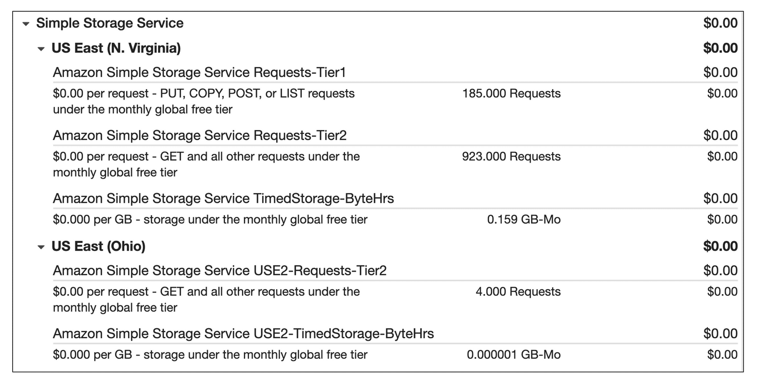

# 8-3. Billing Dashboard

Use the [**AWS Billing & Cost Management dashboard**](https://docs.aws.amazon.com/awsaccountbilling/latest/aboutv2/billing-what-is.html) to pay your AWS bill, monitor your usage, and analyze and control your costs.

* Compare your current month-to-date balance with the previous month, and get a forecast of the next month based on current usage.
* View month-to-date spend by service.
* View Free Tier usage by service.
* Access Cost Explorer and create budgets.
* Purchase and manage Savings Plans.
* Publish [AWS Cost and Usage Reports](https://docs.aws.amazon.com/cur/latest/userguide/what-is-cur.html).

# 8-4. Consolidated Billing

In an earlier module, you learned about AWS Organizations, a service that enables you to manage multiple AWS accounts from a central location. AWS Organizations also provides the option for [**consolidated billing**](https://docs.aws.amazon.com/awsaccountbilling/latest/aboutv2/consolidated-billing.html).

The consolidated billing feature of AWS Organizations **enables you to receive a single bill for all AWS accounts in your organization.** By consolidating, you can easily track the combined costs of all the linked accounts in your organization. The default maximum number of accounts allowed for an organization is 4, but you can contact AWS Support to increase your quota, if needed.

On your monthly bill, you can review itemized charges incurred by each account. This enables you to have greater transparency into your organization’s accounts while still maintaining the convenience of receiving a single monthly bill.

Another benefit of consolidated billing is the ability to share bulk discount pricing, Savings Plans, and Reserved Instances across the accounts in your organization. For instance, one account might not have enough monthly usage to qualify for discount pricing. However, when multiple accounts are combined, their aggregated usage may result in a benefit that applies across all accounts in the organization.

To review and example of consolidated billing, choose the arrow buttons to display the four steps.

# 8-5. AWS Budgets

**AWS Budgets**

In [**AWS Budgets**](https://aws.amazon.com/aws-cost-management/aws-budgets), you can create budgets to plan your service usage, service costs, and instance reservations.

The information in AWS Budgets updates **three times a day**. This helps you to accurately determine how close your usage is to your budgeted amounts or to the AWS Free Tier limits.

In AWS Budgets, you can also **set custom alerts when your usage exceeds** (or is forecasted to exceed) the budgeted amount.

**Example: AWS Budgets**

Suppose that you have set a budget for Amazon EC2. You want to ensure that your company’s usage of Amazon EC2 does not exceed $200 for the month.

In AWS Budgets, you could set a custom budget to notify you when your usage has reached half of this amount ($100). This setting would allow you to receive an alert and decide how you would like to proceed with your continued use of Amazon EC2.

To learn more about AWS Budgets, choose each of the numbered markers.

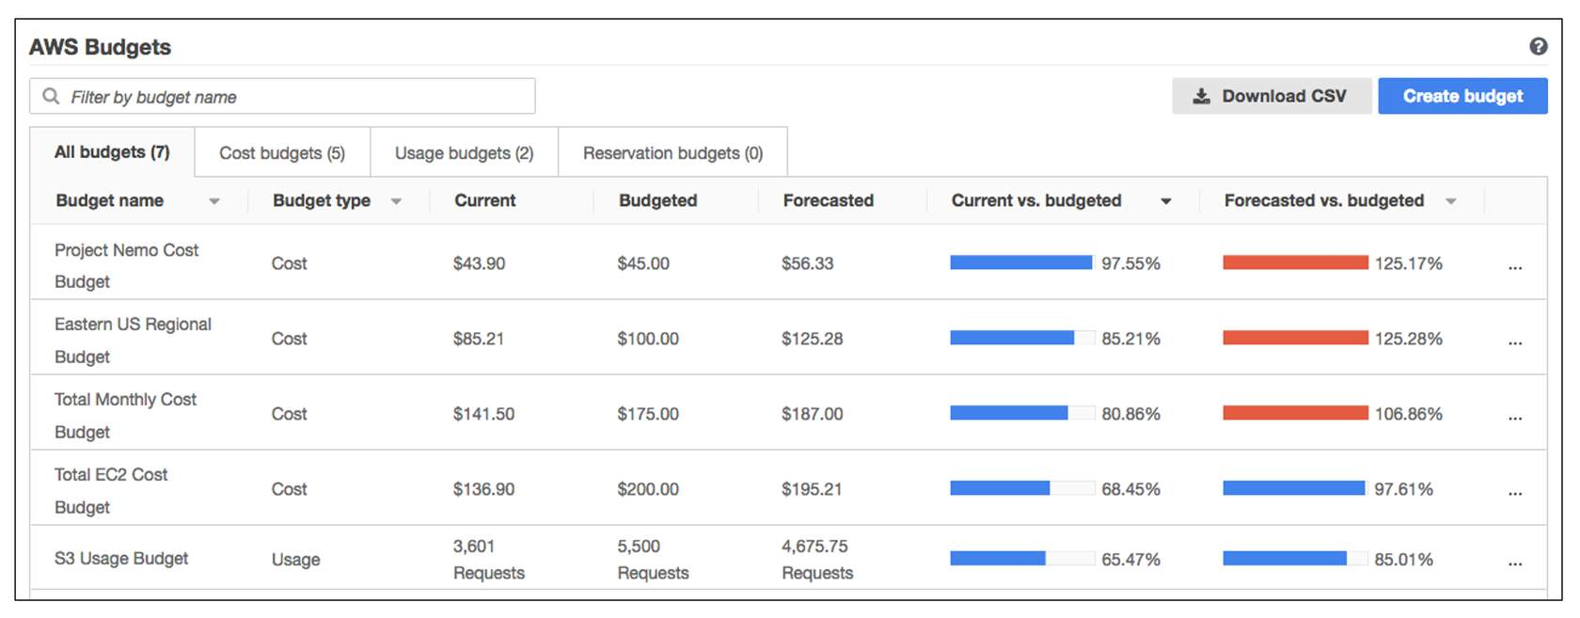

# 8-6. AWS Cost Explorer

**AWS Cost Explorer**

[**AWS Cost Explorer**](https://aws.amazon.com/aws-cost-management/aws-cost-explorer/) is a tool that lets you **visualize**, understand, and manage your AWS costs and usage over time.

AWS Cost Explorer includes a default **report of the costs and usage for your top five cost**-accruing AWS services. You can apply custom filters and groups to analyze your data. For example, **you can view resource usage at the hourly level.**

**Example: AWS Cost Explorer**

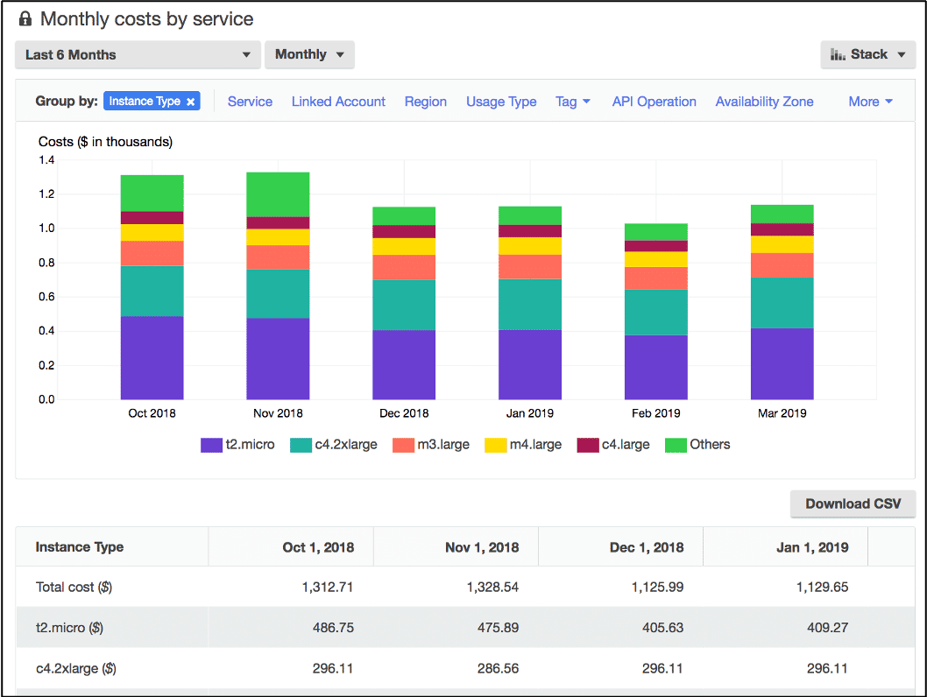

This example of the AWS Cost Explorer dashboard displays monthly costs for Amazon EC2 instances over a 6-month period. The bar for each month separates the costs for **different Amazon EC2 instance types**, such as t2.micro or m3.large.

By analyzing your AWS costs over time, you can make informed decisions about future costs and how to plan your budgets.

# 8-7. AWS Support Plans

**1) AWS Support**

AWS offers four different [**Support plans**](https://aws.amazon.com/premiumsupport/plans/) to help you troubleshoot issues, lower costs, and efficiently use AWS services.

You can choose from the following Support plans to meet your company’s needs:

* Basic
* Developer
* Business
* Enterprise On-Ramp
* Enterprise

**1-1) Basic Support**

**Basic Support** is free for all AWS customers. It includes access to whitepapers, documentation, and support communities. With Basic Support, you can also contact AWS for billing questions and service limit increases.

With Basic Support, you have access to a limited selection of AWS Trusted Advisor checks. Additionally, you can use the **AWS Personal Health Dashboard**, a tool that provides alerts and remediation guidance when AWS is experiencing events that may affect you.

If your company needs support beyond the Basic level, you could consider purchasing Developer, Business, Enterprise On-Ramp, and Enterprise Support.

**1-2) Developer Support**

Customers in the **Developer Support** plan have access to features such as:

* Best practice guidance
* Client-side diagnostic tools
* Building-block architecture support, which consists of guidance for how to use AWS offerings, features, and services together

For example, suppose that your company is exploring AWS services. You’ve heard about a few different AWS services. However, you’re unsure of how to potentially use them together to build applications that can address your company’s needs. In this scenario, the building-block architecture support that is included with the Developer Support plan could help you to identify opportunities for combining specific services and features.

**1-3) Business Support**

Customers with a **Business Support** plan have access to additional features, including:

* Use-case guidance to identify AWS offerings, features, and services that can best support your specific needs
* **All AWS Trusted Advisor checks**
* Limited support for third-party software, such as common operating systems and application stack components

Suppose that your company has the Business Support plan and wants to install a common third-party operating system onto your Amazon EC2 instances. You could contact **AWS Support for assistance** with installing, configuring, and troubleshooting the operating system. For advanced topics such as optimizing performance, using custom scripts, or resolving security issues, you may need to contact the third-party software provider directly.

**1-4) Enterprise On-Ramp Support**

In November 2021, AWS opened enrollment into AWS Enterprise On-Ramp Support plan. In addition to all the features included in the Basic, Developer, and Business Support plans, customers with an Enterprise On-Ramp Support plan have access to:

* A pool of Technical Account Managers to provide proactive guidance and coordinate access to programs and AWS experts
* A Cost Optimization workshop (one per year)
* A Concierge support team for billing and account assistance
* Tools to monitor costs and performance through Trusted Advisor and Health API/Dashboard

Enterprise On-Ramp Support plan also provides access to a specific set of proactive support services, which are provided by a pool of Technical Account Managers.

* Consultative review and architecture guidance (one per year)
* Infrastructure Event Management support (one per year)
* Support automation workflows
* 30 minutes or less response time for business-critical issues

**1-5) Enterprise Support**

In addition to all features included in the Basic, Developer, Business, and Enterprise On-Ramp support plans, customers with Enterprise Support have access to:

* A designated Technical Account Manager to provide proactive guidance and coordinate access to programs and AWS experts
* A Concierge support team for billing and account assistance
* Operations Reviews and tools to monitor health
* Training and Game Days to drive innovation
* Tools to monitor costs and performance through Trusted Advisor and Health API/Dashboard

The Enterprise plan also provides full access to proactive services, which are provided by a designated Technical Account Manager:

* Consultative review and architecture guidance
* Infrastructure Event Management support
* Cost Optimization Workshop and tools
* Support automation workflows
* 15 minutes or less response time for business-critical issues

**# Developer, Business, Enterprise On-Ramp, and Enterprise Support**

The Developer, Business, Enterprise On-Ramp, and Enterprise Support plans include all the benefits of Basic Support, in addition to the ability to open an unrestricted number of technical support cases. These Support plans have pay-by-the-month pricing and require no long-term contracts.  
  
In general, for pricing, the Developer plan has the lowest cost, the Business and Enterprise On-Ramp plans are in the middle, and the Enterprise plan has the highest cost.

**2) Technical Account Manager (TAM)**

The **Enterprise On-Ramp and Enterprise Support plans include** access to a **Technical Account Manager (TAM)**.  
  
The TAM is your primary point of contact at AWS. If your company subscribes to Enterprise Support or Enterprise On-Ramp, your TAM educates, empowers, and evolves your cloud journey across the full range of AWS services. TAMs provide expert engineering guidance, help you design solutions that efficiently integrate AWS services, assist with cost-effective and resilient architectures, and provide direct access to AWS programs and a broad community of experts.  
  
For example, suppose that you are interested in developing an application that uses several AWS services together. Your TAM could provide insights into how to best use the services together. They achieve this, while aligning with the specific needs that your company is hoping to address through the new application.

# 8-8. AWS Marketplace

[**AWS Marketplace**](https://aws.amazon.com/marketplace) is a digital catalog that includes thousands of software listings from independent software vendors. You can use AWS Marketplace to find, test, and buy software that runs on AWS.

For each listing in AWS Marketplace, you can access detailed information on pricing options, available support, and reviews from other AWS customers.

You can also explore software solutions by industry and use case. For example, suppose your company is in the healthcare industry. In AWS Marketplace, you can review use cases that software helps you to address, such as implementing solutions to protect patient records or using machine learning models to analyze a patient’s medical history and predict possible health risks.

**AWS Marketplace categories**

AWS Marketplace offers products in several categories, such as Infrastructure Software, DevOps, Data Products, Professional Services, Business Applications, Machine Learning, Industries, and Internet of Things (IoT).

Within each category, you can narrow your search by browsing through product listings in subcategories. For example, subcategories in the DevOps category include areas such as Application Development, Monitoring, and Testing.

# Module 9 Migration and Innovation

# 9-1. AWS Cloud Adoption Framework (AWS CAF)

**Six core perspectives of the Cloud Adoption Framework**

At the highest level, the [**AWS Cloud Adoption Framework (AWS CAF)**](https://d1.awsstatic.com/whitepapers/aws_cloud_adoption_framework.pdf) organizes guidance into six areas of focus, called **Perspectives**. Each Perspective addresses distinct responsibilities. The planning process helps the right people across the organization prepare for the changes ahead.

In general, the **Business**, **People**, and **Governance** Perspectives focus on **business capabilities**, whereas the **Platform**, **Security**, and **Operations** Perspectives focus on **technical capabilities**.

**1) Business Perspective**

The **Business Perspective** ensures that IT aligns with **business needs** and that IT investments link to key business results. Use the Business Perspective to create a strong business case for cloud adoption and prioritize cloud adoption initiatives. Ensure that your business strategies and goals align with your IT strategies and goals.

Common roles in the Business Perspective include:

* Business managers
* Finance managers
* Budget owners
* Strategy stakeholders

**2) People Perspective**

The **People Perspective** supports development of an organization-wide change management strategy for successful cloud adoption. Use the People Perspective to evaluate organizational structures and roles, new skill and process requirements, and identify gaps. This helps prioritize training, staffing, and organizational changes.

Common roles in the People Perspective include:

* Human resources
* Staffing
* People managers

**3) Governance Perspective**

The **Governance Perspective** focuses on the skills and processes to align IT strategy with business strategy. This ensures that you maximize the business value and minimize risks. Use the Governance Perspective to understand how to update the staff skills and processes necessary to ensure business governance in the cloud. Manage and measure cloud investments to evaluate business outcomes.

Common roles in the Governance Perspective include:

* Chief Information Officer (CIO)
* Program managers
* Enterprise architects
* Business analysts
* Portfolio managers

**4) Platform Perspective**

The **Platform Perspective** includes principles and patterns for implementing new solutions on the cloud and migrating on-premises workloads to the cloud. Use a variety of architectural models to understand and communicate the structure of IT systems and their relationships. Describe the architecture of the target state environment in detail.

Common roles in the Platform Perspective include:

* Chief Technology Officer (CTO)
* IT managers
* Solutions architects

**5) Security Perspective**

The **Security Perspective** ensures that the organization meets security objectives for visibility, auditability, control, and agility. Use the AWS CAF to structure the selection and implementation of security controls that meet the organization’s needs.

Common roles in the Security Perspective include:

* Chief Information Security Officer (CISO)
* IT security managers
* IT security analysts

**6) Operations Perspective**

The **Operations Perspective** helps you to enable, run, use, operate, and recover IT workloads to the level agreed upon with your business stakeholders. Define how day-to-day, quarter-to-quarter, and year-to-year business is conducted. Align with and support the operations of the business. The AWS CAF helps these stakeholders define current operating procedures and identify the process changes and training needed to implement successful cloud adoption.

Common roles in the Operations Perspective include:

* IT operations managers
* IT support managers

# Q) Which Perspective of the AWS Cloud Adoption Framework helps you design, implement, and optimize your AWS infrastructure based on your business goals and perspectives?

The Platform Perspective of the AWS Cloud Adoption Framework also includes principles for implementing new solutions and migrating on-premises workloads to the cloud.

**Q) Which Perspective of the AWS Cloud Adoption Framework helps you structure the selection and implementation of permissions?**

The Security Perspective of the AWS Cloud Adoption Framework also helps you to identify areas on non-compliance and plan ongoing security initiatives.

**9-2. 6 strategies for migration**

When migrating applications to the cloud, six of the most common [migration strategies(opens in a new tab)](https://aws.amazon.com/blogs/enterprise-strategy/6-strategies-for-migrating-applications-to-the-cloud/) that you can implement are:

**1) Rehosting**

**Rehosting** also known as “lift-and-shift” involves moving applications **without changes**.

In the scenario of a large legacy migration, in which the company is looking to implement its migration and scale quickly to meet a business case, the majority of applications are rehosted.

**2) Replatforming**

**Replatforming**, also known as “lift, tinker, and shift,” involves **making a few cloud optimizations to realize a tangible benefit**. Optimization is achieved without changing the core architecture of the application.

**3) Refactoring/re-architecting**

**Refactoring** (also known as **re-architecting**) involves **reimagining how an application is architected and developed by using cloud-native features**. Refactoring is driven by a strong business need to add features, scale, or performance that would otherwise be difficult to achieve in the application’s existing environment.

**4) Repurchasing**

**Repurchasing** involves moving from a traditional license to a **software-as-a-service model**. For example, a business might choose to implement the repurchasing strategy by migrating from a customer relationship management (CRM) system to Salesforce.com.

**5) Retaining**

**Retaining** consists of keeping applications that are critical for the business in the source environment. This might include applications that require major refactoring before they can be migrated, or, work that can be postponed until a later time.

**6) Retiring**

**Retiring** is the process of removing applications that are no longer needed.

**Q) Which migration strategy involves moving to a different product?**

Repurchasing involves replacing an existing application with a cloud-based version, such as software found in AWS Marketplace.

# 9-3. AWS Snow Family

**AWS Snow Family members**

The [**AWS Snow Family**](https://aws.amazon.com/snow) is a collection of physical devices that help to physically transport up to exabytes of data into and out of AWS.

AWS Snow Family is composed of **AWS Snowcone**, **AWS Snowball**, and **AWS Snowmobile**.

These devices offer different capacity points, and most include built-in computing capabilities. AWS owns and manages the Snow Family devices and integrates with AWS security, monitoring, storage management, and computing capabilities.

**1) AWS SNOWCONEAWS**

[**AWS Snowcone**](https://aws.amazon.com/snowcone) is a small, rugged, and secure edge computing and data transfer device.

It features **2 CPUs, 4 GB of memory**, and up to **14 TB of usable storage**.

**2) SNOWBALLAWS**

[**AWS Snowball**](https://aws.amazon.com/snowball/) offers two types of devices:

* **Snowball Edge Storage Optimized**devices are well suited for large-scale data migrations and recurring transfer workflows, in addition to local computing with higher capacity needs.
  + Storage: **80 TB of hard disk** drive (HDD) capacity for block volumes and Amazon S3 compatible object storage, and **1 TB of SATA solid state drive** (SSD) for block volumes.
  + Compute: **40 vCPUs, and 80 GiB of memory** to support Amazon EC2 sbe1 instances (equivalent to C5).
* **Snowball Edge Compute Optimized**provides powerful computing resources for use cases such as machine learning, full motion video analysis, analytics, and local computing stacks.
  + Storage: 80-TB usable HDD capacity for Amazon S3 compatible object storage or Amazon EBS compatible block volumes and **28 TB of usable NVMe SSD capacity for** Amazon EBS compatible block volumes.
  + Compute: **104 vCPUs, 416 GiB** of memory, and an optional NVIDIA Tesla V100 GPU. Devices run Amazon EC2 sbe-c and sbe-g instances, which are equivalent to C5, M5a, G3, and P3 instances.

**3) SNOWMOBILE**

[**AWS Snowmobile**](https://aws.amazon.com/snowmobile) is an **exabyte-scale data transfer service** used to move large amounts of data to AWS. You can transfer up to **100 petabytes of data** per Snowmobile, a 45-foot long ruggedized shipping container, pulled by a semi-trailer truck.

**Q) What is the storage capacity of Snowball Edge Storage Optimized?**

The correct response option is **80 TB**.

# 9-4. Innovation with AWS

**9-1) Innovate with AWS Services**

When examining how to use AWS services, it is important to focus on the desired outcomes. You are properly equipped to drive innovation in the cloud if you can clearly articulate the following conditions:

* The current state
* The desired state
* The problems you are trying to solve

Consider some of the paths you might explore in the future as you continue on your cloud journey. To learn more on ways to innovate with AWS, expand each of the following three categories.

**1) Serverless applications**

With AWS, **serverless** refers to applications that don’t require you to provision, maintain, or administer servers. You don’t need to worry about fault tolerance or availability. AWS handles these capabilities for you.

AWS Lambda is an example of a service that you can use to run serverless applications. If you design your architecture to trigger Lambda functions to run your code, you can bypass the need to manage a fleet of servers. Building your architecture with serverless applications enables your developers to focus on their core product instead of managing and operating servers.

**2) Machine learning**

Traditional **machine learning (ML)** development is complex, expensive, time consuming, and error prone. AWS offers Amazon **SageMaker** to remove the difficult work from the process and empower you to build, train, and deploy ML models quickly. You can use ML to analyze data, solve complex problems, and predict outcomes before they happen.

**3) Artificial intelligence**

AWS offers a variety of services powered by **artificial intelligence (AI)**.

For example, you can perform the following tasks:

* Get code recommendations while writing code and identify security issues in your code with Amazon **CodeWhisperer**.
* Convert speech to text with Amazon **Transcribe**.
* Discover patterns in text with Amazon **Comprehend**.
* Identify potentially fraudulent online activities with **Amazon Fraud Detector**.
* Build voice and text chatbots with Amazon **Lex**.

**Amazon CodeWhisperer**

Amazon CodeWhisperer is an AI software coding companion. It analyzes code and comments as a developer writes code in their integrated development environment. It goes beyond code completion by using natural language processing to comprehend the comments in a developer's code. By understanding English comments, CodeWhisperer generates complete functions and code blocks that align with a developer's descriptions. Additionally, CodeWhisperer analyzes the surrounding code, ensuring the generated code matches a developer's style and naming conventions.

# Module 10 The Cloud Journey

# 6-1. The AWS Well-Architected Framework

The [**AWS Well-Architected Framework**](https://docs.aws.amazon.com/wellarchitected/latest/framework/welcome.html) helps you understand how to design and operate reliable, secure, efficient, and cost-effective systems in the AWS Cloud. It provides a way for you to consistently measure your architecture against best practices and design principles and identify areas for improvement. The Well-Architected Framework is based on six pillars:

**1) Operational excellence**

**Operational excellence** is the **ability to run** and **monitor systems to deliver business value** and to continually **improve supporting processes and procedures**.

Design principles for operational excellence in the cloud include performing operations as code, annotating documentation, anticipating failure, and frequently making small, reversible changes.

**2) Security**

The **Security** pillar is the ability to protect information, systems, and assets while delivering business value through risk assessments and mitigation strategies.

When considering the security of your architecture, apply these best practices:

* Automate security best practices when possible.
* Apply security at all layers.
* Protect data in transit and at rest.

**3) Reliability**

**Reliability** is the ability of a system to do the following:

* Recover from infrastructure or service disruptions
* Dynamically acquire computing resources to meet demand
* Mitigate disruptions such as misconfigurations or transient network issues

Reliability includes testing recovery procedures, scaling horizontally to increase aggregate system availability, and automatically recovering from failure.

**4) Performance efficiency**

**Performance efficiency** is the ability to use computing resources efficiently to meet system requirements and to maintain that efficiency as demand changes and technologies evolve.

Evaluating the performance efficiency of your architecture includes experimenting more often, using serverless architectures, and designing systems to be able to go global in minutes.

**5) Cost optimization**

**Cost optimization** is the ability to run systems to deliver business value at the lowest price point.

Cost optimization includes adopting a consumption model, analyzing and attributing expenditure, and using managed services to reduce the cost of ownership.

**6) Sustainability**

Sustainability is the ability to continually improve sustainability impacts by reducing energy consumption and increasing efficiency across all components of a workload by maximizing the benefits from the provisioned resources and minimizing the total resources required.

To facilitate good design for sustainability:

* Understand your impact
* Establish sustainability goals
* Maximize utilization
* Anticipate and adopt new, more efficient hardware and software offerings
* Use managed services
* Reduce the downstream impact of your cloud workloads

# 6-2. Benefits of the AWS Cloud

**Advantages of cloud computing**

Operating in the AWS Cloud offers many benefits over computing in on-premises or hybrid environments.

**1) Trade upfront expense for variable expense.**

Upfront expenses include data centers, physical servers, and other resources that you would need to invest in before using computing resources. Instead of investing heavily in data centers and servers before you know how you’re going to use them, you can pay only when you consume computing resources.

**2) Benefit from massive economies of scale.**

By using cloud computing, you can achieve a lower variable cost than you can get on your own.

Because usage from hundreds of thousands of customers aggregates in the cloud, providers such as AWS can achieve higher economies of scale. **Economies of scale translate into lower pay-as-you-go prices**.

**3) Stop guessing capacity.**

With cloud computing, you don’t have to predict how much infrastructure capacity you will need before deploying an application.  For example, you can launch Amazon Elastic Compute Cloud (Amazon EC2) instances when needed and pay only for the compute time you use. Instead of paying for resources that are unused or dealing with limited capacity, you can access only the capacity that you need, and scale in or out in response to demand.

**4) Increase speed and agility.**

The flexibility of cloud computing makes it easier for you to develop and deploy applications. This flexibility also provides your development teams with more time to experiment and innovate.

**5) Stop spending money running and maintaining data centers.**

Cloud computing in data centers often requires you to spend more money and time managing infrastructure and servers. A benefit of cloud computing is the ability to focus less on these tasks and more on your applications and customers.

6) **Go global in minutes.**

The AWS Cloud global footprint enables you to quickly deploy applications to customers around the world, while providing them with low latency.

# Q) Which process is an example of benefiting from massive economies of scale?

a. Deploying an application in multiple Regions around the world

b. Receiving lower pay-as-you-go prices as the result of AWS customers’ aggregated usage of services

c. Paying for compute time as you use it instead of investing upfront costs in data centers

d. Scaling your infrastructure capacity in and out to meet demand

# Q) Which pillar of the AWS Well-Architected Framework includes the ability to run workloads effectively and gain insights into their operations?

a. Cost Optimization

b. Operational Excellence

c. Performance Efficiency

d. Reliability

**Q) What are the benefits of cloud computing? (Select TWO.)**

a. Increase speed and agility.

b. Benefit from smaller economies of scale.

c. Trade variable expense for upfront expense.

d. Maintain infrastructure capacity.

e. Stop spending money running and maintaining data centers.

# Module 11 AWS Certified Cloud Practitioner Basics

| **Domain** | **Percentage of exam** |
| --- | --- |
| Domain 1: Cloud Concepts | 26% |
| Domain 2: Security and Compliance | 25% |
| Domain 3: Technology | 33% |
| Domain 4: Billing and Pricing | 16% |
| Total | 100% |

# Q1) Which migration strategy involves changing how an application is architected and developed, typically by using cloud-native features?

Rehosting

**Refactoring**

Replatforming

Repurchasing

# Q2) An application developer wants to send and receive messages between distributed application components. Which service should they use?

AWS Snowball

Amazon ElastiCache

**Amazon Simple Queue Service (Amazon SQS)**

Amazon Route 53

**Q3) An application developer wants to store data in a key-value database. Which service should they use?**

Amazon Aurora

**Amazon DynamoDB**

Amazon DocumentDB

Amazon RDS

**Q4) Which AWS Trusted Advisor category includes checks for high-utilization EC2 instances?**

Security

**Performance**

Cost Optimization

Fault Tolerance

**Q5) Which tool provides the capability to visualize, understand, and manage AWS costs and usage over time?**

AWS Budgets

**AWS Cost Explorer**

AWS Artifact

AWS Pricing Calculator

**Q6) Which service builds the workflows that are required for human review of machine learning predictions?**

Amazon Aurora

Amazon Lex

**Amazon Augmented AI**

Amazon Textract

Amazon Augmented AI (Amazon A2I) provides built-in human review workflows for common machine learning use cases, such as content moderation and text extraction from documents. With Amazon A2I, a person can also create their own workflows for machine learning models built on Amazon SageMaker or any other tools.

**Q7) Which statement best describes an Availability Zone?**

A site that Amazon CloudFront uses to cache copies of content for faster delivery to users at any location

(Edge location.)

**A fully isolated portion of the AWS global infrastructure**

A separate geographical location with multiple locations that are isolated from each other (Region)

The server from which Amazon CloudFront gets files (origin)

**Q8) Which Amazon EC2 pricing option reduces costs when a business makes an hourly spend** **commitment to an instance family and Region for a 1-year or 3-year term?**

* **EC2 Instance Savings Plans**
* Spot Instances
* Dedicated Hosts
* Reserved Instances

**Q9) Which statement is TRUE for AWS Lambda?**

* To use AWS Lambda, businesses must configure the servers that run their code.
* Before using AWS Lambda, a business must prepay for their estimated compute time.
* **Businesses pay only for compute time while their code is running.**
* The first step in using AWS Lambda is provisioning a server.

**Q10) Which statement best describes AWS Marketplace?**

* An online tool that inspects an AWS environment and provides real-time guidance in accordance with AWS best practices
* A resource that can answer questions about best practices and assist with troubleshooting issues
* A resource that provides guidance, architectural reviews, and ongoing communication with companies as they plan, deploy, and optimize their applications
* **A digital catalog that includes thousands of software listings from independent software vendors**

**Q11) Which service runs containerized applications on AWS?**

Amazon SageMaker

**Amazon Elastic Kubernetes Service (Amazon EKS)**

Amazon Redshift

Amazon Aurora

**Q12) Which statement best describes Amazon GuardDuty?**

A service that helps protect applications against distributed denial-of-service (DDoS) attacks

**A service that provides intelligent threat detection for AWS infrastructure and resources**

A service that monitors network requests for web applications

A service that checks applications for security vulnerabilities and deviations from security best practices

**Q13) Which service provides the capability to quickly deploy and scale applications on AWS?**

AWS Snowball

**AWS Elastic Beanstalk**

Amazon CloudFront

AWS Outposts

**Q14) Which virtual private cloud (VPC) component controls inbound and outbound traffic for Amazon EC2 instances?**

* Network access control list
* Internet gateway
* **Security group**
* Subnet
* A security group is a virtual firewall that controls inbound and outbound traffic for an Amazon EC2 instance.
* A subnet is a section of a VPC in which a person can group resources based on security or operational needs.
* A network access control list (ACL) is a virtual firewall that controls inbound and outbound traffic at the subnet level.
* An internet gateway is a connection between a VPC and the internet. It allows public traffic from the internet to access a VPC.

**Q15) Which Support plans include access to all AWS Trusted Advisor checks? (Select TWO.)**

* **Enterprise**
* Basic
* **Business**
* Developer
* AWS Free Tier

**Q16) Which Perspective of the AWS Cloud Adoption Framework focuses on recovering IT workloads to meet the requirements of business stakeholders?**

* People Perspective
* Governance Perspective
* **Operations Perspective**
* Business Perspective

The Operations Perspective of the AWS Cloud Adoption Framework also includes principles for operating in the cloud by using agile best practices.

**Q17) In the S3 Intelligent-Tiering storage class, Amazon S3 moves objects between a frequent access tier and an infrequent access tier. Which storage classes are used for these tiers? (Select TWO.)**

* S3 Glacier Flexible Retrieval
* S3 One Zone-IA
* V S3 Standard-IA
* S3 Glacier Deep Archive
* V S3 Standard

**Q18) Which tool provides automation actions for AWS services and applications through scripts?**

* V AWS Command Line Interface
* Amazon QLDB
* Amazon Redshift
* AWS Snowball

**Q19) Which pillar of the AWS Well-Architected Framework focuses on using computing resources in ways that meet system requirements?**

* V **Performance Efficiency**
* Reliability
* Operational Excellence
* Security

**Q20) Which action can a person perform in Amazon CloudFront?**

* Run infrastructure in a hybrid cloud approach.
* Provision resources by using programming languages or a text file.
* Provision an isolated section of the AWS Cloud to launch resources in a virtual network that a person defines.
* **Deliver content to customers through a global network of edge locations.**

**Q21) A cloud engineer wants to store data in a volume that is attached to an Amazon EC2 instance. Which service should they use?**

* Amazon ElastiCache
* Amazon Simple Storage Service (Amazon S3)
* **Amazon Elastic Block Store (Amazon EBS)**
* AWS Lambda

Amazon EBS provides block-level storage volumes for Amazon EC2 instances. If a person stops or terminates an Amazon EC2 instance, all the data on the attached EBS volume remains available.

Amazon Simple Storage Service (Amazon S3) is a service that provides object-level storage. Amazon S3 stores data as objects within buckets.

**Q22) A cloud engineer is running an Amazon EC2 instance and wants to store data in an attached resource. Their data is temporary and will not be kept long term. Which resource should they use?**

* **Instance store**
* Amazon S3 bucket
* Amazon Elastic Block Store (Amazon EBS) volume
* Subnet

Instance stores are ideal for temporary data that does not need to be kept long term.

**Q23) Which service is used to transfer up to 100 PB of data to AWS?**

* AWS DeepRacer
* Amazon CloudFront
* **AWS Snowmobile**
* Amazon Neptune

**Q24) Which service provides review details for user activities and API calls that have occurred within an AWS environment?**

* Amazon CloudWatch
* **AWS CloudTrail**
* Amazon Inspector
* AWS Trusted Advisor

With CloudTrail, a person can view a complete history of user activity and API calls for their applications and resources.

**Q25) Which actions can a person perform in Amazon Route 53? (Select TWO.)**

* Access AWS security and compliance reports and select online agreements.
* Automate the deployment of workloads into an AWS environment.
* Monitor applications and respond to system-wide performance changes.
* **Connect user requests to infrastructure in AWS and outside of AWS.**
* **Manage DNS records for domain names.**

**Q26) Which component or service establishes a dedicated private connection between an on-premises data center and virtual private cloud (VPC)?**

* Amazon CloudFront
* Virtual private gateway
* **AWS Direct Connect**
* Internet gateway

**Q27) A cloud architect wants Amazon S3 to monitor object access patterns. Which storage class should they use?**

* Amazon S3 Standard-IA
* **Amazon S3 Intelligent-Tiering**
* Amazon S3 Glacier Flexible Retrieval
* Amazon S3 One Zone-IA

**Q28) Which service consolidates and manages multiple AWS accounts from a central location?**

* AWS Key Management Service (AWS KMS)
* AWS Identity and Access Management (IAM)
* AWS Artifact
* **AWS Organizations**

**Q29) Which statement best describes Elastic Load Balancing?**

* A service that provides the capability to create, manage, and scale a distributed in-memory or cache environment in the cloud
* A service that provides data for monitoring applications, optimize resource utilization, and respond to system-wide performance changes
* A service that monitors applications and automatically adds or removes capacity from resource groups in response to changing demand
* **A service that distributes incoming traffic across multiple targets, such as Amazon EC2 instances**

**Q30) Which tasks are the responsibilities of AWS? (Select TWO.)**

* Creating IAM users and groups
* **Maintaining virtualization infrastructure**
* Training company employees on how to use AWS services
* Configuring security groups on Amazon EC2 instances
* **Configuring AWS infrastructure devices**

<https://www.examtopics.com/exams/amazon/aws-certified-cloud-practitioner/view/1/>

Question #1

A company is planning to run a global marketing application in the AWS Cloud. The application will feature videos that can be viewed by users. The company must ensure that all users can view these videos with low latency.  
Which AWS service should the company use to meet this requirement?

* A. AWS Auto Scaling
* B. Amazon Kinesis Video Streams
* C. Elastic Load Balancing
* **D. Amazon CloudFront**

*CloudFront is a content delivery network (CDN) that speeds up the delivery of static and dynamic web content, such as HTML, CSS, JavaScript, and images, as well as videos.*

Question #2*Topic 1*

Which pillar of the AWS Well-Architected Framework refers to the ability of a system to recover from infrastructure or service disruptions and dynamically acquire computing resources to meet demand?

* A. Security
* **B. Reliability**
* C. Performance efficiency
* D. Cost optimization

*The reliability pillar focuses on workloads performing their intended functions and how to recover quickly from failure to meet demands. Key topics include distributed system design, recovery planning, and adapting to changing requirements.*

Question #3*Topic 1*

Which of the following are benefits of migrating to the AWS Cloud? (Choose two.)

* **A. Operational resilience**
* B. Discounts for products on Amazon.com
* **C. Business agility**
* D. Business excellence
* E. Increased staff retention

***A. Operational resilience****: The AWS Cloud is designed to be highly available and scalable, which can help organizations improve their operational resilience and reduce the impact of failures or disruptions.* ***C. Business agility****: Migrating to the AWS Cloud can help organizations to increase their business agility by allowing them to quickly and easily deploy new applications and services, scale their infrastructure up or down as needed, and experiment with new technologies.*

Question #4*Topic 1*

A company is planning to replace its physical on-premises compute servers with AWS serverless compute services. The company wants to be able to take advantage of advanced technologies quickly after the migration.  
Which pillar of the AWS Well-Architected Framework does this plan represent?

* A. Security
* B. **Performance efficiency**
* C. Operational excellence
* D. Reliability

Question #5*Topic 1*

A large company has multiple departments. Each department has its own AWS account. Each department has purchased Amazon EC2 Reserved Instances. Some departments do not use all the Reserved Instances that they purchased, and other departments need more Reserved Instances than they purchased.The company needs to manage the AWS accounts for all the departments so that the departments **can share the Reserved Instances**.  
Which AWS service or tool should the company use to meet these requirements?

* A. AWS Systems Manager
* B. Cost Explorer
* C. AWS Trusted Advisor
* **D. AWS Organizations**

Question #6*Topic 1*

Which component of the AWS global infrastructure is made up of one or more discrete data centers that have redundant power, networking, and connectivity?

* A. AWS Region
* **B. Availability Zone**
* C. Edge location
* D. AWS Outposts

Question #7*Topic 1*

Which duties are the responsibility of a company that is using AWS Lambda? (Choose two.)

* **A. Security inside of code**
* B. Selection of CPU resources
* C. Patching of operating system
* **D. Writing and updating of code**
* E. Security of underlying infrastructure

Question #8*Topic 1*

Which AWS services or features provide disaster recovery solutions for Amazon EC2 instances? (Choose two.)

* A. ׀•׀¡2 Reserved Instances
* B. EC2 Amazon Machine Images (AMIs)
* C. Amazon Elastic Block Store (Amazon EBS) snapshots
* D. AWS Shield
* E. Amazon GuardDuty

[Reveal Solution](https://www.examtopics.com/exams/amazon/aws-certified-cloud-practitioner/view/1/) [Discussion   **26**](https://www.examtopics.com/exams/amazon/aws-certified-cloud-practitioner/view/1/)

Question #9*Topic 1*

A company is migrating to the AWS Cloud instead of running its infrastructure on premises.  
Which of the following are advantages of this migration? (Choose two.)

* A. Elimination of the need to perform security auditing
* B. Increased global reach and agility
* C. Ability to deploy globally in minutes
* D. Elimination of the cost of IT staff members
* E. Redundancy by default for all compute services

[Reveal Solution](https://www.examtopics.com/exams/amazon/aws-certified-cloud-practitioner/view/1/) [Discussion   **123**](https://www.examtopics.com/exams/amazon/aws-certified-cloud-practitioner/view/1/)

Question #10*Topic 1*

A user is comparing purchase options for an application that runs on Amazon EC2 and Amazon RDS. The application cannot sustain any interruption. The application experiences a predictable amount of usage, including some seasonal spikes that last only a few weeks at a time. It is not possible to modify the application.  
Which purchase option meets these requirements MOST cost-effectively?

* A. Review the AWS Marketplace and buy Partial Upfront Reserved Instances to cover the predicted and seasonal load.
* B. Buy Reserved Instances for the predicted amount of usage throughout the year. Allow any seasonal usage to run on Spot Instances.
* C. Buy Reserved Instances for the predicted amount of usage throughout the year. Allow any seasonal usage to run at an On-Demand rate.
* D. Buy Reserved Instances to cover all potential usage that results from the seasonal usage.

[Reveal Solution](https://www.examtopics.com/exams/amazon/aws-certified-cloud-practitioner/view/1/) [Discussion   **140**](https://www.examtopics.com/exams/amazon/aws-certified-cloud-practitioner/view/1/)

[Next Questions](https://www.examtopics.com/exams/amazon/aws-certified-cloud-practitioner/view/2/)

Question #11*Topic 1*

A company wants to review its monthly costs of using Amazon EC2 and Amazon RDS for the past year.  
Which AWS service or tool provides this information?

* A. AWS Trusted Advisor
* B. Cost Explorer
* C. Amazon Forecast
* D. Amazon CloudWatch

[Reveal Solution](https://www.examtopics.com/exams/amazon/aws-certified-cloud-practitioner/view/2/) [Discussion   **36**](https://www.examtopics.com/exams/amazon/aws-certified-cloud-practitioner/view/2/)

Question #12*Topic 1*

A company wants to migrate a critical application to AWS. The application has a short runtime. The application is invoked by changes in data or by shifts in system state. The company needs a compute solution that maximizes operational efficiency and minimizes the cost of running the application.  
Which AWS solution should the company use to meet these requirements?

* A. Amazon EC2 On-Demand Instances
* B. AWS Lambda
* C. Amazon EC2 Reserved Instances
* D. Amazon EC2 Spot Instances

[Reveal Solution](https://www.examtopics.com/exams/amazon/aws-certified-cloud-practitioner/view/2/) [Discussion   **30**](https://www.examtopics.com/exams/amazon/aws-certified-cloud-practitioner/view/2/)

Question #13*Topic 1*

Which AWS service or feature allows users to connect with and deploy AWS services programmatically?

* A. AWS Management Console
* B. AWS Cloud9
* C. AWS CodePipeline
* D. AWS software development kits (SDKs)

[Reveal Solution](https://www.examtopics.com/exams/amazon/aws-certified-cloud-practitioner/view/2/) [Discussion   **46**](https://www.examtopics.com/exams/amazon/aws-certified-cloud-practitioner/view/2/)

Question #14*Topic 1*

A company plans to create a data lake that uses Amazon S3.  
Which factor will have the MOST effect on cost?

* A. The selection of S3 storage tiers
* B. Charges to transfer existing data into Amazon S3
* C. The addition of S3 bucket policies
* D. S3 ingest fees for each request

[Reveal Solution](https://www.examtopics.com/exams/amazon/aws-certified-cloud-practitioner/view/2/) [Discussion   **29**](https://www.examtopics.com/exams/amazon/aws-certified-cloud-practitioner/view/2/)

Question #15*Topic 1*

A company is launching an ecommerce application that must always be available. The application will run on Amazon EC2 instances continuously for the next  
12 months.  
What is the MOST cost-effective instance purchasing option that meets these requirements?

* A. Spot Instances
* B. Savings Plans
* C. Dedicated Hosts
* D. On-Demand Instances

[Reveal Solution](https://www.examtopics.com/exams/amazon/aws-certified-cloud-practitioner/view/2/) [Discussion   **38**](https://www.examtopics.com/exams/amazon/aws-certified-cloud-practitioner/view/2/)

Question #16*Topic 1*

Which AWS service or feature can a company use to determine which business unit is using specific AWS resources?

* A. Cost allocation tags
* B. Key pairs
* C. Amazon Inspector
* D. AWS Trusted Advisor

[Reveal Solution](https://www.examtopics.com/exams/amazon/aws-certified-cloud-practitioner/view/2/) [Discussion   **27**](https://www.examtopics.com/exams/amazon/aws-certified-cloud-practitioner/view/2/)

Question #17*Topic 1*

A company wants to migrate its workloads to AWS, but it lacks expertise in AWS Cloud computing.  
Which AWS service or feature will help the company with its migration?

* A. AWS Trusted Advisor
* B. AWS Consulting Partners
* C. AWS Artifacts
* D. AWS Managed Services

[Reveal Solution](https://www.examtopics.com/exams/amazon/aws-certified-cloud-practitioner/view/2/) [Discussion   **160**](https://www.examtopics.com/exams/amazon/aws-certified-cloud-practitioner/view/2/)

Question #18*Topic 1*

Which AWS service or tool should a company use to centrally request and track service limit increases?

* A. AWS Config
* B. Service Quotas
* C. AWS Service Catalog
* D. AWS Budgets

[Reveal Solution](https://www.examtopics.com/exams/amazon/aws-certified-cloud-practitioner/view/2/) [Discussion   **26**](https://www.examtopics.com/exams/amazon/aws-certified-cloud-practitioner/view/2/)

Question #19*Topic 1*

Which documentation does AWS Artifact provide?

* A. Amazon EC2 terms and conditions
* B. AWS ISO certifications
* C. A history of a company's AWS spending
* D. A list of previous-generation Amazon EC2 instance types

[Reveal Solution](https://www.examtopics.com/exams/amazon/aws-certified-cloud-practitioner/view/2/) [Discussion   **34**](https://www.examtopics.com/exams/amazon/aws-certified-cloud-practitioner/view/2/)

Question #20*Topic 1*

Which task requires using AWS account root user credentials?

* A. Viewing billing information
* B. Changing the AWS Support plan
* C. Starting and stopping Amazon EC2 instances
* D. Opening an AWS Support case

[Reveal Solution](https://www.examtopics.com/exams/amazon/aws-certified-cloud-practitioner/view/2/) [Discussion   **59**](https://www.examtopics.com/exams/amazon/aws-certified-cloud-practitioner/view/2/)

Question #21*Topic 1*

A company needs to simultaneously process hundreds of requests from different users.  
Which combination of AWS services should the company use to build an operationally efficient solution?

* A. Amazon Simple Queue Service (Amazon SQS) and AWS Lambda
* B. AWS Data Pipeline and Amazon EC2
* C. Amazon Kinesis and Amazon Athena
* D. AWS Amplify and AWS AppSync

[Reveal Solution](https://www.examtopics.com/exams/amazon/aws-certified-cloud-practitioner/view/3/) [Discussion   **84**](https://www.examtopics.com/exams/amazon/aws-certified-cloud-practitioner/view/3/)

Question #22*Topic 1*

What is the scope of a VPC within the AWS network?

* A. A VPC can span all Availability Zones globally.
* B. A VPC must span at least two subnets in each AWS Region.
* C. A VPC must span at least two edge locations in each AWS Region.
* D. A VPC can span all Availability Zones within an AWS Region.

[Reveal Solution](https://www.examtopics.com/exams/amazon/aws-certified-cloud-practitioner/view/3/) [Discussion   **26**](https://www.examtopics.com/exams/amazon/aws-certified-cloud-practitioner/view/3/)

Question #23*Topic 1*

Which of the following are components of an AWS Site-to-Site VPN connection? (Choose two.)

* A. AWS Storage Gateway
* B. Virtual private gateway
* C. NAT gateway
* D. Customer gateway
* E. Internet gateway

[Reveal Solution](https://www.examtopics.com/exams/amazon/aws-certified-cloud-practitioner/view/3/) [Discussion   **26**](https://www.examtopics.com/exams/amazon/aws-certified-cloud-practitioner/view/3/)

Question #24*Topic 1*

A company needs to establish a connection between two VPCs. The VPCs are located in two different AWS Regions. The company wants to use the existing infrastructure of the VPCs for this connection.  
Which AWS service or feature can be used to establish this connection?

* A. AWS Client VPN
* B. VPC peering
* C. AWS Direct Connect
* D. VPC endpoints

[Reveal Solution](https://www.examtopics.com/exams/amazon/aws-certified-cloud-practitioner/view/3/) [Discussion   **40**](https://www.examtopics.com/exams/amazon/aws-certified-cloud-practitioner/view/3/)

Question #25*Topic 1*

According to the AWS shared responsibility model, what responsibility does a customer have when using Amazon RDS to host a database?

* A. Manage connections to the database
* B. Install Microsoft SQL Server
* C. Design encryption-at-rest strategies
* D. Apply minor database patches

[Reveal Solution](https://www.examtopics.com/exams/amazon/aws-certified-cloud-practitioner/view/3/) [Discussion   **96**](https://www.examtopics.com/exams/amazon/aws-certified-cloud-practitioner/view/3/)

Question #26*Topic 1*

What are some advantages of using Amazon EC2 instances to host applications in the AWS Cloud instead of on premises? (Choose two.)

* A. EC2 includes operating system patch management.
* B. EC2 integrates with Amazon VPC, AWS CloudTrail, and AWS Identity and Access Management (IAM).
* C. EC2 has a 100% service level agreement (SLA).
* D. EC2 has a flexible, pay-as-you-go pricing model.
* E. EC2 has automatic storage cost optimization.

[Reveal Solution](https://www.examtopics.com/exams/amazon/aws-certified-cloud-practitioner/view/3/) [Discussion   **75**](https://www.examtopics.com/exams/amazon/aws-certified-cloud-practitioner/view/3/)

Question #27*Topic 1*

A user needs to determine whether an Amazon EC2 instance's security groups were modified in the last month.  
How can the user see if a change was made?

* A. Use Amazon EC2 to see if the security group was changed.
* B. Use AWS Identity and Access Management (IAM) to see which user or role changed the security group.
* C. Use AWS CloudTrail to see if the security group was changed.
* D. Use Amazon CloudWatch to see if the security group was changed.

[Reveal Solution](https://www.examtopics.com/exams/amazon/aws-certified-cloud-practitioner/view/3/) [Discussion   **35**](https://www.examtopics.com/exams/amazon/aws-certified-cloud-practitioner/view/3/)

Question #28*Topic 1*

Which AWS service will help protect applications running on AWS from DDoS attacks?

* A. Amazon GuardDuty
* B. AWS WAF
* C. AWS Shield
* D. Amazon Inspector

[Reveal Solution](https://www.examtopics.com/exams/amazon/aws-certified-cloud-practitioner/view/3/) [Discussion   **32**](https://www.examtopics.com/exams/amazon/aws-certified-cloud-practitioner/view/3/)

Question #29*Topic 1*

Which AWS service or feature acts as a firewall for Amazon EC2 instances?

* A. Network ACL
* B. Elastic network interface
* C. Amazon VPC
* D. Security group

[Reveal Solution](https://www.examtopics.com/exams/amazon/aws-certified-cloud-practitioner/view/3/) [Discussion   **23**](https://www.examtopics.com/exams/amazon/aws-certified-cloud-practitioner/view/3/)

Question #30*Topic 1*

How does the AWS Cloud pricing model differ from the traditional on-premises storage pricing model?

* A. AWS resources do not incur costs
* B. There are no infrastructure operating costs
* C. There are no upfront cost commitments
* D. There are no software licensing costs

[Reveal Solution](https://www.examtopics.com/exams/amazon/aws-certified-cloud-practitioner/view/3/) [Discussion   **136**](https://www.examtopics.com/exams/amazon/aws-certified-cloud-practitioner/view/3/)

Question #31*Topic 1*

A company has a single Amazon EC2 instance. The company wants to adopt a highly available architecture.  
What can the company do to meet this requirement?

* A. Scale vertically to a larger EC2 instance size.
* B. Scale horizontally across multiple Availability Zones. **Most Voted**
* C. Purchase an EC2 Dedicated Instance.
* D. Change the EC2 instance family to a compute optimized instance.

[Hide Solution](https://www.examtopics.com/exams/amazon/aws-certified-cloud-practitioner/view/4/) [Discussion   **26**](https://www.examtopics.com/exams/amazon/aws-certified-cloud-practitioner/view/4/)

**Correct Answer:** *B* [🗳️](https://www.examtopics.com/exams/amazon/aws-certified-cloud-practitioner/view/4/)

*Community vote distribution*

B (100%)

Question #32*Topic 1*

A company's on-premises application deployment cycle was 3-4 weeks. After migrating to the AWS Cloud, the company can deploy the application in 2-3 days.  
Which benefit has this company experienced by moving to the AWS Cloud?

* A. Elasticity
* B. Flexibility
* C. Agility **Most Voted**
* D. Resilience

[Hide Solution](https://www.examtopics.com/exams/amazon/aws-certified-cloud-practitioner/view/4/) [Discussion   **119**](https://www.examtopics.com/exams/amazon/aws-certified-cloud-practitioner/view/4/)

**Correct Answer:** *A* [🗳️](https://www.examtopics.com/exams/amazon/aws-certified-cloud-practitioner/view/4/)

*Community vote distribution*

C (98%)

2%

Question #33*Topic 1*

Which of the following are included in AWS Enterprise Support? (Choose two.)

* A. AWS technical account manager (TAM)
* B. AWS partner-led support
* C. AWS Professional Services
* D. Support of third-party software integration to AWS
* E. 5-minute response time for critical issues

[Reveal Solution](https://www.examtopics.com/exams/amazon/aws-certified-cloud-practitioner/view/4/) [Discussion   **71**](https://www.examtopics.com/exams/amazon/aws-certified-cloud-practitioner/view/4/)

Question #34*Topic 1*

A global media company uses AWS Organizations to manage multiple AWS accounts.  
Which AWS service or feature can the company use to limit the access to AWS services for member accounts?

* A. AWS Identity and Access Management (IAM)
* B. Service control policies (SCPs) **Most Voted**
* C. Organizational units (OUs)
* D. Access control lists (ACLs)

[Hide Solution](https://www.examtopics.com/exams/amazon/aws-certified-cloud-practitioner/view/4/) [Discussion   **93**](https://www.examtopics.com/exams/amazon/aws-certified-cloud-practitioner/view/4/)

**Correct Answer:** *C* [🗳️](https://www.examtopics.com/exams/amazon/aws-certified-cloud-practitioner/view/4/)

*Community vote distribution*

B (85%)

Other

Question #35*Topic 1*

A company wants to limit its employees' AWS access to a portfolio of predefined AWS resources.  
Which AWS solution should the company use to meet this requirement?

* A. AWS Config
* B. AWS software development kits (SDKs)
* C. AWS Service Catalog **Most Voted**
* D. AWS AppSync

[Hide Solution](https://www.examtopics.com/exams/amazon/aws-certified-cloud-practitioner/view/4/) [Discussion   **19**](https://www.examtopics.com/exams/amazon/aws-certified-cloud-practitioner/view/4/)

**Correct Answer:** *C* [🗳️](https://www.examtopics.com/exams/amazon/aws-certified-cloud-practitioner/view/4/)

*Community vote distribution*

C (100%)

Question #36*Topic 1*

An online company was running a workload on premises and was struggling to launch new products and features. After migrating the workload to AWS, the company can quickly launch products and features and can scale its infrastructure as required.  
Which AWS Cloud value proposition does this scenario describe?

* A. Business agility **Most Voted**
* B. High availability
* C. Security
* D. Centralized auditing

[Hide Solution](https://www.examtopics.com/exams/amazon/aws-certified-cloud-practitioner/view/4/) [Discussion   **16**](https://www.examtopics.com/exams/amazon/aws-certified-cloud-practitioner/view/4/)

**Correct Answer:** *A* [🗳️](https://www.examtopics.com/exams/amazon/aws-certified-cloud-practitioner/view/4/)

*Community vote distribution*

A (100%)

Question #37*Topic 1*

Which of the following are advantages of the AWS Cloud? (Choose two.)

* A. AWS management of user-owned infrastructure
* B. Ability to quickly change required capacity **Most Voted**
* C. High economies of scale **Most Voted**
* D. Increased deployment time to market
* E. Increased fixed expenses

[Hide Solution](https://www.examtopics.com/exams/amazon/aws-certified-cloud-practitioner/view/4/) [Discussion   **21**](https://www.examtopics.com/exams/amazon/aws-certified-cloud-practitioner/view/4/)

**Correct Answer:** *BC* [🗳️](https://www.examtopics.com/exams/amazon/aws-certified-cloud-practitioner/view/4/)

*Community vote distribution*

BC (92%)

4%

Question #38*Topic 1*

AWS has the ability to achieve lower pay-as-you-go pricing by aggregating usage across hundreds of thousands of users.  
This describes which advantage of the AWS Cloud?

* A. Launch globally in minutes
* B. Increase speed and agility
* C. High economies of scale **Most Voted**
* D. No guessing about compute capacity

[Hide Solution](https://www.examtopics.com/exams/amazon/aws-certified-cloud-practitioner/view/4/) [Discussion   **21**](https://www.examtopics.com/exams/amazon/aws-certified-cloud-practitioner/view/4/)

**Correct Answer:** *C* [🗳️](https://www.examtopics.com/exams/amazon/aws-certified-cloud-practitioner/view/4/)

*Community vote distribution*

C (100%)

Question #39*Topic 1*

A company has a database server that is always running. The company hosts the server on Amazon EC2 instances. The instance sizes are suitable for the workload. The workload will run for 1 year.  
Which EC2 instance purchasing option will meet these requirements MOST cost-effectively?

* A. Standard Reserved Instances **Most Voted**
* B. On-Demand Instances
* C. Spot Instances
* D. Convertible Reserved Instances

[Hide Solution](https://www.examtopics.com/exams/amazon/aws-certified-cloud-practitioner/view/4/) [Discussion   **18**](https://www.examtopics.com/exams/amazon/aws-certified-cloud-practitioner/view/4/)

**Correct Answer:** *A* [🗳️](https://www.examtopics.com/exams/amazon/aws-certified-cloud-practitioner/view/4/)

*Community vote distribution*

A (100%)

Question #40*Topic 1*

A company is developing a mobile app that needs a high-performance NoSQL database.  
Which AWS services could the company use for this database? (Choose two.)

* A. Amazon Aurora
* B. Amazon RDS
* C. Amazon Redshift
* D. Amazon DocumentDB (with MongoDB compatibility) **Most Voted**
* E. Amazon DynamoDB **Most Voted**

[Hide Solution](https://www.examtopics.com/exams/amazon/aws-certified-cloud-practitioner/view/4/) [Discussion   **96**](https://www.examtopics.com/exams/amazon/aws-certified-cloud-practitioner/view/4/)

**Correct Answer:** *BE* [🗳️](https://www.examtopics.com/exams/amazon/aws-certified-cloud-practitioner/view/4/)

*Community vote distribution*

DE (99%)

1%

Question #41*Topic 1*

Which tasks are the responsibility of AWS, according to the AWS shared responsibility model? (Choose two.)

* A. Patch the Amazon EC2 guest operating system.
* B. Upgrade the firmware of the network infrastructure. **Most Voted**
* C. Apply password rotation for IAM users.
* D. Maintain the physical security of edge locations. **Most Voted**
* E. Maintain least privilege access to the root user account.

[Hide Solution](https://www.examtopics.com/exams/amazon/aws-certified-cloud-practitioner/view/5/) [Discussion   **28**](https://www.examtopics.com/exams/amazon/aws-certified-cloud-practitioner/view/5/)

**Correct Answer:** *BD* [🗳️](https://www.examtopics.com/exams/amazon/aws-certified-cloud-practitioner/view/5/)

*Community vote distribution*

BD (95%)

5%

Question #42*Topic 1*

Which of the following are features of network ACLs as they are used in the AWS Cloud? (Choose two.)

* A. They are stateless. **Most Voted**
* B. They are stateful.
* C. They evaluate all rules before allowing traffic.
* D. They process rules in order, starting with the lowest numbered rule, when deciding whether to allow traffic. **Most Voted**
* E. They operate at the instance level.

[Hide Solution](https://www.examtopics.com/exams/amazon/aws-certified-cloud-practitioner/view/5/) [Discussion   **23**](https://www.examtopics.com/exams/amazon/aws-certified-cloud-practitioner/view/5/)

**Correct Answer:** *AD* [🗳️](https://www.examtopics.com/exams/amazon/aws-certified-cloud-practitioner/view/5/)

*Community vote distribution*

AD (97%)

2%

Question #43*Topic 1*

A company has designed its AWS Cloud infrastructure to run its workloads effectively. The company also has protocols in place to continuously improve supporting processes.  
Which pillar of the AWS Well-Architected Framework does this scenario represent?

* A. Security
* B. Performance efficiency
* C. Cost optimization
* D. Operational excellence **Most Voted**

[Hide Solution](https://www.examtopics.com/exams/amazon/aws-certified-cloud-practitioner/view/5/) [Discussion   **26**](https://www.examtopics.com/exams/amazon/aws-certified-cloud-practitioner/view/5/)

**Correct Answer:** *D* [🗳️](https://www.examtopics.com/exams/amazon/aws-certified-cloud-practitioner/view/5/)

*Community vote distribution*

D (94%)

6%

Question #44*Topic 1*

Which AWS service or feature can be used to create a private connection between an on-premises workload and an AWS Cloud workload?

* A. Amazon Route 53
* B. Amazon Macie
* C. AWS Direct Connect **Most Voted**
* D. AWS PrivateLink

[Hide Solution](https://www.examtopics.com/exams/amazon/aws-certified-cloud-practitioner/view/5/) [Discussion   **117**](https://www.examtopics.com/exams/amazon/aws-certified-cloud-practitioner/view/5/)

**Correct Answer:** *D* [🗳️](https://www.examtopics.com/exams/amazon/aws-certified-cloud-practitioner/view/5/)

*Community vote distribution*

C (84%)

D (16%)

Question #45*Topic 1*

A company needs to graphically visualize AWS billing and usage over time. The company also needs information about its AWS monthly costs.  
Which AWS Billing and Cost Management tool provides this data in a graphical format?

* A. AWS Bills
* B. Cost Explorer **Most Voted**
* C. AWS Cost and Usage Report
* D. AWS Budgets

[Hide Solution](https://www.examtopics.com/exams/amazon/aws-certified-cloud-practitioner/view/5/) [Discussion   **24**](https://www.examtopics.com/exams/amazon/aws-certified-cloud-practitioner/view/5/)

**Correct Answer:** *B* [🗳️](https://www.examtopics.com/exams/amazon/aws-certified-cloud-practitioner/view/5/)

*Community vote distribution*

B (94%)

3%

Question #46*Topic 1*

A company wants to run production workloads on AWS. The company needs concierge service, a designated AWS technical account manager (TAM), and technical support that is available 24 hours a day, 7 days a week.  
Which AWS Support plan will meet these requirements?

* A. AWS Basic Support
* B. AWS Enterprise Support **Most Voted**
* C. AWS Business Support
* D. AWS Developer Support

[Hide Solution](https://www.examtopics.com/exams/amazon/aws-certified-cloud-practitioner/view/5/) [Discussion   **15**](https://www.examtopics.com/exams/amazon/aws-certified-cloud-practitioner/view/5/)

**Correct Answer:** *B* [🗳️](https://www.examtopics.com/exams/amazon/aws-certified-cloud-practitioner/view/5/)

*Community vote distribution*

B (100%)

Question #47*Topic 1*

Which architecture design principle describes the need to isolate failures between dependent components in the AWS Cloud?

* A. Use a monolithic design.
* B. Design for automation.
* C. Design for single points of failure.
* D. Loosely couple components. **Most Voted**

[Hide Solution](https://www.examtopics.com/exams/amazon/aws-certified-cloud-practitioner/view/5/) [Discussion   **16**](https://www.examtopics.com/exams/amazon/aws-certified-cloud-practitioner/view/5/)

**Correct Answer:** *D* [🗳️](https://www.examtopics.com/exams/amazon/aws-certified-cloud-practitioner/view/5/)

*Community vote distribution*

D (100%)

Question #48*Topic 1*

Which AWS services are managed database services? (Choose two.)

* A. Amazon Elastic Block Store (Amazon EBS)
* B. Amazon S3
* C. Amazon RDS **Most Voted**
* D. Amazon Elastic File System (Amazon EFS)
* E. Amazon DynamoDB **Most Voted**

[Hide Solution](https://www.examtopics.com/exams/amazon/aws-certified-cloud-practitioner/view/5/) [Discussion   **18**](https://www.examtopics.com/exams/amazon/aws-certified-cloud-practitioner/view/5/)

**Correct Answer:** *CE* [🗳️](https://www.examtopics.com/exams/amazon/aws-certified-cloud-practitioner/view/5/)

*Community vote distribution*

CE (100%)

Question #49*Topic 1*

A company is using the AWS Free Tier for several AWS services for an application.  
What will happen if the Free Tier usage period expires or if the application use exceeds the Free Tier usage limits?

* A. The company will be charged the standard pay-as-you-go service rates for the usage that exceeds the Free Tier usage. **Most Voted**
* B. AWS Support will contact the company to set up standard service charges.
* C. The company will be charged for the services it consumed during the Free Tier period, plus additional charges for service consumption after the Free Tier period.
* D. The company's AWS account will be frozen and can be restarted after a payment plan is established.

[Hide Solution](https://www.examtopics.com/exams/amazon/aws-certified-cloud-practitioner/view/5/) [Discussion   **24**](https://www.examtopics.com/exams/amazon/aws-certified-cloud-practitioner/view/5/)

**Correct Answer:** *A* [🗳️](https://www.examtopics.com/exams/amazon/aws-certified-cloud-practitioner/view/5/)

*Community vote distribution*

A (93%)

4%

Question #50*Topic 1*

A company recently deployed an Amazon RDS instance in its VPC. The company needs to implement a stateful firewall to limit traffic to the private corporate network.  
Which AWS service or feature should the company use to limit network traffic directly to its RDS instance?

* A. Network ACLs
* B. Security groups **Most Voted**
* C. AWS WAF
* D. Amazon GuardDuty

[Hide Solution](https://www.examtopics.com/exams/amazon/aws-certified-cloud-practitioner/view/5/) [Discussion   **67**](https://www.examtopics.com/exams/amazon/aws-certified-cloud-practitioner/view/5/)

**Correct Answer:** *C* [🗳️](https://www.examtopics.com/exams/amazon/aws-certified-cloud-practitioner/view/5/)

*Community vote distribution*

B (96%)

4%

[Previous Questions](https://www.examtopics.com/exams/amazon/aws-certified-cloud-practitioner/view/4/)[Next Questions](https://www.examtopics.com/exams/amazon/aws-certified-cloud-practitioner/view/6/)

Question #51*Topic 1*

Which AWS service uses machine learning to help discover, monitor, and protect sensitive data that is stored in Amazon S3 buckets?

* A. AWS Shield
* B. Amazon Macie **Most Voted**
* C. AWS Network Firewall
* D. Amazon Cognito

[Hide Solution](https://www.examtopics.com/exams/amazon/aws-certified-cloud-practitioner/view/6/) [Discussion   **18**](https://www.examtopics.com/exams/amazon/aws-certified-cloud-practitioner/view/6/)

**Correct Answer:** *B* [🗳️](https://www.examtopics.com/exams/amazon/aws-certified-cloud-practitioner/view/6/)

*Community vote distribution*

B (100%)

Question #52*Topic 1*

A company wants to improve the overall availability and performance of its applications that are hosted on AWS.  
Which AWS service should the company use?

* A. Amazon Connect
* B. Amazon Lightsail
* C. AWS Global Accelerator **Most Voted**
* D. AWS Storage Gateway

[Hide Solution](https://www.examtopics.com/exams/amazon/aws-certified-cloud-practitioner/view/6/) [Discussion   **24**](https://www.examtopics.com/exams/amazon/aws-certified-cloud-practitioner/view/6/)

**Correct Answer:** *C* [🗳️](https://www.examtopics.com/exams/amazon/aws-certified-cloud-practitioner/view/6/)

*Community vote distribution*

C (91%)

9%

Question #53*Topic 1*

Which AWS service or feature identifies whether an Amazon S3 bucket or an IAM role has been shared with an external entity?

* A. AWS Service Catalog
* B. AWS Systems Manager
* C. AWS IAM Access Analyzer **Most Voted**
* D. AWS Organizations

[Hide Solution](https://www.examtopics.com/exams/amazon/aws-certified-cloud-practitioner/view/6/) [Discussion   **10**](https://www.examtopics.com/exams/amazon/aws-certified-cloud-practitioner/view/6/)

**Correct Answer:** *C* [🗳️](https://www.examtopics.com/exams/amazon/aws-certified-cloud-practitioner/view/6/)

*Community vote distribution*

C (100%)

Question #54*Topic 1*

A company does not want to rely on elaborate forecasting to determine its usage of compute resources. Instead, the company wants to pay only for the resources that it uses. The company also needs the ability to increase or decrease its resource usage to meet business requirements.  
Which pillar of the AWS Well-Architected Framework aligns with these requirements?

* A. Operational excellence
* B. Security
* C. Reliability
* D. Cost optimization **Most Voted**

[Hide Solution](https://www.examtopics.com/exams/amazon/aws-certified-cloud-practitioner/view/6/) [Discussion   **49**](https://www.examtopics.com/exams/amazon/aws-certified-cloud-practitioner/view/6/)

**Correct Answer:** *D* [🗳️](https://www.examtopics.com/exams/amazon/aws-certified-cloud-practitioner/view/6/)

*Community vote distribution*

D (70%)

C (30%)

Question #55*Topic 1*

A company wants to launch its workload on AWS and requires the system to automatically recover from failure.  
Which pillar of the AWS Well-Architected Framework includes this requirement?

* A. Cost optimization
* B. Operational excellence
* C. Performance efficiency
* D. Reliability **Most Voted**

[Hide Solution](https://www.examtopics.com/exams/amazon/aws-certified-cloud-practitioner/view/6/) [Discussion   **14**](https://www.examtopics.com/exams/amazon/aws-certified-cloud-practitioner/view/6/)

**Correct Answer:** *D* [🗳️](https://www.examtopics.com/exams/amazon/aws-certified-cloud-practitioner/view/6/)

*Community vote distribution*

D (100%)

Question #56*Topic 1*

A large enterprise with multiple VPCs in several AWS Regions around the world needs to connect and centrally manage network connectivity between its VPCs.  
Which AWS service or feature meets these requirements?

* A. AWS Direct Connect
* B. AWS Transit Gateway **Most Voted**
* C. AWS Site-to-Site VPN
* D. VPC endpoints

[Hide Solution](https://www.examtopics.com/exams/amazon/aws-certified-cloud-practitioner/view/6/) [Discussion   **19**](https://www.examtopics.com/exams/amazon/aws-certified-cloud-practitioner/view/6/)

**Correct Answer:** *B* [🗳️](https://www.examtopics.com/exams/amazon/aws-certified-cloud-practitioner/view/6/)

*Community vote distribution*

B (100%)

Question #57*Topic 1*

Which AWS service supports the creation of visual reports from AWS Cost and Usage Report data?

* A. Amazon Athena
* B. Amazon QuickSight **Most Voted**
* C. Amazon CloudWatch
* D. AWS Organizations

[Hide Solution](https://www.examtopics.com/exams/amazon/aws-certified-cloud-practitioner/view/6/) [Discussion   **77**](https://www.examtopics.com/exams/amazon/aws-certified-cloud-practitioner/view/6/)

**Correct Answer:** *A* [🗳️](https://www.examtopics.com/exams/amazon/aws-certified-cloud-practitioner/view/6/)

*Community vote distribution*

B (80%)

A (20%)

Question #58*Topic 1*

Which AWS service should be used to monitor Amazon EC2 instances for CPU and network utilization?

* A. Amazon Inspector
* B. AWS CloudTrail
* C. Amazon CloudWatch **Most Voted**
* D. AWS Config

[Hide Solution](https://www.examtopics.com/exams/amazon/aws-certified-cloud-practitioner/view/6/) [Discussion   **10**](https://www.examtopics.com/exams/amazon/aws-certified-cloud-practitioner/view/6/)

**Correct Answer:** *C* [🗳️](https://www.examtopics.com/exams/amazon/aws-certified-cloud-practitioner/view/6/)

*Community vote distribution*

C (100%)

Question #59*Topic 1*

A company is preparing to launch a new web store that is expected to receive high traffic for an upcoming event. The web store runs only on AWS, and the company has an AWS Enterprise Support plan.  
Which AWS resource will provide guidance about how the company should scale its architecture and operational support during the event?

* A. AWS Abuse team
* B. The designated AWS technical account manager (TAM)
* C. AWS infrastructure event management **Most Voted**
* D. AWS Professional Services

[Hide Solution](https://www.examtopics.com/exams/amazon/aws-certified-cloud-practitioner/view/6/) [Discussion   **64**](https://www.examtopics.com/exams/amazon/aws-certified-cloud-practitioner/view/6/)

**Correct Answer:** *B* [🗳️](https://www.examtopics.com/exams/amazon/aws-certified-cloud-practitioner/view/6/)

*Community vote distribution*

C (66%)

B (34%)

Question #60*Topic 1*

A user wants to deploy a service to the AWS Cloud by using infrastructure-as-code (IaC) principles.  
Which AWS service can be used to meet this requirement?

* A. AWS Systems Manager
* B. AWS CloudFormation **Most Voted**
* C. AWS CodeCommit
* D. AWS Config

[Hide Solution](https://www.examtopics.com/exams/amazon/aws-certified-cloud-practitioner/view/6/) [Discussion   **14**](https://www.examtopics.com/exams/amazon/aws-certified-cloud-practitioner/view/6/)

**Correct Answer:** *B* [🗳️](https://www.examtopics.com/exams/amazon/aws-certified-cloud-practitioner/view/6/)

*Community vote distribution*

B (100%)

[Previous Questions](https://www.examtopics.com/exams/amazon/aws-certified-cloud-practitioner/view/5/)[Next Questions](https://www.examtopics.com/exams/amazon/aws-certified-cloud-practitioner/view/7/)

Question #61*Topic 1*

A company that has multiple business units wants to centrally manage and govern its AWS Cloud environments. The company wants to automate the creation of  
AWS accounts, apply service control policies (SCPs), and simplify billing processes.  
Which AWS service or tool should the company use to meet these requirements?

* A. AWS Organizations **Most Voted**
* B. Cost Explorer
* C. AWS Budgets
* D. AWS Trusted Advisor

[Hide Solution](https://www.examtopics.com/exams/amazon/aws-certified-cloud-practitioner/view/7/) [Discussion   **13**](https://www.examtopics.com/exams/amazon/aws-certified-cloud-practitioner/view/7/)

**Correct Answer:** *A* [🗳️](https://www.examtopics.com/exams/amazon/aws-certified-cloud-practitioner/view/7/)

*Community vote distribution*

A (100%)

Question #62*Topic 1*

Which IT controls do AWS and the customer share, according to the AWS shared responsibility model? (Choose two.)

* A. Physical and environmental controls
* B. Patch management **Most Voted**
* C. Cloud awareness and training **Most Voted**
* D. Zone security
* E. Application data encryption

[Hide Solution](https://www.examtopics.com/exams/amazon/aws-certified-cloud-practitioner/view/7/) [Discussion   **26**](https://www.examtopics.com/exams/amazon/aws-certified-cloud-practitioner/view/7/)

**Correct Answer:** *BC* [🗳️](https://www.examtopics.com/exams/amazon/aws-certified-cloud-practitioner/view/7/)

*Community vote distribution*

BC (77%)

12%

8%

Question #63*Topic 1*

A company is launching an application in the AWS Cloud. The application will use Amazon S3 storage. A large team of researchers will have shared access to the data. The company must be able to recover data that is accidentally overwritten or deleted.  
Which S3 feature should the company turn on to meet this requirement?

* A. Server access logging
* B. S3 Versioning **Most Voted**
* C. S3 Lifecycle rules
* D. Encryption in transit and at rest

[Hide Solution](https://www.examtopics.com/exams/amazon/aws-certified-cloud-practitioner/view/7/) [Discussion   **12**](https://www.examtopics.com/exams/amazon/aws-certified-cloud-practitioner/view/7/)

**Correct Answer:** *B* [🗳️](https://www.examtopics.com/exams/amazon/aws-certified-cloud-practitioner/view/7/)

*Community vote distribution*

B (100%)

Question #64*Topic 1*

A manufacturing company has a critical application that runs at a remote site that has a slow internet connection. The company wants to migrate the workload to  
AWS. The application is sensitive to latency and interruptions in connectivity. The company wants a solution that can host this application with minimum latency.  
Which AWS service or feature should the company use to meet these requirements?

* A. Availability Zones
* B. AWS Local Zones **Most Voted**
* C. AWS Wavelength
* D. AWS Outposts **Most Voted**

[Hide Solution](https://www.examtopics.com/exams/amazon/aws-certified-cloud-practitioner/view/7/) [Discussion   **139**](https://www.examtopics.com/exams/amazon/aws-certified-cloud-practitioner/view/7/)

**Correct Answer:** *B* [🗳️](https://www.examtopics.com/exams/amazon/aws-certified-cloud-practitioner/view/7/)

*Community vote distribution*

D (50%)

B (46%)

4%

Question #65*Topic 1*

A company wants to migrate its applications from its on-premises data center to a VPC in the AWS Cloud. These applications will need to access on-premises resources.  
Which actions will meet these requirements? (Choose two.)

* A. Use AWS Service Catalog to identify a list of on-premises resources that can be migrated.
* B. Create a VPN connection between an on-premises device and a virtual private gateway in the VPC. **Most Voted**
* C. Use an Amazon CloudFront distribution and configure it to accelerate content delivery close to the on-premises resources.
* D. Set up an AWS Direct Connect connection between the on-premises data center and AWS. **Most Voted**
* E. Use Amazon CloudFront to restrict access to static web content provided through the on-premises web servers.

[Hide Solution](https://www.examtopics.com/exams/amazon/aws-certified-cloud-practitioner/view/7/) [Discussion   **47**](https://www.examtopics.com/exams/amazon/aws-certified-cloud-practitioner/view/7/)

**Correct Answer:** *AD* [🗳️](https://www.examtopics.com/exams/amazon/aws-certified-cloud-practitioner/view/7/)

*Community vote distribution*

BD (88%)

6%

Question #66*Topic 1*

A company wants to use the AWS Cloud to provide secure access to desktop applications that are running in a fully managed environment.  
Which AWS service should the company use to meet this requirement?

* A. Amazon S3
* B. Amazon AppStream 2.0 **Most Voted**
* C. AWS AppSync
* D. AWS Outposts

[Hide Solution](https://www.examtopics.com/exams/amazon/aws-certified-cloud-practitioner/view/7/) [Discussion   **38**](https://www.examtopics.com/exams/amazon/aws-certified-cloud-practitioner/view/7/)

**Correct Answer:** *A* [🗳️](https://www.examtopics.com/exams/amazon/aws-certified-cloud-practitioner/view/7/)

*Community vote distribution*

B (94%)

6%

Question #67*Topic 1*

A company wants to implement threat detection on its AWS infrastructure. However, the company does not want to deploy additional software.  
Which AWS service should the company use to meet these requirements?

* A. Amazon VPC
* B. Amazon EC2
* C. Amazon GuardDuty **Most Voted**
* D. AWS Direct Connect

[Hide Solution](https://www.examtopics.com/exams/amazon/aws-certified-cloud-practitioner/view/7/) [Discussion   **10**](https://www.examtopics.com/exams/amazon/aws-certified-cloud-practitioner/view/7/)

**Correct Answer:** *C* [🗳️](https://www.examtopics.com/exams/amazon/aws-certified-cloud-practitioner/view/7/)

*Community vote distribution*

C (100%)

Question #68*Topic 1*

Which AWS service uses edge locations?

* A. Amazon Aurora
* B. AWS Global Accelerator **Most Voted**
* C. Amazon Connect
* D. AWS Outposts

[Hide Solution](https://www.examtopics.com/exams/amazon/aws-certified-cloud-practitioner/view/7/) [Discussion   **28**](https://www.examtopics.com/exams/amazon/aws-certified-cloud-practitioner/view/7/)

**Correct Answer:** *B* [🗳️](https://www.examtopics.com/exams/amazon/aws-certified-cloud-practitioner/view/7/)  
Reference:  
https://aws.amazon.com/global-accelerator/

*Community vote distribution*

B (91%)

9%

Question #69*Topic 1*

A company needs to install an application in a Docker container.  
Which AWS service eliminates the need to provision and manage the container hosts?

* A. AWS Fargate **Most Voted**
* B. Amazon FSx for Windows File Server
* C. Amazon Elastic Container Service (Amazon ECS) **Most Voted**
* D. Amazon EC2

[Hide Solution](https://www.examtopics.com/exams/amazon/aws-certified-cloud-practitioner/view/7/) [Discussion   **114**](https://www.examtopics.com/exams/amazon/aws-certified-cloud-practitioner/view/7/)

**Correct Answer:** *C* [🗳️](https://www.examtopics.com/exams/amazon/aws-certified-cloud-practitioner/view/7/)

*Community vote distribution*

A (59%)

C (41%)

Question #70*Topic 1*

Which AWS service or feature checks access policies and offers actionable recommendations to help users set secure and functional policies?

* A. AWS Systems Manager
* B. AWS IAM Access Analyzer **Most Voted**
* C. AWS Trusted Advisor
* D. Amazon GuardDuty

[Hide Solution](https://www.examtopics.com/exams/amazon/aws-certified-cloud-practitioner/view/7/) [Discussion   **29**](https://www.examtopics.com/exams/amazon/aws-certified-cloud-practitioner/view/7/)

**Correct Answer:** *B* [🗳️](https://www.examtopics.com/exams/amazon/aws-certified-cloud-practitioner/view/7/)

*Community vote distribution*

B (88%)

13%

[Previous Questions](https://www.examtopics.com/exams/amazon/aws-certified-cloud-practitioner/view/6/)[Next Questions](https://www.examtopics.com/exams/amazon/aws-certified-cloud-practitioner/view/8/)

Question #71*Topic 1*

A company has a fleet of cargo ships. The cargo ships have sensors that collect data at sea, where there is intermittent or no internet connectivity. The company needs to collect, format, and process the data at sea and move the data to AWS later.  
Which AWS service should the company use to meet these requirements?

* A. AWS IoT Core
* B. Amazon Lightsail
* C. AWS Storage Gateway
* D. AWS Snowball Edge **Most Voted**

[Hide Solution](https://www.examtopics.com/exams/amazon/aws-certified-cloud-practitioner/view/8/) [Discussion   **77**](https://www.examtopics.com/exams/amazon/aws-certified-cloud-practitioner/view/8/)

**Correct Answer:** *C* [🗳️](https://www.examtopics.com/exams/amazon/aws-certified-cloud-practitioner/view/8/)

*Community vote distribution*

D (80%)

A (17%)

3%

Question #72*Topic 1*

A retail company needs to build a highly available architecture for a new ecommerce platform. The company is using only AWS services that replicate data across multiple Availability Zones.  
Which AWS services should the company use to meet this requirement? (Choose two.)

* A. Amazon EC2 **Most Voted**
* B. Amazon Elastic Block Store (Amazon EBS) **Most Voted**
* C. Amazon Aurora **Most Voted**
* D. Amazon DynamoDB **Most Voted**
* E. Amazon Redshift

[Hide Solution](https://www.examtopics.com/exams/amazon/aws-certified-cloud-practitioner/view/8/) [Discussion   **79**](https://www.examtopics.com/exams/amazon/aws-certified-cloud-practitioner/view/8/)

**Correct Answer:** *AB* [🗳️](https://www.examtopics.com/exams/amazon/aws-certified-cloud-practitioner/view/8/)  
Reference:  
https://aws.amazon.com/rds/features/multi-az/#:~:text=Amazon%20Aurora%20further%20extends%20the,ways%2C%20across%20three%  
20Availability%20Zones

*Community vote distribution*

CD (73%)

AB (16%)

6%

Question #73*Topic 1*

Which characteristic of the AWS Cloud helps users eliminate underutilized CPU capacity?

* A. Agility
* B. Elasticity **Most Voted**
* C. Reliability
* D. Durability

[Hide Solution](https://www.examtopics.com/exams/amazon/aws-certified-cloud-practitioner/view/8/) [Discussion   **12**](https://www.examtopics.com/exams/amazon/aws-certified-cloud-practitioner/view/8/)

**Correct Answer:** *B* [🗳️](https://www.examtopics.com/exams/amazon/aws-certified-cloud-practitioner/view/8/)

*Community vote distribution*

B (100%)

Question #74*Topic 1*

Service control policies (SCPs) manage permissions for which of the following?

* A. Availability Zones
* B. AWS Regions
* C. AWS Organizations **Most Voted**
* D. Edge locations

[Hide Solution](https://www.examtopics.com/exams/amazon/aws-certified-cloud-practitioner/view/8/) [Discussion   **17**](https://www.examtopics.com/exams/amazon/aws-certified-cloud-practitioner/view/8/)

**Correct Answer:** *C* [🗳️](https://www.examtopics.com/exams/amazon/aws-certified-cloud-practitioner/view/8/)  
Reference:  
https://docs.aws.amazon.com/organizations/latest/userguide/orgs_manage_policies_scps.html

*Community vote distribution*

C (100%)

Question #75*Topic 1*

Which AWS service can be used to encrypt data at rest?

* A. Amazon GuardDuty
* B. AWS Shield
* C. AWS Security Hub
* D. AWS Key Management Service (AWS KMS) **Most Voted**

[Hide Solution](https://www.examtopics.com/exams/amazon/aws-certified-cloud-practitioner/view/8/) [Discussion   **12**](https://www.examtopics.com/exams/amazon/aws-certified-cloud-practitioner/view/8/)

**Correct Answer:** *D* [🗳️](https://www.examtopics.com/exams/amazon/aws-certified-cloud-practitioner/view/8/)  
Reference:  
https://aws.amazon.com/blogs/security/how-to-protect-data-at-rest-with-amazon-ec2-instance-store-encryption/

*Community vote distribution*

D (100%)

Question #76*Topic 1*

Which characteristics are advantages of using the AWS Cloud? (Choose two.)

* A. A 100% service level agreement (SLA) for all AWS services
* B. Compute capacity that is adjusted on demand **Most Voted**
* C. Availability of AWS Support for code development
* D. Enhanced security **Most Voted**
* E. Increases in cost and complexity

[Hide Solution](https://www.examtopics.com/exams/amazon/aws-certified-cloud-practitioner/view/8/) [Discussion   **18**](https://www.examtopics.com/exams/amazon/aws-certified-cloud-practitioner/view/8/)

**Correct Answer:** *BD* [🗳️](https://www.examtopics.com/exams/amazon/aws-certified-cloud-practitioner/view/8/)  
Reference:  
https://intellipaat.com/blog/aws-benefits-and-drawbacks/

*Community vote distribution*

BD (100%)

Question #77*Topic 1*

A user is storing objects in Amazon S3. The user needs to restrict access to the objects to meet compliance obligations.  
What should the user do to meet this requirement?

* A. Use AWS Secrets Manager.
* B. Tag the objects in the S3 bucket. **Most Voted**
* C. Use security groups.
* D. Use network ACLs. **Most Voted**

[Hide Solution](https://www.examtopics.com/exams/amazon/aws-certified-cloud-practitioner/view/8/) [Discussion   **66**](https://www.examtopics.com/exams/amazon/aws-certified-cloud-practitioner/view/8/)

**Correct Answer:** *D* [🗳️](https://www.examtopics.com/exams/amazon/aws-certified-cloud-practitioner/view/8/)

*Community vote distribution*

B (76%)

D (21%)

3%

Question #78*Topic 1*

A company wants to convert video files and audio files from their source format into a format that will play on smartphones, tablets, and web browsers.  
Which AWS service will meet these requirements?

* A. Amazon Elastic Transcoder **Most Voted**
* B. Amazon Comprehend
* C. AWS Glue
* D. Amazon Rekognition

[Hide Solution](https://www.examtopics.com/exams/amazon/aws-certified-cloud-practitioner/view/8/) [Discussion   **17**](https://www.examtopics.com/exams/amazon/aws-certified-cloud-practitioner/view/8/)

**Correct Answer:** *A* [🗳️](https://www.examtopics.com/exams/amazon/aws-certified-cloud-practitioner/view/8/)

*Community vote distribution*

A (100%)

Question #79*Topic 1*

Which of the following are benefits of Amazon EC2 Auto Scaling? (Choose two.)

* A. Improved health and availability of applications **Most Voted**
* B. Reduced network latency
* C. Optimized performance and costs **Most Voted**
* D. Automated snapshots of data
* E. Cross-Region Replication

[Hide Solution](https://www.examtopics.com/exams/amazon/aws-certified-cloud-practitioner/view/8/) [Discussion   **49**](https://www.examtopics.com/exams/amazon/aws-certified-cloud-practitioner/view/8/)

**Correct Answer:** *AB* [🗳️](https://www.examtopics.com/exams/amazon/aws-certified-cloud-practitioner/view/8/)

*Community vote distribution*

AC (100%)

Question #80*Topic 1*

A company has several departments. Each department has its own AWS accounts for its applications. The company wants all AWS costs on a single invoice to simplify payment, but the company wants to know the costs that each department is incurring.  
Which AWS tool or feature will provide this functionality?

* A. AWS Cost and Usage Reports
* B. Consolidated billing **Most Voted**
* C. Savings Plans
* D. AWS Budgets

[Hide Solution](https://www.examtopics.com/exams/amazon/aws-certified-cloud-practitioner/view/8/) [Discussion   **13**](https://www.examtopics.com/exams/amazon/aws-certified-cloud-practitioner/view/8/)

**Correct Answer:** *B* [🗳️](https://www.examtopics.com/exams/amazon/aws-certified-cloud-practitioner/view/8/)

*Community vote distribution*

B (100%)

[Previous Questions](https://www.examtopics.com/exams/amazon/aws-certified-cloud-practitioner/view/7/)[Next Questions](https://www.examtopics.com/exams/amazon/aws-certified-cloud-practitioner/view/9/)

Question #81*Topic 1*

A company runs its workloads on premises. The company wants to forecast the cost of running a large application on AWS.  
Which AWS service or tool can the company use to obtain this information?

* A. AWS Pricing Calculator **Most Voted**
* B. AWS Budgets
* C. AWS Trusted Advisor
* D. Cost Explorer

[Hide Solution](https://www.examtopics.com/exams/amazon/aws-certified-cloud-practitioner/view/9/) [Discussion   **80**](https://www.examtopics.com/exams/amazon/aws-certified-cloud-practitioner/view/9/)

**Correct Answer:** *D* [🗳️](https://www.examtopics.com/exams/amazon/aws-certified-cloud-practitioner/view/9/)  
Reference:  
https://docs.aws.amazon.com/awsaccountbilling/latest/aboutv2/ce-forecast.html

*Community vote distribution*

A (93%)

7%

Question #82*Topic 1*

A company wants to eliminate the need to guess infrastructure capacity before deployments. The company also wants to spend its budget on cloud resources only as the company uses the resources.  
Which advantage of the AWS Cloud matches the company's requirements?

* A. Reliability
* B. Global reach
* C. Economies of scale
* D. Pay-as-you-go pricing **Most Voted**

[Hide Solution](https://www.examtopics.com/exams/amazon/aws-certified-cloud-practitioner/view/9/) [Discussion   **34**](https://www.examtopics.com/exams/amazon/aws-certified-cloud-practitioner/view/9/)

**Correct Answer:** *D* [🗳️](https://www.examtopics.com/exams/amazon/aws-certified-cloud-practitioner/view/9/)  
Reference:  
https://docs.aws.amazon.com/whitepapers/latest/aws-overview/six-advantages-of-cloud-computing.html

*Community vote distribution*

D (88%)

9%

Question #83*Topic 1*

Which AWS service supports a hybrid architecture that gives users the ability to extend AWS infrastructure, AWS services, APIs, and tools to data centers, co- location environments, or on-premises facilities?

* A. AWS Snowmobile
* B. AWS Local Zones
* C. AWS Outposts **Most Voted**
* D. AWS Fargate

[Hide Solution](https://www.examtopics.com/exams/amazon/aws-certified-cloud-practitioner/view/9/) [Discussion   **15**](https://www.examtopics.com/exams/amazon/aws-certified-cloud-practitioner/view/9/)

**Correct Answer:** *C* [🗳️](https://www.examtopics.com/exams/amazon/aws-certified-cloud-practitioner/view/9/)  
Reference:  
https://aws.amazon.com/outposts/

*Community vote distribution*

C (100%)

Question #84*Topic 1*

A company has a physical tape library to store data backups. The tape library is running out of space. The company needs to extend the tape library's capacity to the AWS Cloud.  
Which AWS service should the company use to meet this requirement?

* A. Amazon Elastic Block Store (Amazon EBS)
* B. Amazon S3
* C. Amazon Elastic File System (Amazon EFS)
* D. AWS Storage Gateway **Most Voted**

[Hide Solution](https://www.examtopics.com/exams/amazon/aws-certified-cloud-practitioner/view/9/) [Discussion   **18**](https://www.examtopics.com/exams/amazon/aws-certified-cloud-practitioner/view/9/)

**Correct Answer:** *D* [🗳️](https://www.examtopics.com/exams/amazon/aws-certified-cloud-practitioner/view/9/)

*Community vote distribution*

D (96%)

4%

Question #85*Topic 1*

An online retail company has seasonal sales spikes several times a year, primarily around holidays. Demand is lower at other times. The company finds it difficult to predict the increasing infrastructure demand for each season.  
Which advantages of moving to the AWS Cloud would MOST benefit the company? (Choose two.)

* A. Global footprint
* B. Elasticity **Most Voted**
* C. AWS service quotas
* D. AWS shared responsibility model
* E. Pay-as-you-go pricing **Most Voted**

[Hide Solution](https://www.examtopics.com/exams/amazon/aws-certified-cloud-practitioner/view/9/) [Discussion   **15**](https://www.examtopics.com/exams/amazon/aws-certified-cloud-practitioner/view/9/)

**Correct Answer:** *BE* [🗳️](https://www.examtopics.com/exams/amazon/aws-certified-cloud-practitioner/view/9/)  
Reference:  
https://docs.aws.amazon.com/whitepapers/latest/aws-overview/six-advantages-of-cloud-computing.html

*Community vote distribution*

BE (100%)

Question #86*Topic 1*

Which AWS service can be used to turn text into lifelike speech?

* A. Amazon Polly **Most Voted**
* B. Amazon Kendra
* C. Amazon Rekognition
* D. Amazon Connect

[Hide Solution](https://www.examtopics.com/exams/amazon/aws-certified-cloud-practitioner/view/9/) [Discussion   **15**](https://www.examtopics.com/exams/amazon/aws-certified-cloud-practitioner/view/9/)

**Correct Answer:** *A* [🗳️](https://www.examtopics.com/exams/amazon/aws-certified-cloud-practitioner/view/9/)  
Reference:  
https://aws.amazon.com/polly/#:~:text=Amazon%20Polly%20is%20a%20service,synthesize%20natural%20sounding%20human%20speech

*Community vote distribution*

A (100%)

Question #87*Topic 1*

Which AWS service or tool can be used to capture information about inbound and outbound traffic in an Amazon VPC?

* A. VPC Flow Logs **Most Voted**
* B. Amazon Inspector
* C. VPC endpoint services
* D. NAT gateway

[Hide Solution](https://www.examtopics.com/exams/amazon/aws-certified-cloud-practitioner/view/9/) [Discussion   **10**](https://www.examtopics.com/exams/amazon/aws-certified-cloud-practitioner/view/9/)

**Correct Answer:** *A* [🗳️](https://www.examtopics.com/exams/amazon/aws-certified-cloud-practitioner/view/9/)

*Community vote distribution*

A (100%)

Question #88*Topic 1*

A company wants to ensure that two Amazon EC2 instances are in separate data centers with minimal communication latency between the data centers.  
How can the company meet this requirement?

* A. Place the EC2 instances in two separate AWS Regions connected with a VPC peering connection.
* B. Place the EC2 instances in two separate Availability Zones within the same AWS Region. **Most Voted**
* C. Place one EC2 instance on premises and the other in an AWS Region. Then connect them by using an AWS VPN connection.
* D. Place both EC2 instances in a placement group for dedicated bandwidth.

[Hide Solution](https://www.examtopics.com/exams/amazon/aws-certified-cloud-practitioner/view/9/) [Discussion   **36**](https://www.examtopics.com/exams/amazon/aws-certified-cloud-practitioner/view/9/)

**Correct Answer:** *B* [🗳️](https://www.examtopics.com/exams/amazon/aws-certified-cloud-practitioner/view/9/)

*Community vote distribution*

B (84%)

D (16%)

Question #89*Topic 1*

In which situations should a company create an IAM user instead of an IAM role? (Choose two.)

* A. When an application that runs on Amazon EC2 instances requires access to other AWS services
* B. When the company creates AWS access credentials for individuals **Most Voted**
* C. When the company creates an application that runs on a mobile phone that makes requests to AWS
* D. When the company needs to add users to IAM groups **Most Voted**
* E. When users are authenticated in the corporate network and want to be able to use AWS without having to sign in a second time

[Hide Solution](https://www.examtopics.com/exams/amazon/aws-certified-cloud-practitioner/view/9/) [Discussion   **19**](https://www.examtopics.com/exams/amazon/aws-certified-cloud-practitioner/view/9/)

**Correct Answer:** *BD* [🗳️](https://www.examtopics.com/exams/amazon/aws-certified-cloud-practitioner/view/9/)

*Community vote distribution*

BD (81%)

AC (19%)

Question #90*Topic 1*

Which AWS services should a company use to read and write data that changes frequently? (Choose two.)

* A. Amazon S3 Glacier
* B. Amazon RDS **Most Voted**
* C. AWS Snowball
* D. Amazon Redshift
* E. Amazon Elastic File System (Amazon EFS) **Most Voted**

[Hide Solution](https://www.examtopics.com/exams/amazon/aws-certified-cloud-practitioner/view/9/) [Discussion   **67**](https://www.examtopics.com/exams/amazon/aws-certified-cloud-practitioner/view/9/)

**Correct Answer:** *BD* [🗳️](https://www.examtopics.com/exams/amazon/aws-certified-cloud-practitioner/view/9/)

*Community vote distribution*

BE (76%)

BD (24%)

[Previous Questions](https://www.examtopics.com/exams/amazon/aws-certified-cloud-practitioner/view/8/)[Next Questions](https://www.examtopics.com/exams/amazon/aws-certified-cloud-practitioner/view/10/)

Question #91*Topic 1*

Which AWS service is used to provide encryption for Amazon EBS?

* A. AWS Certificate Manager
* B. AWS Systems Manager
* C. AWS KMS **Most Voted**
* D. AWS Config

[Hide Solution](https://www.examtopics.com/exams/amazon/aws-certified-cloud-practitioner/view/10/) [Discussion   **17**](https://www.examtopics.com/exams/amazon/aws-certified-cloud-practitioner/view/10/)

**Correct Answer:** *C* [🗳️](https://www.examtopics.com/exams/amazon/aws-certified-cloud-practitioner/view/10/)

*Community vote distribution*

C (100%)

Question #92*Topic 1*

Which AWS services make use of global edge locations? (Choose two.)

* A. AWS Fargate
* B. Amazon CloudFront **Most Voted**
* C. AWS Global Accelerator **Most Voted**
* D. AWS Wavelength
* E. Amazon VPC

[Hide Solution](https://www.examtopics.com/exams/amazon/aws-certified-cloud-practitioner/view/10/) [Discussion   **13**](https://www.examtopics.com/exams/amazon/aws-certified-cloud-practitioner/view/10/)

**Correct Answer:** *BC* [🗳️](https://www.examtopics.com/exams/amazon/aws-certified-cloud-practitioner/view/10/)  
Reference:  
https://www.lastweekinaws.com/blog/what-is-an-edge-location-in-aws-a-simple-explanation/#:~:text=CloudFront%20is%20the%20most%  
20commonly,caches%20content%20in%20edge%20locations

*Community vote distribution*

BC (86%)

14%

Question #93*Topic 1*

A company is operating several factories where it builds products. The company needs the ability to process data, store data, and run applications with local system interdependencies that require low latency.  
Which AWS service should the company use to meet these requirements?

* A. AWS IoT Greengrass
* B. AWS Lambda
* C. AWS Outposts **Most Voted**
* D. AWS Snowball Edge

[Hide Solution](https://www.examtopics.com/exams/amazon/aws-certified-cloud-practitioner/view/10/) [Discussion   **55**](https://www.examtopics.com/exams/amazon/aws-certified-cloud-practitioner/view/10/)

**Correct Answer:** *B* [🗳️](https://www.examtopics.com/exams/amazon/aws-certified-cloud-practitioner/view/10/)

*Community vote distribution*

C (87%)

12%

Question #94*Topic 1*

Which of the following is a recommended design principle for AWS Cloud architecture?

* A. Design tightly coupled components.
* B. Build a single application component that can handle all the application functionality.
* C. Make large changes on fewer iterations to reduce chances of failure.
* D. Avoid monolithic architecture by segmenting workloads. **Most Voted**

[Hide Solution](https://www.examtopics.com/exams/amazon/aws-certified-cloud-practitioner/view/10/) [Discussion   **52**](https://www.examtopics.com/exams/amazon/aws-certified-cloud-practitioner/view/10/)

**Correct Answer:** *C* [🗳️](https://www.examtopics.com/exams/amazon/aws-certified-cloud-practitioner/view/10/)

*Community vote distribution*

D (95%)

5%

Question #95*Topic 1*

A company is designing its AWS workloads so that components can be updated regularly and so that changes can be made in small, reversible increments.  
Which pillar of the AWS Well-Architected Framework does this design support?

* A. Security
* B. Performance efficiency
* C. Operational excellence **Most Voted**
* D. Reliability

[Hide Solution](https://www.examtopics.com/exams/amazon/aws-certified-cloud-practitioner/view/10/) [Discussion   **45**](https://www.examtopics.com/exams/amazon/aws-certified-cloud-practitioner/view/10/)

**Correct Answer:** *B* [🗳️](https://www.examtopics.com/exams/amazon/aws-certified-cloud-practitioner/view/10/)

*Community vote distribution*

C (97%)

3%

Question #96*Topic 1*

Which of the following acts as an instance-level firewall to control inbound and outbound access?

* A. Network access control list
* B. Security groups **Most Voted**
* C. AWS Trusted Advisor
* D. Virtual private gateways

[Hide Solution](https://www.examtopics.com/exams/amazon/aws-certified-cloud-practitioner/view/10/) [Discussion   **15**](https://www.examtopics.com/exams/amazon/aws-certified-cloud-practitioner/view/10/)

**Correct Answer:** *B* [🗳️](https://www.examtopics.com/exams/amazon/aws-certified-cloud-practitioner/view/10/)

*Community vote distribution*

B (88%)

13%

Question #97*Topic 1*

A company has a workload that will run continuously for 1 year. The workload cannot tolerate service interruptions.  
Which Amazon EC2 purchasing option will be MOST cost-effective?

* A. All Upfront Reserved Instances **Most Voted**
* B. Partial Upfront Reserved Instances
* C. Dedicated Instances
* D. On-Demand Instances

[Hide Solution](https://www.examtopics.com/exams/amazon/aws-certified-cloud-practitioner/view/10/) [Discussion   **17**](https://www.examtopics.com/exams/amazon/aws-certified-cloud-practitioner/view/10/)

**Correct Answer:** *A* [🗳️](https://www.examtopics.com/exams/amazon/aws-certified-cloud-practitioner/view/10/)

*Community vote distribution*

A (96%)

4%

Question #98*Topic 1*

Which AWS service helps protect against DDoS attacks?

* A. AWS Shield **Most Voted**
* B. Amazon Inspector
* C. Amazon GuardDuty
* D. Amazon Detective

[Hide Solution](https://www.examtopics.com/exams/amazon/aws-certified-cloud-practitioner/view/10/) [Discussion   **12**](https://www.examtopics.com/exams/amazon/aws-certified-cloud-practitioner/view/10/)

**Correct Answer:** *A* [🗳️](https://www.examtopics.com/exams/amazon/aws-certified-cloud-practitioner/view/10/)

*Community vote distribution*

A (100%)

Question #99*Topic 1*

Using AWS Config to record, audit, and evaluate changes to AWS resources to enable traceability is an example of which AWS Well-Architected Framework pillar?

* A. Security **Most Voted**
* B. Operational excellence
* C. Performance efficiency
* D. Cost optimization

[Hide Solution](https://www.examtopics.com/exams/amazon/aws-certified-cloud-practitioner/view/10/) [Discussion   **24**](https://www.examtopics.com/exams/amazon/aws-certified-cloud-practitioner/view/10/)

**Correct Answer:** *A* [🗳️](https://www.examtopics.com/exams/amazon/aws-certified-cloud-practitioner/view/10/)  
Reference:  
https://d1.awsstatic.com/whitepapers/architecture/AWS_Well-Architected_Framework.pdf  
(12)

*Community vote distribution*

A (69%)

B (31%)

Question #100*Topic 1*

Which AWS tool or feature acts as a VPC firewall at the subnet level?

* A. Security group
* B. Network ACL **Most Voted**
* C. Traffic Mirroring
* D. Internet gateway

**Correct Answer:** *B* [🗳️](https://www.examtopics.com/exams/amazon/aws-certified-cloud-practitioner/view/10/)

*Community vote distribution*

B (95%)

5%

Question #101*Topic 1*

Which AWS service can be used to decouple applications?

* A. AWS Config
* B. Amazon Simple Queue Service (Amazon SQS) **Most Voted**
* C. AWS Batch
* D. Amazon Simple Email Service (Amazon SES)

[Hide Solution](https://www.examtopics.com/exams/amazon/aws-certified-cloud-practitioner/view/11/) [Discussion   **10**](https://www.examtopics.com/exams/amazon/aws-certified-cloud-practitioner/view/11/)

**Correct Answer:** *B* [🗳️](https://www.examtopics.com/exams/amazon/aws-certified-cloud-practitioner/view/11/)

*Community vote distribution*

B (100%)

Question #102*Topic 1*

Which disaster recovery option is the LEAST expensive?

* A. Warm standby
* B. Multisite
* C. Backup and restore **Most Voted**
* D. Pilot light

[Hide Solution](https://www.examtopics.com/exams/amazon/aws-certified-cloud-practitioner/view/11/) [Discussion   **17**](https://www.examtopics.com/exams/amazon/aws-certified-cloud-practitioner/view/11/)

**Correct Answer:** *C* [🗳️](https://www.examtopics.com/exams/amazon/aws-certified-cloud-practitioner/view/11/)

*Community vote distribution*

C (100%)

Question #103*Topic 1*

Which type of AWS storage is ephemeral and is deleted when an Amazon EC2 instance is stopped or terminated?

* A. Amazon Elastic Block Store (Amazon EBS)
* B. Amazon EC2 instance store **Most Voted**
* C. Amazon Elastic File System (Amazon EFS)
* D. Amazon S3

[Hide Solution](https://www.examtopics.com/exams/amazon/aws-certified-cloud-practitioner/view/11/) [Discussion   **12**](https://www.examtopics.com/exams/amazon/aws-certified-cloud-practitioner/view/11/)

**Correct Answer:** *B* [🗳️](https://www.examtopics.com/exams/amazon/aws-certified-cloud-practitioner/view/11/)  
When you stop or terminate an instance, every block of storage in the instance store is reset. Therefore, your data cannot be accessed through the instance store of another instance.  
Reference:  
https://docs.aws.amazon.com/AWSEC2/latest/UserGuide/InstanceStorage.html

*Community vote distribution*

B (100%)

Question #104*Topic 1*

Which of the following is a characteristic of the AWS account root user?

* A. The root user is the only user that can be configured with multi-factor authentication (MFA).
* B. The root user is the only user that can access the AWS Management Console.
* C. The root user is the first sign-in identity that is available when an AWS account is created. **Most Voted**
* D. The root user has a password that cannot be changed.

[Hide Solution](https://www.examtopics.com/exams/amazon/aws-certified-cloud-practitioner/view/11/) [Discussion   **51**](https://www.examtopics.com/exams/amazon/aws-certified-cloud-practitioner/view/11/)

**Correct Answer:** *B* [🗳️](https://www.examtopics.com/exams/amazon/aws-certified-cloud-practitioner/view/11/)  
Reference:  
https://docs.aws.amazon.com/IAM/latest/UserGuide/id_root-user.html

*Community vote distribution*

C (100%)

Question #105*Topic 1*

A company hosts an application on an Amazon EC2 instance. The EC2 instance needs to access several AWS resources, including Amazon S3 and Amazon  
DynamoDB.  
What is the MOST operationally efficient solution to delegate permissions?

* A. Create an IAM role with the required permissions. Attach the role to the EC2 instance. **Most Voted**
* B. Create an IAM user and use its access key and secret access key in the application.
* C. Create an IAM user and use its access key and secret access key to create a CLI profile in the EC2 instance
* D. Create an IAM role with the required permissions. Attach the role to the administrative IAM user.

[Hide Solution](https://www.examtopics.com/exams/amazon/aws-certified-cloud-practitioner/view/11/) [Discussion   **16**](https://www.examtopics.com/exams/amazon/aws-certified-cloud-practitioner/view/11/)

**Correct Answer:** *A* [🗳️](https://www.examtopics.com/exams/amazon/aws-certified-cloud-practitioner/view/11/)  
Reference:  
https://docs.aws.amazon.com/IAM/latest/UserGuide/id_roles_use_switch-role-ec2.html

*Community vote distribution*

A (90%)

10%

Question #106*Topic 1*

Which of the following is a component of the AWS Global Infrastructure?

* A. Amazon Alexa
* B. AWS Regions **Most Voted**
* C. Amazon Lightsail
* D. AWS Organizations

[Hide Solution](https://www.examtopics.com/exams/amazon/aws-certified-cloud-practitioner/view/11/) [Discussion   **13**](https://www.examtopics.com/exams/amazon/aws-certified-cloud-practitioner/view/11/)

**Correct Answer:** *B* [🗳️](https://www.examtopics.com/exams/amazon/aws-certified-cloud-practitioner/view/11/)  
Reference:  
https://aws.amazon.com/about-aws/global-infrastructure/

*Community vote distribution*

B (100%)

Question #107*Topic 1*

What is the purpose of having an internet gateway within a VPC?

* A. To create a VPN connection to the VPC
* B. To allow communication between the VPC and the internet **Most Voted**
* C. To impose bandwidth constraints on internet traffic
* D. To load balance traffic from the internet across Amazon EC2 instances

[Hide Solution](https://www.examtopics.com/exams/amazon/aws-certified-cloud-practitioner/view/11/) [Discussion   **13**](https://www.examtopics.com/exams/amazon/aws-certified-cloud-practitioner/view/11/)

**Correct Answer:** *B* [🗳️](https://www.examtopics.com/exams/amazon/aws-certified-cloud-practitioner/view/11/)

*Community vote distribution*

B (100%)

Question #108*Topic 1*

Which AWS service allows users to download security and compliance reports about the AWS infrastructure on demand?

* A. Amazon GuardDuty
* B. AWS Security Hub
* C. AWS Artifact **Most Voted**
* D. AWS Shield

[Hide Solution](https://www.examtopics.com/exams/amazon/aws-certified-cloud-practitioner/view/11/) [Discussion   **16**](https://www.examtopics.com/exams/amazon/aws-certified-cloud-practitioner/view/11/)

**Correct Answer:** *C* [🗳️](https://www.examtopics.com/exams/amazon/aws-certified-cloud-practitioner/view/11/)

*Community vote distribution*

C (100%)

Question #109*Topic 1*

A pharmaceutical company operates its infrastructure in a single AWS Region. The company has thousands of VPCs in a various AWS accounts that it wants to interconnect.  
Which AWS service or feature should the company use to help simplify management and reduce operational costs?

* A. VPC endpoint
* B. AWS Direct Connect
* C. AWS Transit Gateway **Most Voted**
* D. VPC peering

[Hide Solution](https://www.examtopics.com/exams/amazon/aws-certified-cloud-practitioner/view/11/) [Discussion   **85**](https://www.examtopics.com/exams/amazon/aws-certified-cloud-practitioner/view/11/)

**Correct Answer:** *D* [🗳️](https://www.examtopics.com/exams/amazon/aws-certified-cloud-practitioner/view/11/)  
Reference:  
https://d1.awsstatic.com/whitepapers/building-a-scalable-and-secure-multi-vpc-aws-network-infrastructure.pdf  
(9)

*Community vote distribution*

C (83%)

D (17%)

Question #110*Topic 1*

A company is planning an infrastructure deployment to the AWS Cloud. Before the deployment, the company wants a cost estimate for running the infrastructure.  
Which AWS service or feature can provide this information?

* A. Cost Explorer
* B. AWS Trusted Advisor
* C. AWS Cost and Usage Report
* D. AWS Pricing Calculator **Most Voted**

[Hide Solution](https://www.examtopics.com/exams/amazon/aws-certified-cloud-practitioner/view/11/) [Discussion   **14**](https://www.examtopics.com/exams/amazon/aws-certified-cloud-practitioner/view/11/)

**Correct Answer:** *D* [🗳️](https://www.examtopics.com/exams/amazon/aws-certified-cloud-practitioner/view/11/)

*Community vote distribution*

D (100%)

Question #111*Topic 1*

Which AWS service of tool helps to centrally manage billing and allow controlled access to resources across AWS accounts?

* A. AWS Identity and Access Management (IAM)
* B. AWS Organizations **Most Voted**
* C. Cost Explorer
* D. AWS Budgets

[Hide Solution](https://www.examtopics.com/exams/amazon/aws-certified-cloud-practitioner/view/12/) [Discussion   **16**](https://www.examtopics.com/exams/amazon/aws-certified-cloud-practitioner/view/12/)

**Correct Answer:** *B* [🗳️](https://www.examtopics.com/exams/amazon/aws-certified-cloud-practitioner/view/12/)

*Community vote distribution*

B (94%)

6%

Question #112*Topic 1*

Which of the following are Amazon Virtual Private Cloud (Amazon VPC) resources?

* A. Objects; access control lists (ACLs)
* B. Subnets; internet gateways **Most Voted**
* C. Access policies; buckets
* D. Groups; roles

[Hide Solution](https://www.examtopics.com/exams/amazon/aws-certified-cloud-practitioner/view/12/) [Discussion   **12**](https://www.examtopics.com/exams/amazon/aws-certified-cloud-practitioner/view/12/)

**Correct Answer:** *B* [🗳️](https://www.examtopics.com/exams/amazon/aws-certified-cloud-practitioner/view/12/)

*Community vote distribution*

B (100%)

Question #113*Topic 1*

A company needs to identify the last time that a specific user accessed the AWS Management Console.  
Which AWS service will provide this information?

* A. Amazon Cognito
* B. AWS CloudTrail **Most Voted**
* C. Amazon Inspector
* D. Amazon GuardDuty

[Hide Solution](https://www.examtopics.com/exams/amazon/aws-certified-cloud-practitioner/view/12/) [Discussion   **12**](https://www.examtopics.com/exams/amazon/aws-certified-cloud-practitioner/view/12/)

**Correct Answer:** *B* [🗳️](https://www.examtopics.com/exams/amazon/aws-certified-cloud-practitioner/view/12/)

*Community vote distribution*

B (100%)

Question #114*Topic 1*

A company launched an Amazon EC2 instance with the latest Amazon Linux 2 Amazon Machine Image (AMI).  
Which actions can a system administrator take to connect to the EC2 instance? (Choose two.)

* A. Use Amazon EC2 Instance Connect. **Most Voted**
* B. Use a Remote Desktop Protocol (RDP) connection.
* C. Use AWS Batch
* D. Use AWS Systems Manager Session Manager. **Most Voted**
* E. Use Amazon Connect

[Hide Solution](https://www.examtopics.com/exams/amazon/aws-certified-cloud-practitioner/view/12/) [Discussion   **38**](https://www.examtopics.com/exams/amazon/aws-certified-cloud-practitioner/view/12/)

**Correct Answer:** *AC* [🗳️](https://www.examtopics.com/exams/amazon/aws-certified-cloud-practitioner/view/12/)

*Community vote distribution*

AD (100%)

Question #115*Topic 1*

A company wants to perform sentiment analysis on customer service email messages that it receives. The company wants to identify whether the customer service engagement was positive or negative.  
Which AWS service should the company use to perform this analysis?

* A. Amazon Textract
* B. Amazon Translate
* C. Amazon Comprehend **Most Voted**
* D. Amazon Rekognition

[Hide Solution](https://www.examtopics.com/exams/amazon/aws-certified-cloud-practitioner/view/12/) [Discussion   **20**](https://www.examtopics.com/exams/amazon/aws-certified-cloud-practitioner/view/12/)

**Correct Answer:** *C* [🗳️](https://www.examtopics.com/exams/amazon/aws-certified-cloud-practitioner/view/12/)

*Community vote distribution*

C (88%)

12%

Question #116*Topic 1*

What is the total amount of storage offered by Amazon S3?

* A. 100MB
* B. 5 GB
* C. 5 TB
* D. Unlimited **Most Voted**

[Hide Solution](https://www.examtopics.com/exams/amazon/aws-certified-cloud-practitioner/view/12/) [Discussion   **20**](https://www.examtopics.com/exams/amazon/aws-certified-cloud-practitioner/view/12/)

**Correct Answer:** *D* [🗳️](https://www.examtopics.com/exams/amazon/aws-certified-cloud-practitioner/view/12/)

*Community vote distribution*

D (96%)

4%

Question #117*Topic 1*

A company is migrating to Amazon S3. The company needs to transfer 60 TB of data from an on-premises data center to AWS within 10 days.  
Which AWS service should the company use to accomplish this migration?

* A. Amazon S3 Glacier
* B. AWS Database Migration Service (AWS DMS)
* C. AWS Snowball **Most Voted**
* D. AWS Direct Connect

[Hide Solution](https://www.examtopics.com/exams/amazon/aws-certified-cloud-practitioner/view/12/) [Discussion   **13**](https://www.examtopics.com/exams/amazon/aws-certified-cloud-practitioner/view/12/)

**Correct Answer:** *C* [🗳️](https://www.examtopics.com/exams/amazon/aws-certified-cloud-practitioner/view/12/)

*Community vote distribution*

C (100%)

Question #118*Topic 1*

What type of database is Amazon DynamoDB?

* A. In-memory
* B. Relational
* C. Key-value **Most Voted**
* D. Graph

[Hide Solution](https://www.examtopics.com/exams/amazon/aws-certified-cloud-practitioner/view/12/) [Discussion   **11**](https://www.examtopics.com/exams/amazon/aws-certified-cloud-practitioner/view/12/)

**Correct Answer:** *C* [🗳️](https://www.examtopics.com/exams/amazon/aws-certified-cloud-practitioner/view/12/)

*Community vote distribution*

C (100%)

Question #119*Topic 1*

A large organization has a single AWS account.  
What are the advantages of reconfiguring the single account into multiple AWS accounts? (Choose two.)

* A. It allows for administrative isolation between different workloads. **Most Voted**
* B. Discounts can be applied on a quarterly basis by submitting cases in the AWS Management Console.
* C. Transitioning objects from Amazon S3 to Amazon S3 Glacier in separate AWS accounts will be less expensive.
* D. Having multiple accounts reduces the risks associated with malicious activity targeted at a single account. **Most Voted**
* E. Amazon QuickSight offers access to a cost tool that provides application-specific recommendations for environments running in multiple accounts.

[Hide Solution](https://www.examtopics.com/exams/amazon/aws-certified-cloud-practitioner/view/12/) [Discussion   **42**](https://www.examtopics.com/exams/amazon/aws-certified-cloud-practitioner/view/12/)

**Correct Answer:** *AC* [🗳️](https://www.examtopics.com/exams/amazon/aws-certified-cloud-practitioner/view/12/)

*Community vote distribution*

AD (98%)

2%

Question #120*Topic 1*

A retail company has recently migrated its website to AWS. The company wants to ensure that it is protected from SQL injection attacks. The website uses an  
Application Load Balancer to distribute traffic to multiple Amazon EC2 instances.  
Which AWS service or feature can be used to create a custom rule that blocks SQL injection attacks?

* A. Security groups
* B. AWS WAF **Most Voted**
* C. Network ACLs
* D. AWS Shield

[Hide Solution](https://www.examtopics.com/exams/amazon/aws-certified-cloud-practitioner/view/12/) [Discussion   **13**](https://www.examtopics.com/exams/amazon/aws-certified-cloud-practitioner/view/12/)

**Correct Answer:** *B* [🗳️](https://www.examtopics.com/exams/amazon/aws-certified-cloud-practitioner/view/12/)

*Community vote distribution*

B (100%)

[Previous Questions](https://www.examtopics.com/exams/amazon/aws-certified-cloud-practitioner/view/11/)[Next Questions](https://www.examtopics.com/exams/amazon/aws-certified-cloud-practitioner/view/13/)

Question #121*Topic 1*

Which AWS service provides a feature that can be used to proactively monitor and plan for the service quotas of AWS resources?

* A. AWS CloudTrail
* B. AWS Personal Health Dashboard
* C. AWS Trusted Advisor **Most Voted**
* D. Amazon CloudWatch **Most Voted**

[Hide Solution](https://www.examtopics.com/exams/amazon/aws-certified-cloud-practitioner/view/13/) [Discussion   **103**](https://www.examtopics.com/exams/amazon/aws-certified-cloud-practitioner/view/13/)

**Correct Answer:** *D* [🗳️](https://www.examtopics.com/exams/amazon/aws-certified-cloud-practitioner/view/13/)

*Community vote distribution*

C (64%)

D (35%)

1%

Question #122*Topic 1*

Which of the following is an advantage that users experience when they move on-premises workloads to the AWS Cloud?

* A. Elimination of expenses for running and maintaining data centers **Most Voted**
* B. Price discounts that are identical to discounts from hardware providers
* C. Distribution of all operational controls to AWS
* D. Elimination of operational expenses

[Hide Solution](https://www.examtopics.com/exams/amazon/aws-certified-cloud-practitioner/view/13/) [Discussion   **14**](https://www.examtopics.com/exams/amazon/aws-certified-cloud-practitioner/view/13/)

**Correct Answer:** *A* [🗳️](https://www.examtopics.com/exams/amazon/aws-certified-cloud-practitioner/view/13/)

*Community vote distribution*

A (100%)

Question #123*Topic 1*

Which design principle is included in the operational excellence pillar of the AWS Well-Architected Framework?

* A. Create annotated documentation.
* B. Anticipate failure. **Most Voted**
* C. Ensure performance efficiency.
* D. Optimize costs.

[Hide Solution](https://www.examtopics.com/exams/amazon/aws-certified-cloud-practitioner/view/13/) [Discussion   **21**](https://www.examtopics.com/exams/amazon/aws-certified-cloud-practitioner/view/13/)

**Correct Answer:** *B* [🗳️](https://www.examtopics.com/exams/amazon/aws-certified-cloud-practitioner/view/13/)

*Community vote distribution*

B (86%)

14%

Question #124*Topic 1*

Which AWS services offer gateway VPC endpoints that can be used to avoid sending traffic over the internet? (Choose two.)

* A. Amazon Simple Notification Service (Amazon SNS)
* B. Amazon Simple Queue Service (Amazon SQS)
* C. AWS CodeBuild
* D. Amazon S3 **Most Voted**
* E. Amazon DynamoDB **Most Voted**

[Hide Solution](https://www.examtopics.com/exams/amazon/aws-certified-cloud-practitioner/view/13/) [Discussion   **28**](https://www.examtopics.com/exams/amazon/aws-certified-cloud-practitioner/view/13/)

**Correct Answer:** *BD* [🗳️](https://www.examtopics.com/exams/amazon/aws-certified-cloud-practitioner/view/13/)

*Community vote distribution*

DE (100%)

Question #125*Topic 1*

Which of the following is the customer responsible for updating and patching, according to the AWS shared responsibility model?

* A. Amazon FSx for Windows File Server
* B. Amazon WorkSpaces virtual Windows desktop **Most Voted**
* C. AWS Directory Service for Microsoft Active Directory
* D. Amazon RDS for Microsoft SQL Server

[Hide Solution](https://www.examtopics.com/exams/amazon/aws-certified-cloud-practitioner/view/13/) [Discussion   **11**](https://www.examtopics.com/exams/amazon/aws-certified-cloud-practitioner/view/13/)

**Correct Answer:** *B* [🗳️](https://www.examtopics.com/exams/amazon/aws-certified-cloud-practitioner/view/13/)

*Community vote distribution*

B (86%)

14%

Question #126*Topic 1*

Who has the responsibility to patch the host operating system of an Amazon EC2 instance, according to the AWS shared responsibility model?

* A. Both AWS and the customer
* B. The customer only
* C. The EC2 hardware manufacturer
* D. AWS only **Most Voted**

[Hide Solution](https://www.examtopics.com/exams/amazon/aws-certified-cloud-practitioner/view/13/) [Discussion   **95**](https://www.examtopics.com/exams/amazon/aws-certified-cloud-practitioner/view/13/)

**Correct Answer:** *B* [🗳️](https://www.examtopics.com/exams/amazon/aws-certified-cloud-practitioner/view/13/)

*Community vote distribution*

D (73%)

B (27%)

Question #127*Topic 1*

A company is using an Amazon RDS DB instance for an application that is deployed in the AWS Cloud. The company needs regular patching of the operating system of the server where the DB instance runs.  
What is the company's responsibility in this situation, according to the AWS shared responsibility model?

* A. Open a support case to obtain administrative access to the server so that the company can patch the DB instance operating system.
* B. Open a support case and request that AWS patch the DB instance operating system.
* C. Use administrative access to the server, and apply the operating system patches during the regular maintenance window that is defined for the DB instance.
* D. Establish a regular maintenance window that tells AWS when to patch the DB instance operating system. **Most Voted**

[Hide Solution](https://www.examtopics.com/exams/amazon/aws-certified-cloud-practitioner/view/13/) [Discussion   **49**](https://www.examtopics.com/exams/amazon/aws-certified-cloud-practitioner/view/13/)

**Correct Answer:** *B* [🗳️](https://www.examtopics.com/exams/amazon/aws-certified-cloud-practitioner/view/13/)

*Community vote distribution*

D (68%)

B (24%)

8%

Question #128*Topic 1*

Why is an AWS Well-Architected review a critical part of the cloud design process?

* A. A Well-Architected review is mandatory before a workload can run on AWS.
* B. A Well-Architected review helps identify design gaps and helps evaluate design decisions and related documents. **Most Voted**
* C. A Well-Architected review is an audit mechanism that is a part of requirements for service level agreements.
* D. A Well-Architected review eliminates the need for ongoing auditing and compliance tests.

[Hide Solution](https://www.examtopics.com/exams/amazon/aws-certified-cloud-practitioner/view/13/) [Discussion   **13**](https://www.examtopics.com/exams/amazon/aws-certified-cloud-practitioner/view/13/)

**Correct Answer:** *B* [🗳️](https://www.examtopics.com/exams/amazon/aws-certified-cloud-practitioner/view/13/)

*Community vote distribution*

B (100%)

Question #129*Topic 1*

A company implements an Amazon EC2 Auto Scaling policy along with an Application Load Balancer to automatically recover unhealthy applications that run on  
Amazon EC2 instances.  
Which pillar of the AWS Well-Architected Framework does this action cover?

* A. Security
* B. Performance efficiency
* C. Operational excellence
* D. Reliability **Most Voted**

[Hide Solution](https://www.examtopics.com/exams/amazon/aws-certified-cloud-practitioner/view/13/) [Discussion   **20**](https://www.examtopics.com/exams/amazon/aws-certified-cloud-practitioner/view/13/)

**Correct Answer:** *D* [🗳️](https://www.examtopics.com/exams/amazon/aws-certified-cloud-practitioner/view/13/)  
Reference:  
https://docs.aws.amazon.com/wellarchitected/latest/reliability-pillar/wellarchitected-reliability-pillar.pdf

*Community vote distribution*

D (100%)

Question #130*Topic 1*

Which AWS Cloud benefit is shown by an architecture's ability to withstand failures with minimal downtime?

* A. Agility
* B. Elasticity
* C. Scalability
* D. High availability **Most Voted**

[Hide Solution](https://www.examtopics.com/exams/amazon/aws-certified-cloud-practitioner/view/13/) [Discussion   **14**](https://www.examtopics.com/exams/amazon/aws-certified-cloud-practitioner/view/13/)

**Correct Answer:** *D* [🗳️](https://www.examtopics.com/exams/amazon/aws-certified-cloud-practitioner/view/13/)

*Community vote distribution*

D (100%)

[Previous Questions](https://www.examtopics.com/exams/amazon/aws-certified-cloud-practitioner/view/12/)[Next Questions](https://www.examtopics.com/exams/amazon/aws-certified-cloud-practitioner/view/14/)

Question #131*Topic 1*

Under the AWS shared responsibility model, which task is the customer's responsibility when managing AWS Lambda functions?

* A. Creating versions of Lambda functions **Most Voted**
* B. Maintaining server and operating systems
* C. Scaling Lambda resources according to demand
* D. Updating the Lambda runtime environment

[Hide Solution](https://www.examtopics.com/exams/amazon/aws-certified-cloud-practitioner/view/14/) [Discussion   **117**](https://www.examtopics.com/exams/amazon/aws-certified-cloud-practitioner/view/14/)

**Correct Answer:** *A* [🗳️](https://www.examtopics.com/exams/amazon/aws-certified-cloud-practitioner/view/14/)

*Community vote distribution*

A (75%)

D (21%)

4%

Question #132*Topic 1*

What does the AWS Concierge Support team provide?

* A. A technical expert dedicated to the user
* B. A primary point of contact for AWS Billing and AWS Support **Most Voted**
* C. A partner to help provide scaling guidance for an event launch
* D. A dedicated AWS staff member who reviews the user's application architecture

[Hide Solution](https://www.examtopics.com/exams/amazon/aws-certified-cloud-practitioner/view/14/) [Discussion   **30**](https://www.examtopics.com/exams/amazon/aws-certified-cloud-practitioner/view/14/)

**Correct Answer:** *A* [🗳️](https://www.examtopics.com/exams/amazon/aws-certified-cloud-practitioner/view/14/)

*Community vote distribution*

B (100%)

Question #133*Topic 1*

A company needs to generate reports that can break down cloud costs by product, by company-defined tags, and by hour, day, and month.  
Which AWS tool should the company use to meet these requirements?

* A. Reserved Instance utilization and coverage reports
* B. Savings Plans utilization reports
* C. AWS Budgets reports
* D. AWS Cost and Usage Reports **Most Voted**

[Hide Solution](https://www.examtopics.com/exams/amazon/aws-certified-cloud-practitioner/view/14/) [Discussion   **8**](https://www.examtopics.com/exams/amazon/aws-certified-cloud-practitioner/view/14/)

**Correct Answer:** *D* [🗳️](https://www.examtopics.com/exams/amazon/aws-certified-cloud-practitioner/view/14/)

*Community vote distribution*

D (100%)

Question #134*Topic 1*

A company has a serverless application that includes an Amazon API Gateway API, an AWS Lambda function, and an Amazon DynamoDB database.  
Which AWS service can the company use to trace user requests as they move through the application's components?

* A. AWS CloudTrail **Most Voted**
* B. Amazon CloudWatch
* C. Amazon Inspector
* D. AWS X-Ray **Most Voted**

[Hide Solution](https://www.examtopics.com/exams/amazon/aws-certified-cloud-practitioner/view/14/) [Discussion   **61**](https://www.examtopics.com/exams/amazon/aws-certified-cloud-practitioner/view/14/)

**Correct Answer:** *D* [🗳️](https://www.examtopics.com/exams/amazon/aws-certified-cloud-practitioner/view/14/)

*Community vote distribution*

D (92%)

8%

Question #135*Topic 1*

A company needs to set up a petabyte-scale data warehouse in the AWS Cloud.  
Which AWS service will meet this requirement?

* A. Amazon DynamoDB
* B. Amazon RDS
* C. Amazon Redshift **Most Voted**
* D. Amazon ElastiCache

[Hide Solution](https://www.examtopics.com/exams/amazon/aws-certified-cloud-practitioner/view/14/) [Discussion   **13**](https://www.examtopics.com/exams/amazon/aws-certified-cloud-practitioner/view/14/)

**Correct Answer:** *C* [🗳️](https://www.examtopics.com/exams/amazon/aws-certified-cloud-practitioner/view/14/)

*Community vote distribution*

C (100%)

Question #136*Topic 1*

Which AWS service is always provided at no charge?

* A. Amazon S3
* B. AWS Identity and Access Management (IAM) **Most Voted**
* C. Elastic Load Balancers
* D. AWS WAF

[Hide Solution](https://www.examtopics.com/exams/amazon/aws-certified-cloud-practitioner/view/14/) [Discussion   **7**](https://www.examtopics.com/exams/amazon/aws-certified-cloud-practitioner/view/14/)

**Correct Answer:** *B* [🗳️](https://www.examtopics.com/exams/amazon/aws-certified-cloud-practitioner/view/14/)

*Community vote distribution*

B (100%)

Question #137*Topic 1*

A company needs to design an AWS disaster recovery plan to cover multiple geographic areas.  
Which action will meet this requirement?

* A. Configure multiple AWS accounts.
* B. Configure the architecture across multiple Availability Zones in an AWS Region. **Most Voted**
* C. Configure the architecture across multiple AWS Regions. **Most Voted**
* D. Configure the architecture among many edge locations.

[Hide Solution](https://www.examtopics.com/exams/amazon/aws-certified-cloud-practitioner/view/14/) [Discussion   **31**](https://www.examtopics.com/exams/amazon/aws-certified-cloud-practitioner/view/14/)

**Correct Answer:** *C* [🗳️](https://www.examtopics.com/exams/amazon/aws-certified-cloud-practitioner/view/14/)

*Community vote distribution*

C (84%)

B (16%)

Question #138*Topic 1*

Which of the following is a benefit of moving from an on-premises data center to the AWS Cloud?

* A. Compute instances can be launched and terminated as needed to optimize costs. **Most Voted**
* B. Compute costs can be viewed in the AWS Billing and Cost Management console.
* C. Users retain full administrative access to their compute instances.
* D. Users can optimize costs by permanently running enough instances at peak load.

[Hide Solution](https://www.examtopics.com/exams/amazon/aws-certified-cloud-practitioner/view/14/) [Discussion   **22**](https://www.examtopics.com/exams/amazon/aws-certified-cloud-practitioner/view/14/)

**Correct Answer:** *A* [🗳️](https://www.examtopics.com/exams/amazon/aws-certified-cloud-practitioner/view/14/)

*Community vote distribution*

A (88%)

13%

Question #139*Topic 1*

In which ways does the AWS Cloud offer lower total cost of ownership (TCO) of computing resources than on-premises data centers? (Choose two.)

* A. AWS replaces upfront capital expenditures with pay-as-you-go costs. **Most Voted**
* B. AWS is designed for high availability, which eliminates user downtime.
* C. AWS eliminates the need for on-premises IT staff.
* D. AWS uses economies of scale to continually reduce prices. **Most Voted**
* E. AWS offers a single pricing model for Amazon EC2 instances.

[Hide Solution](https://www.examtopics.com/exams/amazon/aws-certified-cloud-practitioner/view/14/) [Discussion   **44**](https://www.examtopics.com/exams/amazon/aws-certified-cloud-practitioner/view/14/)

**Correct Answer:** *AC* [🗳️](https://www.examtopics.com/exams/amazon/aws-certified-cloud-practitioner/view/14/)

*Community vote distribution*

AD (87%)

10%

Question #140*Topic 1*

Which AWS service monitors AWS accounts for security threats?

* A. Amazon GuardDuty **Most Voted**
* B. AWS Secrets Manager
* C. Amazon Cognito
* D. AWS Certificate Manager (ACM)

[Hide Solution](https://www.examtopics.com/exams/amazon/aws-certified-cloud-practitioner/view/14/) [Discussion   **13**](https://www.examtopics.com/exams/amazon/aws-certified-cloud-practitioner/view/14/)

**Correct Answer:** *A* [🗳️](https://www.examtopics.com/exams/amazon/aws-certified-cloud-practitioner/view/14/)

*Community vote distribution*

A (85%)

C (15%)

[Previous Questions](https://www.examtopics.com/exams/amazon/aws-certified-cloud-practitioner/view/13/)[Next Questions](https://www.examtopics.com/exams/amazon/aws-certified-cloud-practitioner/view/15/)

Question #141*Topic 1*

Which benefit is included with an AWS Enterprise Support plan?

* A. AWS Partner Network (APN) support at no cost.
* B. Designated support from an AWS technical account manager (TAM) **Most Voted**
* C. On-site support from AWS engineers
* D. AWS managed compliance as code with AWS Config

[Hide Solution](https://www.examtopics.com/exams/amazon/aws-certified-cloud-practitioner/view/15/) [Discussion   **8**](https://www.examtopics.com/exams/amazon/aws-certified-cloud-practitioner/view/15/)

**Correct Answer:** *B* [🗳️](https://www.examtopics.com/exams/amazon/aws-certified-cloud-practitioner/view/15/)

*Community vote distribution*

B (100%)

Question #142*Topic 1*

Which task does AWS perform automatically?

* A. Encrypt data that is stored in Amazon DynamoDB. **Most Voted**
* B. Patch Amazon EC2 instances.
* C. Encrypt user network traffic.
* D. Create TLS certificates for users' websites.

[Hide Solution](https://www.examtopics.com/exams/amazon/aws-certified-cloud-practitioner/view/15/) [Discussion   **41**](https://www.examtopics.com/exams/amazon/aws-certified-cloud-practitioner/view/15/)

**Correct Answer:** *A* [🗳️](https://www.examtopics.com/exams/amazon/aws-certified-cloud-practitioner/view/15/)

*Community vote distribution*

A (65%)

B (31%)

4%

Question #143*Topic 1*

Which AWS service or tool can a company use to visualize, understand, and manage AWS spending and usage over time?

* A. AWS Trusted Advisor
* B. Amazon CloudWatch
* C. Cost Explorer **Most Voted**
* D. AWS Budgets

[Hide Solution](https://www.examtopics.com/exams/amazon/aws-certified-cloud-practitioner/view/15/) [Discussion   **9**](https://www.examtopics.com/exams/amazon/aws-certified-cloud-practitioner/view/15/)

**Correct Answer:** *C* [🗳️](https://www.examtopics.com/exams/amazon/aws-certified-cloud-practitioner/view/15/)

*Community vote distribution*

C (100%)

Question #144*Topic 1*

A company wants to deploy some of its resources in the AWS Cloud. To meet regulatory requirements, the data must remain local and on premises. There must be low latency between AWS and the company resources.  
Which AWS service or feature can be used to meet these requirements?

* A. AWS Local Zones
* B. Availability Zones
* C. AWS Outposts **Most Voted**
* D. AWS Wavelength Zones

[Hide Solution](https://www.examtopics.com/exams/amazon/aws-certified-cloud-practitioner/view/15/) [Discussion   **54**](https://www.examtopics.com/exams/amazon/aws-certified-cloud-practitioner/view/15/)

**Correct Answer:** *A* [🗳️](https://www.examtopics.com/exams/amazon/aws-certified-cloud-practitioner/view/15/)  
Reference:  
https://d1.awsstatic.com/whitepapers/hybrid-cloud-with-aws.pdf  
(18)

*Community vote distribution*

C (85%)

A (15%)

Question #145*Topic 1*

A company requires an isolated environment within AWS for security purposes.  
Which action can be taken to accomplish this?

* A. Create a separate Availability Zone to host the resources.
* B. Create a separate VPC to host the resources. **Most Voted**
* C. Create a placement group to host the resources.
* D. Create an AWS Direct Connect connection between the company and AWS.

[Hide Solution](https://www.examtopics.com/exams/amazon/aws-certified-cloud-practitioner/view/15/) [Discussion   **24**](https://www.examtopics.com/exams/amazon/aws-certified-cloud-practitioner/view/15/)

**Correct Answer:** *B* [🗳️](https://www.examtopics.com/exams/amazon/aws-certified-cloud-practitioner/view/15/)  
Reference:  
https://docs.aws.amazon.com/AWSEC2/latest/WindowsGuide/infrastructure-security.html

*Community vote distribution*

B (92%)

8%

Question #146*Topic 1*

Which AWS service is a highly available and scalable DNS web service?

* A. Amazon VPC
* B. Amazon CloudFront
* C. Amazon Route 53 **Most Voted**
* D. Amazon Connect

[Hide Solution](https://www.examtopics.com/exams/amazon/aws-certified-cloud-practitioner/view/15/) [Discussion   **7**](https://www.examtopics.com/exams/amazon/aws-certified-cloud-practitioner/view/15/)

**Correct Answer:** *C* [🗳️](https://www.examtopics.com/exams/amazon/aws-certified-cloud-practitioner/view/15/)  
Reference:  
https://aws.amazon.com/route53/

*Community vote distribution*

C (100%)

Question #147*Topic 1*

Which of the following is an AWS best practice for managing an AWS account root user?

* A. Keep the root user password with the security team.
* B. Enable multi-factor authentication (MFA) for the root user. **Most Voted**
* C. Create an access key for the root user. **Most Voted**
* D. Keep the root user password consistent for compliance purposes.

[Hide Solution](https://www.examtopics.com/exams/amazon/aws-certified-cloud-practitioner/view/15/) [Discussion   **50**](https://www.examtopics.com/exams/amazon/aws-certified-cloud-practitioner/view/15/)

**Correct Answer:** *B* [🗳️](https://www.examtopics.com/exams/amazon/aws-certified-cloud-practitioner/view/15/)  
Reference:  
https://docs.aws.amazon.com/IAM/latest/UserGuide/best-practices.html

*Community vote distribution*

B (86%)

14%

Question #148*Topic 1*

A company wants to improve its security and audit posture by limiting Amazon EC2 inbound access.  
What should the company use to access instances remotely instead of opening inbound SSH ports and managing SSH keys?

* A. EC2 key pairs
* B. AWS Systems Manager Session Manager **Most Voted**
* C. AWS Identity and Access Management (IAM)
* D. Network ACLs

[Hide Solution](https://www.examtopics.com/exams/amazon/aws-certified-cloud-practitioner/view/15/) [Discussion   **11**](https://www.examtopics.com/exams/amazon/aws-certified-cloud-practitioner/view/15/)

**Correct Answer:** *B* [🗳️](https://www.examtopics.com/exams/amazon/aws-certified-cloud-practitioner/view/15/)  
Reference:  
https://docs.aws.amazon.com/systems-manager/latest/userguide/session-manager.html

*Community vote distribution*

B (100%)

Question #149*Topic 1*

After selecting an Amazon EC2 Dedicated Host reservation, which pricing option would provide the largest discount?

* A. No upfront payment
* B. Hourly on-demand payment
* C. Partial upfront payment
* D. All upfront payment **Most Voted**

[Hide Solution](https://www.examtopics.com/exams/amazon/aws-certified-cloud-practitioner/view/15/) [Discussion   **18**](https://www.examtopics.com/exams/amazon/aws-certified-cloud-practitioner/view/15/)

**Correct Answer:** *D* [🗳️](https://www.examtopics.com/exams/amazon/aws-certified-cloud-practitioner/view/15/)  
Reference:  
https://aws.amazon.com/ec2/pricing/reserved-instances/pricing/

*Community vote distribution*

D (100%)

Question #150*Topic 1*

A company has refined its workload to use specific AWS services to improve efficiency and reduce cost.  
Which best practice for cost governance does this example show?

* A. Resource controls
* B. Cost allocation
* C. Architecture optimization **Most Voted**
* D. Tagging enforcement

[Hide Solution](https://www.examtopics.com/exams/amazon/aws-certified-cloud-practitioner/view/15/) [Discussion   **38**](https://www.examtopics.com/exams/amazon/aws-certified-cloud-practitioner/view/15/)

**Correct Answer:** *B* [🗳️](https://www.examtopics.com/exams/amazon/aws-certified-cloud-practitioner/view/15/)  
Reference:  
https://d1.awsstatic.com/whitepapers/architecture/AWS-Cost-Optimization-Pillar.pdf

*Community vote distribution*

C (79%)

B (21%)

[Previous Questions](https://www.examtopics.com/exams/amazon/aws-certified-cloud-practitioner/view/14/)[Next Questions](https://www.examtopics.com/exams/amazon/aws-certified-cloud-practitioner/view/16/)

Question #151*Topic 1*

A company would like to host its MySQL databases on AWS and maintain full control over the operating system, database installation, and configuration.  
Which AWS service should the company use to host the databases?

* A. Amazon RDS
* B. Amazon EC2 **Most Voted**
* C. Amazon DynamoDB
* D. Amazon Aurora

[Hide Solution](https://www.examtopics.com/exams/amazon/aws-certified-cloud-practitioner/view/16/) [Discussion   **35**](https://www.examtopics.com/exams/amazon/aws-certified-cloud-practitioner/view/16/)

**Correct Answer:** *A* [🗳️](https://www.examtopics.com/exams/amazon/aws-certified-cloud-practitioner/view/16/)  
Reference:  
https://d1.awsstatic.com/whitepapers/best-practices-for-running-oracle-database-on-aws.pdf?did=wp_card&trk=wp_card  
(6)

*Community vote distribution*

B (95%)

5%

Question #152*Topic 1*

How does the AWS global infrastructure offer high availability and fault tolerance to its users?

* A. The AWS infrastructure is made up of multiple AWS Regions within various Availability Zones located in areas that have low flood risk, and are interconnected with low-latency networks and redundant power supplies.
* B. The AWS infrastructure consists of subnets containing various Availability Zones with multiple data centers located in the same geographic location.
* C. AWS allows users to choose AWS Regions and data centers so that users can select the closest data centers in different Regions.
* D. The AWS infrastructure consists of isolated AWS Regions with independent Availability Zones that are connected with low-latency networking and redundant power supplies. **Most Voted**

[Hide Solution](https://www.examtopics.com/exams/amazon/aws-certified-cloud-practitioner/view/16/) [Discussion   **7**](https://www.examtopics.com/exams/amazon/aws-certified-cloud-practitioner/view/16/)

**Correct Answer:** *D* [🗳️](https://www.examtopics.com/exams/amazon/aws-certified-cloud-practitioner/view/16/)

*Community vote distribution*

D (100%)

Question #153*Topic 1*

A company is using Amazon EC2 Auto Scaling to scale its Amazon EC2 instances.  
Which benefit of the AWS Cloud does this example illustrate?

* A. High availability **Most Voted**
* B. Elasticity **Most Voted**
* C. Reliability
* D. Global reach

[Hide Solution](https://www.examtopics.com/exams/amazon/aws-certified-cloud-practitioner/view/16/) [Discussion   **55**](https://www.examtopics.com/exams/amazon/aws-certified-cloud-practitioner/view/16/)

**Correct Answer:** *A* [🗳️](https://www.examtopics.com/exams/amazon/aws-certified-cloud-practitioner/view/16/)

*Community vote distribution*

B (76%)

A (21%)

3%

Question #154*Topic 1*

Which AWS service or feature is used to send both text and email messages from distributed applications?

* A. Amazon Simple Notification Service (Amazon SNS) **Most Voted**
* B. Amazon Simple Email Service (Amazon SES)
* C. Amazon CloudWatch alerts
* D. Amazon Simple Queue Service (Amazon SQS)

[Hide Solution](https://www.examtopics.com/exams/amazon/aws-certified-cloud-practitioner/view/16/) [Discussion   **98**](https://www.examtopics.com/exams/amazon/aws-certified-cloud-practitioner/view/16/)

**Correct Answer:** *D* [🗳️](https://www.examtopics.com/exams/amazon/aws-certified-cloud-practitioner/view/16/)  
Reference:  
https://aws.amazon.com/getting-started/hands-on/send-messages-distributed-applications/#:~:text=Send%20Messages%20Between%20Distributed%  
20Applications%20with%20Amazon%20Simple%20Queue%20Service%20(SQS)

*Community vote distribution*

A (75%)

D (25%)

Question #155*Topic 1*

A user is able to set up a master payer account to view consolidated billing reports through:

* A. AWS Budgets.
* B. Amazon Macie.
* C. Amazon QuickSight.
* D. AWS Organizations. **Most Voted**

[Hide Solution](https://www.examtopics.com/exams/amazon/aws-certified-cloud-practitioner/view/16/) [Discussion   **6**](https://www.examtopics.com/exams/amazon/aws-certified-cloud-practitioner/view/16/)

**Correct Answer:** *D* [🗳️](https://www.examtopics.com/exams/amazon/aws-certified-cloud-practitioner/view/16/)  
Reference:  
https://docs.aws.amazon.com/awsaccountbilling/latest/aboutv2/consolidated-billing.html

*Community vote distribution*

D (100%)

Question #156*Topic 1*

According to the AWS shared responsibility model, which task is the customer's responsibility?

* A. Maintaining the infrastructure needed to run AWS Lambda
* B. Updating the operating system of Amazon DynamoDB instances
* C. Maintaining Amazon S3 infrastructure
* D. Updating the guest operating system on Amazon EC2 instances **Most Voted**

[Hide Solution](https://www.examtopics.com/exams/amazon/aws-certified-cloud-practitioner/view/16/) [Discussion   **9**](https://www.examtopics.com/exams/amazon/aws-certified-cloud-practitioner/view/16/)

**Correct Answer:** *D* [🗳️](https://www.examtopics.com/exams/amazon/aws-certified-cloud-practitioner/view/16/)  
Reference:  
https://aws.amazon.com/compliance/shared-responsibility-model/#:~:text=Customers%20are%20responsible%20for%20managing,also%20extends%  
20to%20IT%20controls

*Community vote distribution*

D (100%)

Question #157*Topic 1*

A company wants to migrate a small website and database quickly from on-premises infrastructure to the AWS Cloud. The company has limited operational knowledge to perform the migration.  
Which AWS service supports this use case?

* A. Amazon EC2
* B. Amazon Lightsail **Most Voted**
* C. Amazon S3
* D. AWS Lambda

[Hide Solution](https://www.examtopics.com/exams/amazon/aws-certified-cloud-practitioner/view/16/) [Discussion   **57**](https://www.examtopics.com/exams/amazon/aws-certified-cloud-practitioner/view/16/)

**Correct Answer:** *C* [🗳️](https://www.examtopics.com/exams/amazon/aws-certified-cloud-practitioner/view/16/)

*Community vote distribution*

B (85%)

C (15%)

Question #158*Topic 1*

A company is moving multiple applications to a single AWS account. The company wants to monitor the AWS Cloud costs incurred by each application.  
What can the company do to meet this requirement?

* A. Set up invoiced billing.
* B. Use AWS Artifact.
* C. Set budgets in Cost Explorer.
* D. Create cost allocation tags. **Most Voted**

[Hide Solution](https://www.examtopics.com/exams/amazon/aws-certified-cloud-practitioner/view/16/) [Discussion   **25**](https://www.examtopics.com/exams/amazon/aws-certified-cloud-practitioner/view/16/)

**Correct Answer:** *C* [🗳️](https://www.examtopics.com/exams/amazon/aws-certified-cloud-practitioner/view/16/)

*Community vote distribution*

D (88%)

12%

Question #159*Topic 1*

Which design principle is achieved by following the reliability pillar of the AWS Well-Architected Framework?

* A. Vertical scaling
* B. Manual failure recovery
* C. Testing recovery procedures **Most Voted**
* D. Changing infrastructure manually

[Hide Solution](https://www.examtopics.com/exams/amazon/aws-certified-cloud-practitioner/view/16/) [Discussion   **15**](https://www.examtopics.com/exams/amazon/aws-certified-cloud-practitioner/view/16/)

**Correct Answer:** *C* [🗳️](https://www.examtopics.com/exams/amazon/aws-certified-cloud-practitioner/view/16/)  
Reference:  
https://aws.amazon.com/blogs/apn/the-5-pillars-of-the-aws-well-architected-framework/

*Community vote distribution*

C (100%)

Question #160*Topic 1*

A user needs to quickly deploy a non-relational database on AWS. The user does not want to manage the underlying hardware or the database software.  
Which AWS service can be used to accomplish this?

* A. Amazon RDS
* B. Amazon DynamoDB **Most Voted**
* C. Amazon Aurora
* D. Amazon Redshift

[Hide Solution](https://www.examtopics.com/exams/amazon/aws-certified-cloud-practitioner/view/16/) [Discussion   **10**](https://www.examtopics.com/exams/amazon/aws-certified-cloud-practitioner/view/16/)

**Correct Answer:** *B* [🗳️](https://www.examtopics.com/exams/amazon/aws-certified-cloud-practitioner/view/16/)  
Reference:  
https://docs.aws.amazon.com/amazondynamodb/latest/developerguide/SQLtoNoSQL.html

*Community vote distribution*

B (100%)

[Previous Questions](https://www.examtopics.com/exams/amazon/aws-certified-cloud-practitioner/view/15/)[Next Questions](https://www.examtopics.com/exams/amazon/aws-certified-cloud-practitioner/view/17/)

Question #161*Topic 1*

Which task is an AWS responsibility when a workload is running in Amazon RDS?

* A. Creating the database table
* B. Updating the database schema
* C. Installing the database engine **Most Voted**
* D. Dropping the database records

[Hide Solution](https://www.examtopics.com/exams/amazon/aws-certified-cloud-practitioner/view/17/) [Discussion   **9**](https://www.examtopics.com/exams/amazon/aws-certified-cloud-practitioner/view/17/)

**Correct Answer:** *C* [🗳️](https://www.examtopics.com/exams/amazon/aws-certified-cloud-practitioner/view/17/)

*Community vote distribution*

C (100%)

Question #162*Topic 1*

A development team wants to publish and manage web services that provide REST APIs.  
Which AWS service will meet this requirement?

* A. AWS App Mesh
* B. Amazon API Gateway **Most Voted**
* C. Amazon CloudFront
* D. AWS Cloud Map

[Hide Solution](https://www.examtopics.com/exams/amazon/aws-certified-cloud-practitioner/view/17/) [Discussion   **6**](https://www.examtopics.com/exams/amazon/aws-certified-cloud-practitioner/view/17/)

**Correct Answer:** *B* [🗳️](https://www.examtopics.com/exams/amazon/aws-certified-cloud-practitioner/view/17/)

*Community vote distribution*

B (100%)

Question #163*Topic 1*

A company has a social media platform in which users upload and share photos with other users. The company wants to identify and remove inappropriate photos. The company has no machine learning (ML) scientists and must build this detection capability with no ML expertise.  
Which AWS service should the company use to build this capability?

* A. Amazon SageMaker
* B. Amazon Textract
* C. Amazon Rekognition **Most Voted**
* D. Amazon Comprehend

[Hide Solution](https://www.examtopics.com/exams/amazon/aws-certified-cloud-practitioner/view/17/) [Discussion   **26**](https://www.examtopics.com/exams/amazon/aws-certified-cloud-practitioner/view/17/)

**Correct Answer:** *D* [🗳️](https://www.examtopics.com/exams/amazon/aws-certified-cloud-practitioner/view/17/)

*Community vote distribution*

C (100%)

Question #164*Topic 1*

Which responsibility belongs to AWS when a company hosts its databases on Amazon EC2 instances?

* A. Database backups
* B. Database software patches
* C. Operating system patches
* D. Operating system installations. **Most Voted**

[Hide Solution](https://www.examtopics.com/exams/amazon/aws-certified-cloud-practitioner/view/17/) [Discussion   **29**](https://www.examtopics.com/exams/amazon/aws-certified-cloud-practitioner/view/17/)

**Correct Answer:** *D* [🗳️](https://www.examtopics.com/exams/amazon/aws-certified-cloud-practitioner/view/17/)

*Community vote distribution*

D (86%)

7%

Question #165*Topic 1*

A company wants to use Amazon S3 to store its legacy data. The data is rarely accessed. However, the data is critical and cannot be recreated. The data needs to be available for retrieval within seconds.  
Which S3 storage class meets these requirements MOST cost-effectively?

* A. S3 Standard
* B. S3 One Zone-Infrequent Access (S3 One Zone-IA)
* C. S3 Standard-Infrequent Access (S3 Standard-IA) **Most Voted**
* D. S3 Glacier

[Hide Solution](https://www.examtopics.com/exams/amazon/aws-certified-cloud-practitioner/view/17/) [Discussion   **75**](https://www.examtopics.com/exams/amazon/aws-certified-cloud-practitioner/view/17/)

**Correct Answer:** *A* [🗳️](https://www.examtopics.com/exams/amazon/aws-certified-cloud-practitioner/view/17/)

*Community vote distribution*

C (68%)

B (26%)

5%

Question #166*Topic 1*

An online retail company wants to migrate its on-premises workload to AWS. The company needs to automatically handle a seasonal workload increase in a cost- effective manner.  
Which AWS Cloud features will help the company meet this requirement? (Choose two.)

* A. Cross-Region workload deployment
* B. Pay-as-you-go pricing **Most Voted**
* C. Built-in AWS CloudTrail audit capabilities
* D. Auto Scaling policies **Most Voted**
* E. Centralized logging

[Hide Solution](https://www.examtopics.com/exams/amazon/aws-certified-cloud-practitioner/view/17/) [Discussion   **8**](https://www.examtopics.com/exams/amazon/aws-certified-cloud-practitioner/view/17/)

**Correct Answer:** *BD* [🗳️](https://www.examtopics.com/exams/amazon/aws-certified-cloud-practitioner/view/17/)

*Community vote distribution*

BD (100%)

Question #167*Topic 1*

Which AWS service helps developers use loose coupling and reliable messaging between microservices?

* A. Elastic Load Balancing
* B. Amazon Simple Notification Service (Amazon SNS)
* C. Amazon CloudFront
* D. Amazon Simple Queue Service (Amazon SQS) **Most Voted**

[Hide Solution](https://www.examtopics.com/exams/amazon/aws-certified-cloud-practitioner/view/17/) [Discussion   **6**](https://www.examtopics.com/exams/amazon/aws-certified-cloud-practitioner/view/17/)

**Correct Answer:** *D* [🗳️](https://www.examtopics.com/exams/amazon/aws-certified-cloud-practitioner/view/17/)

*Community vote distribution*

D (100%)

Question #168*Topic 1*

A company needs to build an application that uses AWS services. The application will be delivered to residents in European Counties. The company must abide by regional regulatory requirements.  
Which AWS service or program should the company use to determine which AWS services meet the regional requirements?

* A. AWS Audit Manager
* B. AWS Shield
* C. AWS Compliance Program **Most Voted**
* D. AWS Artifact **Most Voted**

[Hide Solution](https://www.examtopics.com/exams/amazon/aws-certified-cloud-practitioner/view/17/) [Discussion   **44**](https://www.examtopics.com/exams/amazon/aws-certified-cloud-practitioner/view/17/)

**Correct Answer:** *C* [🗳️](https://www.examtopics.com/exams/amazon/aws-certified-cloud-practitioner/view/17/)

*Community vote distribution*

C (80%)

D (20%)

Question #169*Topic 1*

A company needs to implement identity management for a fleet of mobile apps that are running in the AWS Cloud.  
Which AWS service will meet this requirement?

* A. Amazon Cognito **Most Voted**
* B. AWS Security Hub
* C. AWS Shield
* D. AWS WAF

[Hide Solution](https://www.examtopics.com/exams/amazon/aws-certified-cloud-practitioner/view/17/) [Discussion   **6**](https://www.examtopics.com/exams/amazon/aws-certified-cloud-practitioner/view/17/)

**Correct Answer:** *A* [🗳️](https://www.examtopics.com/exams/amazon/aws-certified-cloud-practitioner/view/17/)

*Community vote distribution*

A (100%)

Question #170*Topic 1*

A company needs an Amazon EC2 instance for a rightsized database server that must run constantly for 1 year.  
Which EC2 instance purchasing option will meet these requirements MOST cost-effectively?

* A. Standard Reserved Instance **Most Voted**
* B. Convertible Reserved Instance
* C. On-Demand Instance
* D. Spot Instance

[Hide Solution](https://www.examtopics.com/exams/amazon/aws-certified-cloud-practitioner/view/17/) [Discussion   **13**](https://www.examtopics.com/exams/amazon/aws-certified-cloud-practitioner/view/17/)

**Correct Answer:** *A* [🗳️](https://www.examtopics.com/exams/amazon/aws-certified-cloud-practitioner/view/17/)

*Community vote distribution*

A (88%)

12%

[Previous Questions](https://www.examtopics.com/exams/amazon/aws-certified-cloud-practitioner/view/16/)[Next Questions](https://www.examtopics.com/exams/amazon/aws-certified-cloud-practitioner/view/18/)

Question #171*Topic 1*

A company has multiple applications and is now building a new multi-tier application. The company will host the new application on Amazon EC2 instances. The company wants the network routing and traffic between the various applications to follow the security principle of least privilege.  
Which AWS service or feature should the company use to enforce this principle?

* A. Security groups **Most Voted**
* B. AWS Shield
* C. AWS Global Accelerator
* D. AWS Direct Connect gateway

[Hide Solution](https://www.examtopics.com/exams/amazon/aws-certified-cloud-practitioner/view/18/) [Discussion   **6**](https://www.examtopics.com/exams/amazon/aws-certified-cloud-practitioner/view/18/)

**Correct Answer:** *A* [🗳️](https://www.examtopics.com/exams/amazon/aws-certified-cloud-practitioner/view/18/)

*Community vote distribution*

A (100%)

Question #172*Topic 1*

A company's web application requires AWS credentials and authorizations to use an AWS service.  
Which IAM entity should the company use as best practice?

* A. IAM role **Most Voted**
* B. IAM user
* C. IAM group
* D. IAM multi-factor authentication (MFA)

[Hide Solution](https://www.examtopics.com/exams/amazon/aws-certified-cloud-practitioner/view/18/) [Discussion   **12**](https://www.examtopics.com/exams/amazon/aws-certified-cloud-practitioner/view/18/)

**Correct Answer:** *A* [🗳️](https://www.examtopics.com/exams/amazon/aws-certified-cloud-practitioner/view/18/)

*Community vote distribution*

A (75%)

D (25%)

Question #173*Topic 1*

A company is creating a document that defines the operating system patch routine for all the company's systems.  
Which AWS resources should the company include in this document? (Choose two.)

* A. Amazon EC2 instances **Most VotedMost Voted**
* B. AWS Lambda functions
* C. AWS Fargate tasks
* D. Amazon RDS instances **Most Voted**
* E. Amazon Elastic Container Service (Amazon ECS) instances **Most Voted**

[Hide Solution](https://www.examtopics.com/exams/amazon/aws-certified-cloud-practitioner/view/18/) [Discussion   **55**](https://www.examtopics.com/exams/amazon/aws-certified-cloud-practitioner/view/18/)

**Correct Answer:** *AD* [🗳️](https://www.examtopics.com/exams/amazon/aws-certified-cloud-practitioner/view/18/)

*Community vote distribution*

AD (53%)

AE (41%)

5%

Question #174*Topic 1*

Which AWS service or feature gives a company the ability to control incoming traffic and outgoing traffic for Amazon EC2 instances?

* A. Security groups **Most Voted**
* B. Amazon Route 53
* C. AWS Direct Connect
* D. Amazon VPC

[Hide Solution](https://www.examtopics.com/exams/amazon/aws-certified-cloud-practitioner/view/18/) [Discussion   **22**](https://www.examtopics.com/exams/amazon/aws-certified-cloud-practitioner/view/18/)

**Correct Answer:** *D* [🗳️](https://www.examtopics.com/exams/amazon/aws-certified-cloud-practitioner/view/18/)

*Community vote distribution*

A (100%)

Question #175*Topic 1*

A company is starting to build its infrastructure in the AWS Cloud. The company wants access to technical support during business hours. The company also wants general architectural guidance as teams build and test new applications.  
Which AWS Support plan will meet these requirements at the LOWEST cost?

* A. AWS Basic Support
* B. AWS Developer Support **Most Voted**
* C. AWS Business Support
* D. AWS Enterprise Support

[Hide Solution](https://www.examtopics.com/exams/amazon/aws-certified-cloud-practitioner/view/18/) [Discussion   **20**](https://www.examtopics.com/exams/amazon/aws-certified-cloud-practitioner/view/18/)

**Correct Answer:** *B* [🗳️](https://www.examtopics.com/exams/amazon/aws-certified-cloud-practitioner/view/18/)

*Community vote distribution*

B (94%)

3%

Question #176*Topic 1*

A company is migrating its public website to AWS. The company wants to host the domain name for the website on AWS.  
Which AWS service should the company use to meet this requirement?

* A. AWS Lambda
* B. Amazon Route 53 **Most Voted**
* C. Amazon CloudFront
* D. AWS Direct Connect

[Hide Solution](https://www.examtopics.com/exams/amazon/aws-certified-cloud-practitioner/view/18/) [Discussion   **6**](https://www.examtopics.com/exams/amazon/aws-certified-cloud-practitioner/view/18/)

**Correct Answer:** *B* [🗳️](https://www.examtopics.com/exams/amazon/aws-certified-cloud-practitioner/view/18/)

*Community vote distribution*

B (100%)

Question #177*Topic 1*

A company needs to evaluate its AWS environment and provide best practice recommendations in five categories: cost, performance, service limits, fault tolerance, and security.  
Which AWS service can the company use to meet these requirements?

* A. AWS Shield
* B. AWS WAF
* C. AWS Trusted Advisor **Most Voted**
* D. AWS Service Catalog

[Hide Solution](https://www.examtopics.com/exams/amazon/aws-certified-cloud-practitioner/view/18/) [Discussion   **9**](https://www.examtopics.com/exams/amazon/aws-certified-cloud-practitioner/view/18/)

**Correct Answer:** *C* [🗳️](https://www.examtopics.com/exams/amazon/aws-certified-cloud-practitioner/view/18/)

*Community vote distribution*

C (100%)

Question #178*Topic 1*

Which AWS service provides the capability to view end-to-end performance metrics and troubleshoot distributed applications?

* A. AWS Cloud9
* B. AWS CodeStar
* C. AWS Cloud Map
* D. AWS X-Ray **Most Voted**

[Hide Solution](https://www.examtopics.com/exams/amazon/aws-certified-cloud-practitioner/view/18/) [Discussion   **9**](https://www.examtopics.com/exams/amazon/aws-certified-cloud-practitioner/view/18/)

**Correct Answer:** *D* [🗳️](https://www.examtopics.com/exams/amazon/aws-certified-cloud-practitioner/view/18/)

*Community vote distribution*

D (100%)

Question #179*Topic 1*

Which cloud computing benefit does AWS demonstrate with its ability to offer lower variable costs as a result of high purchase volumes?

* A. Pay-as-you-go pricing
* B. High availability
* C. Global reach
* D. Economies of scale **Most Voted**

[Hide Solution](https://www.examtopics.com/exams/amazon/aws-certified-cloud-practitioner/view/18/) [Discussion   **31**](https://www.examtopics.com/exams/amazon/aws-certified-cloud-practitioner/view/18/)

**Correct Answer:** *A* [🗳️](https://www.examtopics.com/exams/amazon/aws-certified-cloud-practitioner/view/18/)

*Community vote distribution*

D (98%)

2%

Question #180*Topic 1*

Which AWS service provides threat detection by monitoring for malicious activities and unauthorized actions to protect AWS accounts, workloads, and data that is stored in Amazon S3?

* A. AWS Shield
* B. AWS Firewall Manager
* C. Amazon GuardDuty **Most Voted**
* D. Amazon Inspector

[Hide Solution](https://www.examtopics.com/exams/amazon/aws-certified-cloud-practitioner/view/18/) [Discussion   **8**](https://www.examtopics.com/exams/amazon/aws-certified-cloud-practitioner/view/18/)

**Correct Answer:** *C* [🗳️](https://www.examtopics.com/exams/amazon/aws-certified-cloud-practitioner/view/18/)

*Community vote distribution*

C (100%)

[Previous Questions](https://www.examtopics.com/exams/amazon/aws-certified-cloud-practitioner/view/17/)[Next Questions](https://www.examtopics.com/exams/amazon/aws-certified-cloud-practitioner/view/19/)

Question #181*Topic 1*

Which AWS service can a company use to store and manage Docker images?

* A. Amazon DynamoDB
* B. Amazon Kinesis Data Streams
* C. Amazon Elastic Container Registry (Amazon ECR) **Most Voted**
* D. Amazon Elastic File System (Amazon EFS)

[Hide Solution](https://www.examtopics.com/exams/amazon/aws-certified-cloud-practitioner/view/19/) [Discussion   **8**](https://www.examtopics.com/exams/amazon/aws-certified-cloud-practitioner/view/19/)

**Correct Answer:** *C* [🗳️](https://www.examtopics.com/exams/amazon/aws-certified-cloud-practitioner/view/19/)

*Community vote distribution*

C (100%)

Question #182*Topic 1*

A company needs an automated security assessment report that will identify unintended network access to Amazon EC2 instances. The report also must identify operating system vulnerabilities on those instances.  
Which AWS service or feature should the company use to meet this requirement?

* A. AWS Trusted Advisor
* B. Security groups
* C. Amazon Macie
* D. Amazon Inspector **Most Voted**

[Hide Solution](https://www.examtopics.com/exams/amazon/aws-certified-cloud-practitioner/view/19/) [Discussion   **8**](https://www.examtopics.com/exams/amazon/aws-certified-cloud-practitioner/view/19/)

**Correct Answer:** *D* [🗳️](https://www.examtopics.com/exams/amazon/aws-certified-cloud-practitioner/view/19/)

*Community vote distribution*

D (100%)

Question #183*Topic 1*

A global company is building a simple time-tracking mobile app. The app needs to operate globally and must store collected data in a database. Data must be accessible from the AWS Region that is closest to the user.  
What should the company do to meet these data storage requirements with the LEAST amount of operational overhead?

* A. Use Amazon EC2 in multiple Regions to host separate databases
* B. Use Amazon RDS cross-Region replication
* C. Use Amazon DynamoDB global tables **Most Voted**
* D. Use AWS Database Migration Service (AWS DMS)

[Hide Solution](https://www.examtopics.com/exams/amazon/aws-certified-cloud-practitioner/view/19/) [Discussion   **13**](https://www.examtopics.com/exams/amazon/aws-certified-cloud-practitioner/view/19/)

**Correct Answer:** *C* [🗳️](https://www.examtopics.com/exams/amazon/aws-certified-cloud-practitioner/view/19/)

*Community vote distribution*

C (100%)

Question #184*Topic 1*

Which of the following are economic advantages of the AWS Cloud? (Choose two.)

* A. Increased workforce productivity **Most VotedMost Voted**
* B. Decreased need to encrypt user data
* C. Manual compliance audits
* D. Simplified total cost of ownership (TCO) accounting **Most Voted**
* E. Faster product launches **Most Voted**

[Hide Solution](https://www.examtopics.com/exams/amazon/aws-certified-cloud-practitioner/view/19/) [Discussion   **64**](https://www.examtopics.com/exams/amazon/aws-certified-cloud-practitioner/view/19/)

**Correct Answer:** *DE* [🗳️](https://www.examtopics.com/exams/amazon/aws-certified-cloud-practitioner/view/19/)

*Community vote distribution*

AE (51%)

DE (35%)

14%

Question #185*Topic 1*

Which controls does the customer fully inherit from AWS in the AWS shared responsibility model?

* A. Patch management controls
* B. Awareness and training controls
* C. Physical and environmental controls **Most Voted**
* D. Configuration management controls

[Hide Solution](https://www.examtopics.com/exams/amazon/aws-certified-cloud-practitioner/view/19/) [Discussion   **47**](https://www.examtopics.com/exams/amazon/aws-certified-cloud-practitioner/view/19/)

**Correct Answer:** *A* [🗳️](https://www.examtopics.com/exams/amazon/aws-certified-cloud-practitioner/view/19/)

*Community vote distribution*

C (84%)

D (16%)

Question #186*Topic 1*

Which task is a customer's responsibility, according to the AWS shared responsibility model?

* A. Management of the guest operating systems **Most Voted**
* B. Maintenance of the configuration of infrastructure devices
* C. Management of the host operating systems and virtualization
* D. Maintenance of the software that powers Availability Zones

[Hide Solution](https://www.examtopics.com/exams/amazon/aws-certified-cloud-practitioner/view/19/) [Discussion   **8**](https://www.examtopics.com/exams/amazon/aws-certified-cloud-practitioner/view/19/)

**Correct Answer:** *A* [🗳️](https://www.examtopics.com/exams/amazon/aws-certified-cloud-practitioner/view/19/)

*Community vote distribution*

A (100%)

Question #187*Topic 1*

A company needs to deliver new website features quickly in an iterative manner to minimize the time to market.  
Which AWS Cloud concept does this requirement represent?

* A. Reliability
* B. Elasticity
* C. Agility **Most Voted**
* D. High availability

[Hide Solution](https://www.examtopics.com/exams/amazon/aws-certified-cloud-practitioner/view/19/) [Discussion   **6**](https://www.examtopics.com/exams/amazon/aws-certified-cloud-practitioner/view/19/)

**Correct Answer:** *C* [🗳️](https://www.examtopics.com/exams/amazon/aws-certified-cloud-practitioner/view/19/)

*Community vote distribution*

C (100%)

Question #188*Topic 1*

A company wants to increase its ability to recover its infrastructure in the case of a natural disaster.  
Which pillar of the AWS Well-Architected Framework does this ability represent?

* A. Cost optimization
* B. Performance efficiency
* C. Reliability **Most Voted**
* D. Security

[Hide Solution](https://www.examtopics.com/exams/amazon/aws-certified-cloud-practitioner/view/19/) [Discussion   **11**](https://www.examtopics.com/exams/amazon/aws-certified-cloud-practitioner/view/19/)

**Correct Answer:** *C* [🗳️](https://www.examtopics.com/exams/amazon/aws-certified-cloud-practitioner/view/19/)

*Community vote distribution*

C (100%)

Question #189*Topic 1*

Which AWS service tracks API calls and user activity?

* A. AWS Organizations
* B. AWS Config
* C. Amazon CloudWatch
* D. AWS CloudTrail **Most Voted**

[Hide Solution](https://www.examtopics.com/exams/amazon/aws-certified-cloud-practitioner/view/19/) [Discussion   **6**](https://www.examtopics.com/exams/amazon/aws-certified-cloud-practitioner/view/19/)

**Correct Answer:** *D* [🗳️](https://www.examtopics.com/exams/amazon/aws-certified-cloud-practitioner/view/19/)

*Community vote distribution*

D (100%)

Question #190*Topic 1*

Which AWS service, feature, or tool uses machine learning to continuously monitor cost and usage for unusual cloud spending?

* A. Amazon Lookout for Metrics
* B. AWS Budgets
* C. Amazon CloudWatch
* D. AWS Cost Anomaly Detection **Most Voted**

[Hide Solution](https://www.examtopics.com/exams/amazon/aws-certified-cloud-practitioner/view/19/) [Discussion   **11**](https://www.examtopics.com/exams/amazon/aws-certified-cloud-practitioner/view/19/)

**Correct Answer:** *D* [🗳️](https://www.examtopics.com/exams/amazon/aws-certified-cloud-practitioner/view/19/)

*Community vote distribution*

D (100%)

[Previous Questions](https://www.examtopics.com/exams/amazon/aws-certified-cloud-practitioner/view/18/)[Next Questions](https://www.examtopics.com/exams/amazon/aws-certified-cloud-practitioner/view/20/)

Question #191*Topic 1*

A company deployed an application on an Amazon EC2 instance. The application ran as expected for 6 months in the past week, users have reported latency issues. A system administrator found that the CPU utilization was at 100% during business hours. The company wants a scalable solution to meet demand.  
Which AWS service or feature should the company use to handle the load for its application during periods of high demand?

* A. Auto Scaling groups **Most Voted**
* B. AWS Global Accelerator
* C. Amazon Route 53
* D. An Elastic IP address

[Hide Solution](https://www.examtopics.com/exams/amazon/aws-certified-cloud-practitioner/view/20/) [Discussion   **26**](https://www.examtopics.com/exams/amazon/aws-certified-cloud-practitioner/view/20/)

**Correct Answer:** *C* [🗳️](https://www.examtopics.com/exams/amazon/aws-certified-cloud-practitioner/view/20/)

*Community vote distribution*

A (98%)

2%

Question #192*Topic 1*

A company wants to migrate to AWS and use the same security software it uses on premises. The security software vendor offers its security software as a service on AWS.  
Where can the company purchase the security solution?

* A. AWS Partner Solutions Finder
* B. AWS Support Center
* C. AWS Management Console
* D. AWS Marketplace **Most Voted**

[Hide Solution](https://www.examtopics.com/exams/amazon/aws-certified-cloud-practitioner/view/20/) [Discussion   **5**](https://www.examtopics.com/exams/amazon/aws-certified-cloud-practitioner/view/20/)

**Correct Answer:** *D* [🗳️](https://www.examtopics.com/exams/amazon/aws-certified-cloud-practitioner/view/20/)

*Community vote distribution*

D (100%)

Question #193*Topic 1*

A company is generating large sets of critical data in its on-premises data center. The company needs to securely transfer the data to AWS for processing. These transfers must occur daily over a dedicated connection.  
Which AWS service should the company use to meet these requirements?

* A. AWS Backup
* B. AWS DataSync **Most Voted**
* C. AWS Direct Connect **Most Voted**
* D. AWS Snowball

[Hide Solution](https://www.examtopics.com/exams/amazon/aws-certified-cloud-practitioner/view/20/) [Discussion   **61**](https://www.examtopics.com/exams/amazon/aws-certified-cloud-practitioner/view/20/)

**Correct Answer:** *B* [🗳️](https://www.examtopics.com/exams/amazon/aws-certified-cloud-practitioner/view/20/)

*Community vote distribution*

C (81%)

Other

Question #194*Topic 1*

A company wants to run production workloads on AWS. The company wants access to technical support from engineers 24 hours a day, 7 days a week. The company also wants access to the AWS Health API and contextual architectural guidance for business use cases. The company has a strong IT support team and does not need concierge support.  
Which AWS Support plan will meet these requirements at the LOWEST cost?

* A. AWS Basic Support
* B. AWS Developer Support
* C. AWS Business Support **Most Voted**
* D. AWS Enterprise Support

[Hide Solution](https://www.examtopics.com/exams/amazon/aws-certified-cloud-practitioner/view/20/) [Discussion   **24**](https://www.examtopics.com/exams/amazon/aws-certified-cloud-practitioner/view/20/)

**Correct Answer:** *D* [🗳️](https://www.examtopics.com/exams/amazon/aws-certified-cloud-practitioner/view/20/)

*Community vote distribution*

C (94%)

6%

Question #195*Topic 1*

Which of the following is a managed AWS service that is used specifically for extract, transform, and load (ETL) data?

* A. Amazon Athena
* B. AWS Glue **Most Voted**
* C. Amazon S3
* D. AWS Snowball Edge

[Hide Solution](https://www.examtopics.com/exams/amazon/aws-certified-cloud-practitioner/view/20/) [Discussion   **11**](https://www.examtopics.com/exams/amazon/aws-certified-cloud-practitioner/view/20/)

**Correct Answer:** *B* [🗳️](https://www.examtopics.com/exams/amazon/aws-certified-cloud-practitioner/view/20/)

*Community vote distribution*

B (100%)

Question #196*Topic 1*

Which of the following actions are controlled with AWS Identity and Access Management (IAM)? (Choose two.)

* A. Control access to AWS service APIs and to other specific resources. **Most Voted**
* B. Provide intelligent threat detection and continuous monitoring.
* C. Protect the AWS environment using multi-factor authentication (MFA). **Most Voted**
* D. Grant users access to AWS data centers.
* E. Provide firewall protection for applications from common web attacks.

[Hide Solution](https://www.examtopics.com/exams/amazon/aws-certified-cloud-practitioner/view/20/) [Discussion   **19**](https://www.examtopics.com/exams/amazon/aws-certified-cloud-practitioner/view/20/)

**Correct Answer:** *AC* [🗳️](https://www.examtopics.com/exams/amazon/aws-certified-cloud-practitioner/view/20/)

*Community vote distribution*

AC (79%)

14%

7%

Question #197*Topic 1*

Which of the following are shared controls that apply to both AWS and the customer, according to the AWS shared responsibility model? (Choose two.)

* A. Resource configuration management **Most Voted**
* B. Network data integrity
* C. Employee awareness and training **Most Voted**
* D. Physical and environmental security
* E. Replacement and disposal of disk drives

[Hide Solution](https://www.examtopics.com/exams/amazon/aws-certified-cloud-practitioner/view/20/) [Discussion   **6**](https://www.examtopics.com/exams/amazon/aws-certified-cloud-practitioner/view/20/)

**Correct Answer:** *AC* [🗳️](https://www.examtopics.com/exams/amazon/aws-certified-cloud-practitioner/view/20/)

*Community vote distribution*

AC (100%)

Question #198*Topic 1*

What information is found on an AWS Identity and Access Management (IAM) credential report? (Choose two.)

* A. The date and time when an IAM user's password was last used to sign in to the AWS Management Console. **Most Voted**
* B. The type of multi-factor authentication (MFA) device assigned to an IAM user.
* C. The User-Agent browser identifier for each IAM user currently logged in.
* D. Whether multi-factor authentication (MFA) has been enabled for an IAM user. **Most Voted**
* E. The number of incorrect login attempts by each IAM user in the previous 30 days.

[Hide Solution](https://www.examtopics.com/exams/amazon/aws-certified-cloud-practitioner/view/20/) [Discussion   **17**](https://www.examtopics.com/exams/amazon/aws-certified-cloud-practitioner/view/20/)

**Correct Answer:** *AC* [🗳️](https://www.examtopics.com/exams/amazon/aws-certified-cloud-practitioner/view/20/)

*Community vote distribution*

AD (96%)

4%

Question #199*Topic 1*

What is the LEAST expensive AWS Support plan that contains a full set of AWS Trusted Advisor best practice checks?

* A. AWS Enterprise Support
* B. AWS Business Support **Most Voted**
* C. AWS Developer Support
* D. AWS Basic Support

[Hide Solution](https://www.examtopics.com/exams/amazon/aws-certified-cloud-practitioner/view/20/) [Discussion   **10**](https://www.examtopics.com/exams/amazon/aws-certified-cloud-practitioner/view/20/)

**Correct Answer:** *B* [🗳️](https://www.examtopics.com/exams/amazon/aws-certified-cloud-practitioner/view/20/)

*Community vote distribution*

B (100%)

Question #200*Topic 1*

Which AWS service provides domain registration, DNS routing, and service health checks?

* A. AWS Direct Connect
* B. Amazon Route 53 **Most Voted**
* C. Amazon CloudFront
* D. Amazon API Gateway

[Hide Solution](https://www.examtopics.com/exams/amazon/aws-certified-cloud-practitioner/view/20/) [Discussion   **5**](https://www.examtopics.com/exams/amazon/aws-certified-cloud-practitioner/view/20/)

**Correct Answer:** *B* [🗳️](https://www.examtopics.com/exams/amazon/aws-certified-cloud-practitioner/view/20/)

*Community vote distribution*

B (100%)

[Previous Questions](https://www.examtopics.com/exams/amazon/aws-certified-cloud-practitioner/view/19/)[Next Questions](https://www.examtopics.com/exams/amazon/aws-certified-cloud-practitioner/view/21/)

Question #201*Topic 1*

A bank needs to store recordings of calls made to its contact center for 6 years. The recordings must be accessible within 48 hours from the time they are requested.  
Which AWS service will provide a secure and cost-effective solution for retaining these files?

* A. Amazon DynamoDB
* B. Amazon S3 Glacier **Most Voted**
* C. Amazon Connect
* D. Amazon ElastiCache

[Hide Solution](https://www.examtopics.com/exams/amazon/aws-certified-cloud-practitioner/view/21/) [Discussion   **44**](https://www.examtopics.com/exams/amazon/aws-certified-cloud-practitioner/view/21/)

**Correct Answer:** *C* [🗳️](https://www.examtopics.com/exams/amazon/aws-certified-cloud-practitioner/view/21/)

*Community vote distribution*

B (90%)

10%

Question #202*Topic 1*

Which AWS service should be used to migrate a company's on-premises MySQL database to Amazon RDS?

* A. AWS Direct Connect
* B. AWS Server Migration Service (AWS SMS)
* C. AWS Database Migration Service (AWS DMS) **Most Voted**
* D. AWS Schema Conversion Tool (AWS SCT)

[Hide Solution](https://www.examtopics.com/exams/amazon/aws-certified-cloud-practitioner/view/21/) [Discussion   **6**](https://www.examtopics.com/exams/amazon/aws-certified-cloud-practitioner/view/21/)

**Correct Answer:** *C* [🗳️](https://www.examtopics.com/exams/amazon/aws-certified-cloud-practitioner/view/21/)

*Community vote distribution*

C (100%)

Question #203*Topic 1*

Which benefits does a company gain when the company moves from on-premises IT architecture to the AWS Cloud? (Choose two.)

* A. Reduced or eliminated tasks for hardware troubleshooting, capacity planning, and procurement **Most Voted**
* B. Elimination of the need for trained IT staff
* C. Automatic security configuration of all applications that are migrated to the cloud
* D. Elimination of the need for disaster recovery planning
* E. Faster deployment of new features and applications **Most Voted**

[Hide Solution](https://www.examtopics.com/exams/amazon/aws-certified-cloud-practitioner/view/21/) [Discussion   **7**](https://www.examtopics.com/exams/amazon/aws-certified-cloud-practitioner/view/21/)

**Correct Answer:** *AE* [🗳️](https://www.examtopics.com/exams/amazon/aws-certified-cloud-practitioner/view/21/)

*Community vote distribution*

AE (100%)

Question #204*Topic 1*

Which of the following is a benefit of decoupling an AWS Cloud architecture?

* A. Reduced latency
* B. Ability to upgrade components independently **Most Voted**
* C. Decreased costs
* D. Fewer components to manage

[Hide Solution](https://www.examtopics.com/exams/amazon/aws-certified-cloud-practitioner/view/21/) [Discussion   **5**](https://www.examtopics.com/exams/amazon/aws-certified-cloud-practitioner/view/21/)

**Correct Answer:** *B* [🗳️](https://www.examtopics.com/exams/amazon/aws-certified-cloud-practitioner/view/21/)

*Community vote distribution*

B (100%)

Question #205*Topic 1*

Which task is the responsibility of the customer according to the AWS shared responsibility model?

* A. Maintain the security of the hardware that runs Amazon EC2 instances.
* B. Patch the guest operating system of Amazon EC2 instances. **Most Voted**
* C. Protect the security of the AWS global infrastructure.
* D. Patch Amazon RDS software.

[Hide Solution](https://www.examtopics.com/exams/amazon/aws-certified-cloud-practitioner/view/21/) [Discussion   **7**](https://www.examtopics.com/exams/amazon/aws-certified-cloud-practitioner/view/21/)

**Correct Answer:** *B* [🗳️](https://www.examtopics.com/exams/amazon/aws-certified-cloud-practitioner/view/21/)

*Community vote distribution*

B (100%)

Question #206*Topic 1*

Which AWS Organizations feature can be used to track charges across multiple accounts and report the combined cost?

* A. Service control policies (SCPs)
* B. Cost Explorer
* C. Consolidated billing **Most Voted**
* D. AWS Identity and Access Management (IAM)

[Hide Solution](https://www.examtopics.com/exams/amazon/aws-certified-cloud-practitioner/view/21/) [Discussion   **7**](https://www.examtopics.com/exams/amazon/aws-certified-cloud-practitioner/view/21/)

**Correct Answer:** *C* [🗳️](https://www.examtopics.com/exams/amazon/aws-certified-cloud-practitioner/view/21/)

*Community vote distribution*

C (100%)

Question #207*Topic 1*

Which of the following is a cloud benefit that AWS offers to its users?

* A. The ability to configure AWS data center hypervisors
* B. The ability to purchase hardware in advance of increased traffic
* C. The ability to deploy to AWS on a global scale **Most Voted**
* D. Compliance audits for user IT environments

[Hide Solution](https://www.examtopics.com/exams/amazon/aws-certified-cloud-practitioner/view/21/) [Discussion   **6**](https://www.examtopics.com/exams/amazon/aws-certified-cloud-practitioner/view/21/)

**Correct Answer:** *C* [🗳️](https://www.examtopics.com/exams/amazon/aws-certified-cloud-practitioner/view/21/)

*Community vote distribution*

C (100%)

Question #208*Topic 1*

An ecommerce company has migrated its IT infrastructure from an on-premises data center to the AWS Cloud.  
Which cost is the company's direct responsibility?

* A. Cost of application software licenses **Most Voted**
* B. Cost of the hardware infrastructure on AWS
* C. Cost of power for the AWS servers
* D. Cost of physical security for the AWS data center

[Hide Solution](https://www.examtopics.com/exams/amazon/aws-certified-cloud-practitioner/view/21/) [Discussion   **9**](https://www.examtopics.com/exams/amazon/aws-certified-cloud-practitioner/view/21/)

**Correct Answer:** *A* [🗳️](https://www.examtopics.com/exams/amazon/aws-certified-cloud-practitioner/view/21/)

*Community vote distribution*

A (100%)

Question #209*Topic 1*

What are the five pillars of the AWS Well-Architected Framework?

* A. Encryption, documentation, speed, hybrid design, and cost optimization
* B. Containerization, cost margins, globalization, marketplace, and developer operations
* C. Network, compute, storage, security, and developer operations
* D. Operational excellence, reliability, performance efficiency, security, and cost optimization **Most Voted**

[Hide Solution](https://www.examtopics.com/exams/amazon/aws-certified-cloud-practitioner/view/21/) [Discussion   **12**](https://www.examtopics.com/exams/amazon/aws-certified-cloud-practitioner/view/21/)

**Correct Answer:** *D* [🗳️](https://www.examtopics.com/exams/amazon/aws-certified-cloud-practitioner/view/21/)

*Community vote distribution*

D (100%)

Question #210*Topic 1*

A company accepts enrollment applications on handwritten paper forms. The company uses a manual process to enter the form data into its backend systems.  
The company wants to automate the process by scanning the forms and capturing the enrollment data from scanned PDF files.  
Which AWS service should the company use to build this process?

* A. Amazon Rekognition
* B. Amazon Textract **Most Voted**
* C. Amazon Transcribe
* D. Amazon Comprehend

[Hide Solution](https://www.examtopics.com/exams/amazon/aws-certified-cloud-practitioner/view/21/) [Discussion   **13**](https://www.examtopics.com/exams/amazon/aws-certified-cloud-practitioner/view/21/)

**Correct Answer:** *B* [🗳️](https://www.examtopics.com/exams/amazon/aws-certified-cloud-practitioner/view/21/)

*Community vote distribution*

B (100%)

[Previous Questions](https://www.examtopics.com/exams/amazon/aws-certified-cloud-practitioner/view/20/)[Next Questions](https://www.examtopics.com/exams/amazon/aws-certified-cloud-practitioner/view/22/)

Question #211*Topic 1*

Which AWS service should a company use to organize, characterize, and search large numbers of images?

* A. Amazon Transcribe
* B. Amazon Rekognition **Most Voted**
* C. Amazon Aurora
* D. Amazon QuickSight

[Hide Solution](https://www.examtopics.com/exams/amazon/aws-certified-cloud-practitioner/view/22/) [Discussion   **6**](https://www.examtopics.com/exams/amazon/aws-certified-cloud-practitioner/view/22/)

**Correct Answer:** *B* [🗳️](https://www.examtopics.com/exams/amazon/aws-certified-cloud-practitioner/view/22/)

*Community vote distribution*

B (100%)

Question #212*Topic 1*

An ecommerce company wants to use Amazon EC2 Auto Scaling to add and remove EC2 instances based on CPU utilization.  
Which AWS service or feature can initiate an Amazon EC2 Auto Scaling action to achieve this goal?

* A. Amazon Simple Queue Service (Amazon SQS)
* B. Amazon Simple Notification Service (Amazon SNS)
* C. AWS Systems Manager
* D. Amazon CloudWatch alarm **Most Voted**

[Hide Solution](https://www.examtopics.com/exams/amazon/aws-certified-cloud-practitioner/view/22/) [Discussion   **27**](https://www.examtopics.com/exams/amazon/aws-certified-cloud-practitioner/view/22/)

**Correct Answer:** *B* [🗳️](https://www.examtopics.com/exams/amazon/aws-certified-cloud-practitioner/view/22/)

*Community vote distribution*

D (96%)

4%

Question #213*Topic 1*

A company wants to host a private version control system for its application code in the AWS Cloud.  
Which AWS service should the company use to meet this requirement?

* A. AWS CodePipeline
* B. AWS CodeStar
* C. AWS CodeCommit **Most Voted**
* D. AWS CodeDeploy

[Hide Solution](https://www.examtopics.com/exams/amazon/aws-certified-cloud-practitioner/view/22/) [Discussion   **5**](https://www.examtopics.com/exams/amazon/aws-certified-cloud-practitioner/view/22/)

**Correct Answer:** *C* [🗳️](https://www.examtopics.com/exams/amazon/aws-certified-cloud-practitioner/view/22/)

*Community vote distribution*

C (100%)

Question #214*Topic 1*

Which AWS service or tool can a company set up to send notifications that a custom spending threshold has been reached or exceeded?

* A. AWS Budgets **Most Voted**
* B. AWS Trusted Advisor
* C. AWS CloudTrail
* D. AWS Support

[Hide Solution](https://www.examtopics.com/exams/amazon/aws-certified-cloud-practitioner/view/22/) [Discussion   **5**](https://www.examtopics.com/exams/amazon/aws-certified-cloud-practitioner/view/22/)

**Correct Answer:** *A* [🗳️](https://www.examtopics.com/exams/amazon/aws-certified-cloud-practitioner/view/22/)

*Community vote distribution*

A (100%)

Question #215*Topic 1*

Which AWS service is used to host static websites?

* A. Amazon S3 **Most Voted**
* B. Amazon Elastic Block Store (Amazon EBS)
* C. AWS CloudFormation
* D. Amazon Elastic File System (Amazon EFS)

[Hide Solution](https://www.examtopics.com/exams/amazon/aws-certified-cloud-practitioner/view/22/) [Discussion   **5**](https://www.examtopics.com/exams/amazon/aws-certified-cloud-practitioner/view/22/)

**Correct Answer:** *A* [🗳️](https://www.examtopics.com/exams/amazon/aws-certified-cloud-practitioner/view/22/)

*Community vote distribution*

A (100%)

Question #216*Topic 1*

Which AWS service contains built-in engines to protect web applications that run in the cloud from SQL injection attacks and cross-site scripting?

* A. AWS WAF **Most Voted**
* B. AWS Shield Advanced
* C. Amazon GuardDuty
* D. Amazon Detective

[Hide Solution](https://www.examtopics.com/exams/amazon/aws-certified-cloud-practitioner/view/22/) [Discussion   **15**](https://www.examtopics.com/exams/amazon/aws-certified-cloud-practitioner/view/22/)

**Correct Answer:** *A* [🗳️](https://www.examtopics.com/exams/amazon/aws-certified-cloud-practitioner/view/22/)

*Community vote distribution*

A (95%)

5%

Question #217*Topic 1*

A company owns per-core software licenses.  
Which Amazon EC2 instance purchasing option must the company use for this license type?

* A. Reserved Instances
* B. Dedicated Hosts **Most Voted**
* C. Spot Instances
* D. Dedicated Instances

[Hide Solution](https://www.examtopics.com/exams/amazon/aws-certified-cloud-practitioner/view/22/) [Discussion   **25**](https://www.examtopics.com/exams/amazon/aws-certified-cloud-practitioner/view/22/)

**Correct Answer:** *A* [🗳️](https://www.examtopics.com/exams/amazon/aws-certified-cloud-practitioner/view/22/)

*Community vote distribution*

B (90%)

10%

Question #218*Topic 1*

A company needs to set up user authentication for a new application. Users must be able to sign in directly with a user name and password, or through a third- party provider.  
Which AWS service should the company use to meet these requirements?

* A. AWS Single Sign-On
* B. AWS Signer
* C. Amazon Cognito **Most Voted**
* D. AWS Directory Service

[Hide Solution](https://www.examtopics.com/exams/amazon/aws-certified-cloud-practitioner/view/22/) [Discussion   **10**](https://www.examtopics.com/exams/amazon/aws-certified-cloud-practitioner/view/22/)

**Correct Answer:** *C* [🗳️](https://www.examtopics.com/exams/amazon/aws-certified-cloud-practitioner/view/22/)

*Community vote distribution*

C (94%)

6%

Question #219*Topic 1*

A company's IT team is managing MySQL database server clusters. The IT team has to patch the database and take backup snapshots of the data in the clusters.  
The company wants to move this workload to AWS so that these tasks will be completed automatically.  
What should the company do to meet these requirements?

* A. Deploy MySQL database server clusters on Amazon EC2 instances.
* B. Use Amazon RDS with a MySQL database. **Most Voted**
* C. Use an AWS CloudFormation template to deploy MySQL database servers on Amazon EC2 instances.
* D. Migrate all the MySQL database data to Amazon S3.

[Hide Solution](https://www.examtopics.com/exams/amazon/aws-certified-cloud-practitioner/view/22/) [Discussion   **6**](https://www.examtopics.com/exams/amazon/aws-certified-cloud-practitioner/view/22/)

**Correct Answer:** *B* [🗳️](https://www.examtopics.com/exams/amazon/aws-certified-cloud-practitioner/view/22/)

*Community vote distribution*

B (100%)

Question #220*Topic 1*

What is the primary use case for Amazon GuardDuty?

* A. Prevention of DDoS attacks
* B. Protection against SQL injection attacks
* C. Automatic monitoring for threats to AWS workloads **Most Voted**
* D. Automatic provisioning of AWS resources

[Hide Solution](https://www.examtopics.com/exams/amazon/aws-certified-cloud-practitioner/view/22/) [Discussion   **11**](https://www.examtopics.com/exams/amazon/aws-certified-cloud-practitioner/view/22/)

**Correct Answer:** *C* [🗳️](https://www.examtopics.com/exams/amazon/aws-certified-cloud-practitioner/view/22/)

*Community vote distribution*

C (100%)

[Previous Questions](https://www.examtopics.com/exams/amazon/aws-certified-cloud-practitioner/view/21/)[Next Questions](https://www.examtopics.com/exams/amazon/aws-certified-cloud-practitioner/view/23/)

Question #221*Topic 1*

Which statements explain the business value of migration to the AWS Cloud? (Choose two.)

* A. The migration of enterprise applications to the AWS Cloud makes these applications automatically available on mobile devices.
* B. AWS availability and security provide the ability to improve service level agreements (SLAs) while reducing risk and unplanned downtime. **Most Voted**
* C. Companies that migrate to the AWS Cloud eliminate the need to plan for high availability and disaster recovery.
* D. Companies that migrate to the AWS Cloud reduce IT costs related to infrastructure, freeing budget for reinvestment in other areas. **Most Voted**
* E. Applications are modernized because migration to the AWS Cloud requires companies to rearchitect and rewrite all enterprise applications.

[Hide Solution](https://www.examtopics.com/exams/amazon/aws-certified-cloud-practitioner/view/23/) [Discussion   **17**](https://www.examtopics.com/exams/amazon/aws-certified-cloud-practitioner/view/23/)

**Correct Answer:** *CD* [🗳️](https://www.examtopics.com/exams/amazon/aws-certified-cloud-practitioner/view/23/)

*Community vote distribution*

BD (100%)

Question #222*Topic 1*

A company needs to identify personally identifiable information (PII), such as credit card numbers, from data that is stored in Amazon S3.  
Which AWS service should the company use to meet this requirement?

* A. Amazon Inspector
* B. AWS Shield
* C. Amazon GuardDuty
* D. Amazon Macie **Most Voted**

[Hide Solution](https://www.examtopics.com/exams/amazon/aws-certified-cloud-practitioner/view/23/) [Discussion   **7**](https://www.examtopics.com/exams/amazon/aws-certified-cloud-practitioner/view/23/)

**Correct Answer:** *D* [🗳️](https://www.examtopics.com/exams/amazon/aws-certified-cloud-practitioner/view/23/)  
Reference:  
https://aws.amazon.com/macie/

*Community vote distribution*

D (100%)

Question #223*Topic 1*

Which AWS services or tools are designed to protect a workload from SQL injections, cross-site scripting, and DDoS attacks? (Choose two.)

* A. VPC endpoint
* B. Virtual private gateway
* C. AWS Shield Standard **Most Voted**
* D. AWS Config
* E. AWS WAF **Most Voted**

[Hide Solution](https://www.examtopics.com/exams/amazon/aws-certified-cloud-practitioner/view/23/) [Discussion   **35**](https://www.examtopics.com/exams/amazon/aws-certified-cloud-practitioner/view/23/)

**Correct Answer:** *C* [🗳️](https://www.examtopics.com/exams/amazon/aws-certified-cloud-practitioner/view/23/)  
Reference:  
https://aws.amazon.com/waf/  
https://aws.amazon.com/shield/?whats-new-cards.sort-by=item.additionalFields.postDateTime&whats-new-cards.sort-order=desc

*Community vote distribution*

E (56%)

C (44%)

Question #224*Topic 1*

A company wants to forecast future costs and usage of AWS resources based on past consumption.  
Which AWS service or tool will provide this forecast?

* A. AWS Cost and Usage Report
* B. Amazon Forecast
* C. AWS Pricing Calculator
* D. Cost Explorer **Most Voted**

[Hide Solution](https://www.examtopics.com/exams/amazon/aws-certified-cloud-practitioner/view/23/) [Discussion   **22**](https://www.examtopics.com/exams/amazon/aws-certified-cloud-practitioner/view/23/)

**Correct Answer:** *D* [🗳️](https://www.examtopics.com/exams/amazon/aws-certified-cloud-practitioner/view/23/)  
Reference:  
https://docs.aws.amazon.com/cost-management/latest/userguide/ce-forecast.html

*Community vote distribution*

D (90%)

5%

Question #225*Topic 1*

Which AWS services use cloud-native storage that provides replication across multiple Availability Zones by default? (Choose two.)

* A. Amazon ElastiCache
* B. Amazon RDS for Oracle **Most Voted**
* C. Amazon Neptune **Most VotedMost Voted**
* D. Amazon DocumentDB (with MongoDB compatibility) **Most Voted**
* E. Amazon Redshift **Most VotedMost Voted**

[Hide Solution](https://www.examtopics.com/exams/amazon/aws-certified-cloud-practitioner/view/23/) [Discussion   **49**](https://www.examtopics.com/exams/amazon/aws-certified-cloud-practitioner/view/23/)

**Correct Answer:** *CD* [🗳️](https://www.examtopics.com/exams/amazon/aws-certified-cloud-practitioner/view/23/)  
Reference:  
https://docs.aws.amazon.com/documentdb/latest/developerguide/replication.html https://docs.aws.amazon.com/neptune/latest/userguide/feature-overview-storage.html

*Community vote distribution*

CD (45%)

CE (33%)

12%

8%

Question #226*Topic 1*

Which AWS services are serverless? (Choose two.)

* A. AWS Fargate **Most Voted**
* B. Amazon Managed Streaming for Apache Kafka
* C. Amazon EMR
* D. Amazon S3 **Most Voted**
* E. Amazon EC2

[Hide Solution](https://www.examtopics.com/exams/amazon/aws-certified-cloud-practitioner/view/23/) [Discussion   **14**](https://www.examtopics.com/exams/amazon/aws-certified-cloud-practitioner/view/23/)

**Correct Answer:** *AD* [🗳️](https://www.examtopics.com/exams/amazon/aws-certified-cloud-practitioner/view/23/)  
Reference:  
https://aws.amazon.com/serverless/?nc2=h_ql_prod_serv_s

*Community vote distribution*

AD (91%)

9%

Question #227*Topic 1*

Which task is the responsibility of AWS, according to the AWS shared responsibility model?

* A. Apply guest operating system patches to Amazon EC2 instances.
* B. Provide monitoring of human resources information management (HRIM) systems.
* C. Perform automated backups of Amazon RDS instances. **Most Voted**
* D. Optimize the costs of running AWS services.

[Hide Solution](https://www.examtopics.com/exams/amazon/aws-certified-cloud-practitioner/view/23/) [Discussion   **6**](https://www.examtopics.com/exams/amazon/aws-certified-cloud-practitioner/view/23/)

**Correct Answer:** *C* [🗳️](https://www.examtopics.com/exams/amazon/aws-certified-cloud-practitioner/view/23/)  
Reference:  
https://docs.aws.amazon.com/AmazonRDS/latest/UserGuide/UsingWithRDS.html

*Community vote distribution*

C (100%)

Question #228*Topic 1*

A company needs to deploy a PostgreSQL database into Amazon RDS. The database must be highly available and fault tolerant.  
Which AWS solution should the company use to meet these requirements?

* A. Amazon RDS with a single Availability Zone
* B. Amazon RDS snapshots
* C. Amazon RDS with multiple Availability Zones **Most Voted**
* D. AWS Database Migration Service (AWS DMS)

[Hide Solution](https://www.examtopics.com/exams/amazon/aws-certified-cloud-practitioner/view/23/) [Discussion   **5**](https://www.examtopics.com/exams/amazon/aws-certified-cloud-practitioner/view/23/)

**Correct Answer:** *C* [🗳️](https://www.examtopics.com/exams/amazon/aws-certified-cloud-practitioner/view/23/)  
Reference:  
https://aws.amazon.com/rds/features/multi-az/

*Community vote distribution*

C (100%)

Question #229*Topic 1*

A company wants to add facial identification to its user verification process on an application.  
Which AWS service should the company use to meet this requirement?

* A. Amazon Polly
* B. Amazon Transcribe
* C. Amazon Lex
* D. Amazon Rekognition **Most Voted**

[Hide Solution](https://www.examtopics.com/exams/amazon/aws-certified-cloud-practitioner/view/23/) [Discussion   **7**](https://www.examtopics.com/exams/amazon/aws-certified-cloud-practitioner/view/23/)

**Correct Answer:** *D* [🗳️](https://www.examtopics.com/exams/amazon/aws-certified-cloud-practitioner/view/23/)

*Community vote distribution*

D (100%)

Question #230*Topic 1*

A company wants the ability to quickly upload its applications to the AWS Cloud without needing to provision underlying resources.  
Which AWS service will meet these requirements?

* A. AWS CloudFormation
* B. AWS Elastic Beanstalk **Most Voted**
* C. AWS CodeDeploy
* D. AWS CodeCommit

[Hide Solution](https://www.examtopics.com/exams/amazon/aws-certified-cloud-practitioner/view/23/) [Discussion   **11**](https://www.examtopics.com/exams/amazon/aws-certified-cloud-practitioner/view/23/)

**Correct Answer:** *B* [🗳️](https://www.examtopics.com/exams/amazon/aws-certified-cloud-practitioner/view/23/)  
Reference:  
https://docs.aws.amazon.com/elasticbeanstalk/latest/dg/Welcome.html

*Community vote distribution*

B (100%)

[Previous Questions](https://www.examtopics.com/exams/amazon/aws-certified-cloud-practitioner/view/22/)[Next Questions](https://www.examtopics.com/exams/amazon/aws-certified-cloud-practitioner/view/24/)